INTRODUCTION TO REGULATOR AND RELIEF VALVE SIZING

MARK DYKOFF
MANAGER, GAS REGULATION AND CONTROL
CALTROL, INC.

Introduction

Regulators used in natural gas applications are devices made up of a valve and actuator, in combination, that use the motive force generated by an imbalance between the process pressure and a loading element to throttle a valve, maintaining the process pressure at a set value under varying demand. Throughout this paper the term “regulator” will be used for any device that is sensing and controlling a downstream pressure (P₂) and a “relief valve” is any device sensing an upstream pressure (P₁), particularly with the intent of providing overpressure protection. Both devices operate under the same principles however the application of each device is unique. We’ll start with an introduction to the principles of operation and sizing of regulators and the discussion of relief valves will follow.

Types of Regulators and Basic Operation

Regulators can be broadly classified into two basic types, direct (or spring) operated, and pilot operated. Direct operated regulators are made up of three essential components, or elements. The restricting element, which is the valve, or more specifically the plug and seat. The other two

elements make up the actuator. They are the sensing element, which would typically be some kind of diaphragm, and the loading element, which is most commonly a spring.

Fig 1.
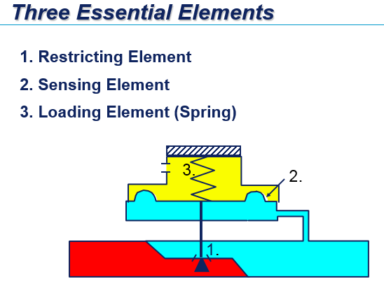
These elements allow for control of the downstream pressure through the force balance between the force exerted by the downstream pressure over the area of the diaphragm, and the force generated, in the opposite direction, by the spring load. When these forces are equal the restricting element is not changing position, if either force is changed the plug will move until balance is achieved again. Imbalance in the forces can be caused by either changing the spring load, which is how the setpoint of the regulator is changed, or by a change in the force acting on the diaphragm.
Under constant demand conditions the force balance will be maintained and the valve will be positioned for the setpoint at the current flow rate. Once demand (flow) downstream changes P2 will change, assuming demand went up the pressure in the downstream pipe will drop as more gas is consumed. This drop in pressure will create an imbalance between the force exerted by the diaphragm and force exerted by the spring due to spring load. With less force being exerted against the spring, the spring will relax causing it to extend which will open the valve and provide more flow to meet the increased demand. The spring load is a function of the compression of the spring, typically expressed in inches, and the spring rate (K) expressed in lbs/in. For example, a spring with K=100 lbs/in that is compressed 1inch will exert a spring force (F_{s}) of 100 lbs. The force of the diaphragm is a function of the diaphragm area and the pressure being applied to it. For example, a diaphragm with an area of 10sq. in. with 10 psig applied to it would exert a diaphragm force (F_{d}) of 100 lbs. See fig 2 for a representation of how these forces work in a typical direct acting regulator.
Fig 2.
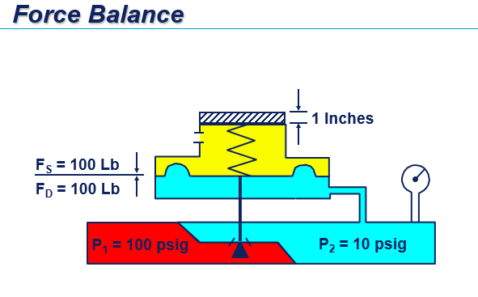
Initial compression of the spring establishes the setpoint at a given flow rate. Further discussion of the operation of the regulator assumes the spring compression is set and no further adjustments to spring compression take place.
In the example in Fig 2, if the demand in the downstream system were to increase P₂ would start to lower as gas was consumed. If the increased demand caused P₂ to decrease to 9psig the resultant force the diaphragm is producing against the spring would be 90 lbs, since our area remained the same (10 sq. in.). The imbalance in the spring force would result in the spring relaxing (or extending) until F_{s} equals 90 lbs. Since K = 100 lbs/in this would result in a 0.1in travel of the plug away from the seat, since it is directly related to the travel of the spring. This results in the valve opening, under its own power, to increase the flow proportionally to the increase in demand. Since there is no external driving force the regulator can only open to match the demand at a slightly lower outlet pressure, where force balance is once again maintained. Assuming a fixed inlet pressure and carrying out load changes of increasing demand you can derive a curve that shows the performance of a direct acting regulator see Fig 3
Fig 3.
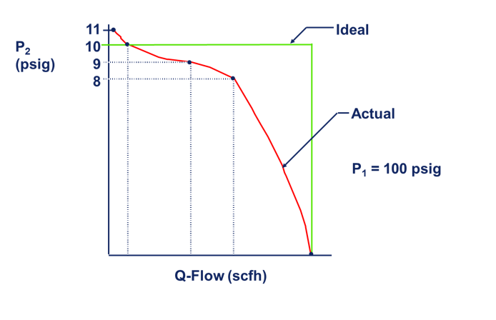
The derived performance curve in figure 3 demonstrates the reduction in outlet pressure that results from increased demand that is commonly referred to as “droop”. It is possible for a direct operated regulator to have areas in the performance curve where outlet pressure tends to rise as flow increases. This tendency is called “boost” and is dependent on how and where the regulator is sensing the inlet pressure. Due to the venturi effect, as the velocity of a gas increases though a constriction, such as the orifice in a regulator, the pressure drops. The point where that effect is at its peak is the called the vena contracta.

Fig 4
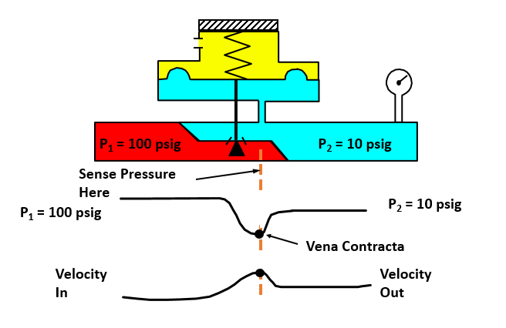

If the pressure exerted on the diaphragm is sensed closer to the vena contracta the resulting diaphragm force is reduced further as the gas velocity increases. This results in more travel in the valve. When the gas downstream, away from the contraction expands the outlet pressure is higher at that flow rate. See fig 4 and 5.

Fig 5
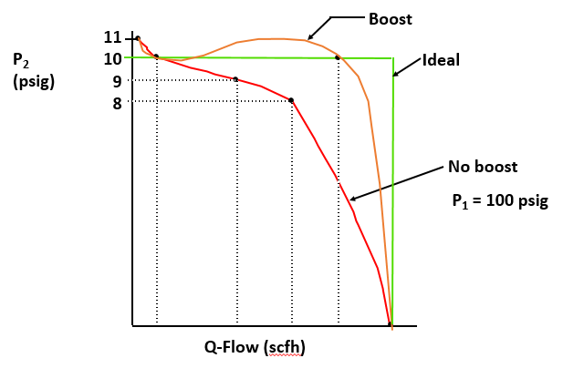
Boost can exist inherently in the regulator based on several considerations such as flow geometry of the body, size of the throat, etc., or it may be designed into the regulator to reduce inherent droop with the addition of devices such as a pitot tube.
Understanding the operation of direct operated regulators, as well as the derivation of the performance curve, especially lends itself to sizing and selection of regulators, in that it demonstrates two key components of sizing, capacity and accuracy.
An ideal regulator would maintain the desired setpoint over the complete range of demand for the system it was installed in. However due to the effects of boost and droop there is variation in the outlet pressure through the available range of flow rates until you reach critical flow. Critical flow is the maximum flow rate for a given restriction dependent on P1 and the orifice size. Depending on the application anywhere from 20% variation around setpoint may be acceptable to as little as +/- 1% abs variation to meet fixed-factor billing requirements. A properly sized regulator, in the real world, will have a performance curve that stays within the desired, or acceptable, range of variability (accuracy) on the outlet pressure over the entire range of flow rates (capacity) required by the load accounting for boost, droop, and critical flow. Direct operated regulators are capable of a wide range of flow rates at different levels of accuracy, requiring more accuracy limits the capacity as droop over the range of flow increases until you ultimately approach critical flow, limiting the capacity. One way to increase the capacity is to increase the size of the regulator. However, that can reach a point where it becomes impractical because of existing line size limitations, the amount of spring load that would be required to lock up a larger orifice, and a number of other practical limitations.
Pilot Operated Regulators
To increase either the capacity or accuracy of a given regulator in a given line size beyond the capability of available direct operated regulators you may need to select a pilot operated regulator. Pilot operated regulators are available in two general styles, but basically operate with a small direct operated regulator, the pilot, providing control to a larger, main throttling valve. The way the pilot controls the main valve is what determines the two general styles.
Pilot Loading Style
Pilots that respond to downstream pressure by supplying a loading pressure to move the main valve in response to changes in demand are referred to as pilot loading regulators. See Fig 6 for a general schematic of pilot loaded regulator. In normal operation the pilot spring tends to open the pilot, just like a typical direct operated regulator. The spring in the main valve tends to close it. As demand downstream increases and P₂ lowers the force imbalance in the pilot opens it increasing the loading pressure, opposing the main spring and opening the main valve to increase flow in response to the new demand. These devices are more complex than the simple, three-element direct operated regulator leading to a large amount of variability making them suitable for a number of more challenging applications. The selection of the proper main springs, pilot, restrictors, etc… all play into the proper application of pilot operated regulators to fit the particular demands of the system. These variables go beyond the scope of this paper, however one of those attributes will be explored a little further.
Fig 6
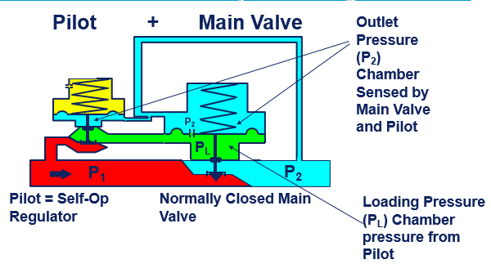
Pilot Gain
The pilot and the restriction that is included in all pilot regulators contribute to the gain of the regulator. Pilot gain is the key to the accuracy and stability of the regulator as it responds to changes in demand. Gain is the ratio of the absolute change in loading pressure (P_{L}) compared to the absolute change in P₂. When the downstream pressure decreases, the pilot opens, increasing the pressure in the loading chamber acting against the main spring. The restriction allows a bleed of some of this loading pressure, it also allows a path to equalize P_{L} and P₂ when the regulator needs to lock-up. The gain allows for the regulator to respond to smaller changes in the downstream pressure. It also allows for using larger main valve restrictions and larger main springs because of the additional force that can be generated. This means you can get more flow for the given line size.

Pilot Unloading Style
The second style of piloted operated regulator is the pilot unloading style. In this type the pilot opens the same way, in response to an increased demand but the effect on the main regulator is that a loading pressure is bled off by the pilot, unloading the main regulator and allowing P₁ to open the main valve’s restricting element. Gain is also achieved through the use of a restrictor in this type of regulator but the method that it is achieved is slightly different. Selection of the type of pilot operated regulator is again beyond the scope of an introduction to regulator sizing. Now that we’ve discussed the operation of the various styles of regulators we can discuss the parameters required to begin sizing and selecting the right device.
Conditions and Parameters required for Sizing Regulators—ISA standardized method
Our discussion of sizing will focus on a few different methods; the ISA six-step sizing procedure will form the outline for the first method. This method can be applied to regulators or control valves and will determine the required flow coefficient (C_{v}), the C_{v} is then compared to published tables provided by the original equipment manufacturer.
Step 1 requires specifying the necessary variables to size the valve. The first variable would be the type of valve desired, meaning a control valve, whether it was rotary or globe for example, or in our case we would be considering a regulator, and ultimately what type of regulator. The remaining parameters required by step 1 are process and service related. First you need to know the process fluid and the attributes of it, including temperature, mole weight or specific gravity (G_{g}), ratio of specific heats (k), and compressibility factor (z). For natural gas we usually consider the process to be at ambient temperature (on the inlet) with an SG of 0.6 and k of approximately 1.3. The remaining parameters would be service related and include P₁, P₂ or delta P, and required flow rate(Q).
Once the required process and service parameters are established, a constant will need to be included in the C_{v} to correct the units. C_{v} is a unit-less coefficient, so working with volumetric or mass flow rates requires a different N constant to account for the different units. Typically, NG applications would be sized for volumetric flowrates using N₇ for a known SG. Using the molecular weight of the gas, or mass flow rates would require a different N equation constant. There are various resources available for N constant look up tables. Determination of the N constant is the second step in the six-step process.
Steps 3 and 4 may not be required depending on the service and application conditions. They are concerned with the effects of fittings and reducers attached to the valve inlet and outlets. Determination of the Cv without steps 3 and 4 on the first pass can be used to determine if a less-than-line size regulator would be appropriate, once that is determined a recalculation with the effect of reducers may be necessary to verify your selection.
Step 3 involves the piping geometry at the valve. If reducers, elbows, or tees are attached directly to the inlet or outlet of the valve a piping geometry factor (F_{p}) should be included in the sizing equation. If the installation details about connections at the inlet and outlet aren’t determined at the time of sizing the factor is entered as 1. Determination of the F_{p} requires resistance coefficients of any upstream and downstream fittings, assumed nominal valve size, inlet and outlet valve size, and an 100% open C_{v} of the assumed valve size. In practice, starting with an F_{p} of 1 to determine a rough idea of the required C_{v} initially, to see if reducers would be necessary, and then revaluating the Cv using the reduced sized valve’s 100% open C_{v} is the easiest way to determine what value to use for F_{p} for less-than-line sized valves.
Step 4 determines the expansion factor (Y) using the ratio of specific heat factor (F_{k}), ratio of specific heats (K), the pressure drop ratio (x) and the pressure drop ratio factor (x_{t}) which is the pressure drop ratio required to produce critical flow. The variables are used to determine Y in the following formula:
$$Y=1-\left(\frac{x}{3Fk\left(xt\right)}\right)$$

Step 5 is the C_{v} calculation, this is performed for volumetric flows and known specific gravities with the following equation:
$$Cv=\frac{q}{N_{7}F_{P}P_{1}Y\sqrt{\frac{x}{G_{g}T_{1}Z}}}$$
Step 6, now that the C_{v} has been determined the valve size can be selected based on published tables from the valve or regulator manufacturers.
This, and most other methods of valve sizing, requires some experience with products and proper application of the equations. Many different sizing software programs are available to assist with the C_{v} calculation and often include built in tables for common process fluid variables, default settings for initial variable selection, valve attribute factors, and other calculations performed in the background, including noise, choked flow, and critical pressure drop ratios. Even with the data tables provided in the software, experience in valve sizing, knowledge of products, and application of the equations is important to know, if you have any questions you should consult the application specialists with the particular vendor’s product you are interested in.
The above six-step method can be applied to regulators or control valves and should be used to determine maximum and minimum Cv requirements, at least, to make sure the selected valve has adequate capacity and turn down for the application demands.
Turndown is the ability of a control valve or regulator to control at the high end of required capacity as well as the low end. It is usually expressed in a ratio and varies with valve design. All pilot operated regulators have some minimum turndown, generally direct operated regulators with soft seats are considered to have infinite turndown.
Sizing Using the Universal Gas Sizing Equation-traditional method
Derivations of sizing equations based on Daniel Bernoulli’s conservation of energy have been applied to valves to determine the flow rates of liquids with known specific gravities under given differential pressures through an orifice. The relationship of the flow rate through that orifice is the square of the fluid velocity is directly proportional to the differential pressure and inversely proportional to the specific gravity. To get a sizing equation from that relationship you just need an experimentally determined coefficient for the valve design in question. That coefficient is the C_{v}. By adjusting these early valve sizing equations, that were designed around liquids, with factors to adjust the units for gas flow rates, and factors to correct the pressures and SG for gasses or vapors you can derive a series of sizing equations specifically useful for compressible fluids i.e. gasses and vapors. The most useful of these are the Universal Gas Sizing Equations illustrated below:

$$Q_{SCFH}=\sqrt{\frac{520}{GT} }{ C}_{g}P_{1}SIN\left[\left(\frac{59.64}{C_{1}}\right)\left(\sqrt{\frac{∆P}{P_{1}}}\right)\right]rad$$
Or
$$Q_{SCFH}=\sqrt{\frac{520}{GT}}C_{G}P_{1}SIN\left[\left(\frac{3417}{C_{1}}\right)\left(\sqrt{\frac{∆P}{P_{1}}}\right)\right]Deg$$
These equations can be used to predict flow for high or low recovery valves, for any gas that adheres to the perfect gas laws, and under various process conditions. Along with the process and service data such as SG, temperature (T), and pressures these equations require 2 new coefficients. C₁ accounts for the recovery factor of the valve in question, the recovery is a function of how low the pressure is at the vena contracta, or how much the outlet pressure has to “recover” from the lowest point through the valve. C_{g} is the gas sizing coefficient and it is used to relate critical flow to the absolute inlet pressure to account for issues with predicting critical flow. These values would be published by the manufacture, C₁ can also be determined by C_{g} divided by the C_{v}. Rearranging the equation for either Cg, or Cv using the relationship with C₁ yields a value that can be looked up using the manufactures data to determine the correct valve or regulator for the required application conditions.
Sizing Using Manufacture’s Performance Data
For direct operated regulators specifically, and some pilot operated regulators that have sensing inside the throat of the main regulator (i.e. internal sensing) manufactures publish tables, or performance curves, to demonstrate the capacity of a given regulator, within a specific accuracy band, under a number of inlet and outlet pressure ranges. These tables may be based on actual test data, a range of calculations similar to the above, or interpolation from various test points. In many regulator applications sizing based on the manufacturer’s tables is the preferred method of regulator selection. These tables account for the boost and droop that may exist due to the particular performance curves of the regulator due to sensing closer to the vena contracta.
Regulator sizing based on the manufacture’s data tables does require either a resource to narrow down the wide range of available regulator regulators, or a great deal of experience to know where to start. Most manufactures publish selection guides, or have developed selection tools, to help narrow down the list of potential solutions. The general procedure for this method would be to gather the necessary data, for NG applications this would include the inlet and outlet pressures, required flow rate, and line size at a minimum. Using a selection guide or tool to select an appropriate regulator model then referring to the capacity tables for that model to select the appropriate regulator size, orifice size, and spring range. Complete the selection by verifying the materials of construction and pressure temperature limits. In pilot operated regulators it is important to also verify the minimum differential pressure required to stroke the valve. Figure 7 below is an example of a typical table, this one is from Emerson-Regulator Technologies
Fig 7
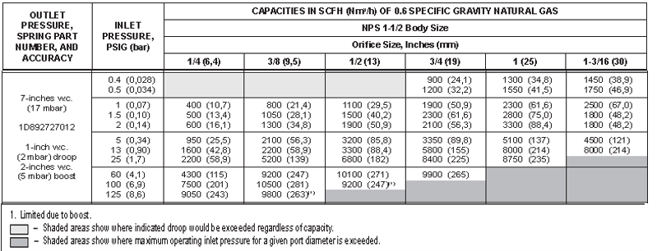
Installation considerations
Along with establishing the correct valve in regards to Cv, there are number of piping and installation related issues to keep in mind to get the desired performance out of the regulators. Straight pipe run on either side of the valve should be adequate to allow for stable conditions on both sides of the regulator minimizing turbulence. Manufactures guidelines regarding straight run of pipe should be followed whenever possible. If the regulator has external sensing line connections and either shared or separate bleed lines, they should be connected in an area with as little turbulence as possible, away from any elbows, tees, rotary or turbine meters, swages, or other causes of turbulence that could affect the sensed pressure or adequate bleed capacity. These lines should also be sized per manufacturers guidelines and may require up-sizing depending on the length of the line. Separate sense and bleed lines should not normally be connected to the same tap with a tee. Some regulators may be sensitive to the orientation of the spring case and body in the pipe line, particularly with very low setpoints. The installation instructions for specific models should always be referred to when determining the layout of an installation to confirm that the selected regulator will function as expected.
Direct operated regulators, and the pilot on pilot operated regulators have a vent to atmosphere to allow the diaphragm casing to breath. These vents should be arranged so that they able to stay clear of water or pest intrusion. Obstructed vents could affect the regulator setpoint, or ability to lockup potentially causing an overpressure event downstream. In some cases, these vents may be piped-away to avoid IRV’s from relieving near possible sources of combustion or near access points to the building. Vent lines that are piped away must be adequately sized to allow free-breathing of the vent and preventing backpressure on the diaphragm. Undersized vents may also limit the relief capacity of an IRV leading to an overpressure event. As a general rule of thumb the vent piping should be the same size as the connection to the vent and should be increased a nominal pipe size for every 10 straight feet of vent pipe. Any elbows (90 degree) in the vent piping should be considered as equivalent to 3 straight feet of vent.
It is also important to make sure the regulator is not oversized for the application. Often times a reduced size e.g. 2:1 line size to regulator size would be preferred to maintain adequate low flow control. Restricted trim that does not reduce the port size of the regulator, or other capacity limiting devices usually do not improve the low flow control of a regulator which may lead to instability. Oversized regulators will also significantly increase the size of required relief valves downstream if they are used for over pressure protection.

Overpressure protection
Regulators are designed to maintain the pressure downstream at a desired value over a range of possible flow rates. In the event that the regulator fails to maintain pressure and allows the higher P₁ to pass on to the downstream side, some form of overpressure protection will be required if that P₁ exceeds the maximum allowable operating pressure (MAOP) of any component downstream. That could include downstream equipment like appliances that are being supplied, the downstream pipe itself, or even the outlet side components of the regulator e.g. the spring case and diaphragm or other internal parts. Various methods of overpressure protection are available, including staged regulation, relief valves, monitors, and internal relief valves. Staged regulation would be the use of regulators upstream maintaining P₁ below the MAOP of components downstream of a second regulator. This method isn’t necessarily practical because of the additional devices and additional pressure drops that would be required throughout a distribution system. We’ll be looking specifically at sizing relief valves, and also discuss monitor sets and the sizing considerations required when using them.
Relief Valve Sizing
When using relief valves as your method of overpressure protection there are options ranging from a “pop” relief, direct operated relief, and pilot operated relief. Selecting the type of relief valve depends on the demands of the system. A simple pop relief may be adequate but the stability downstream will be impacted by the on/off action of the relief. Throttling can be achieved with more controlled action using a direct operated relief valve. In systems with very tight tolerances between the regulator, or monitor setpoint, relief start-to-discharge, and high alarms, or the MAOP itself the additional accuracy and capacity of a pilot operated relief may be required. Determination of the required Cv is no different than the sizing method for a regulator, however, it does require very careful consideration of the parameters used, to make sure there is adequate capacity to maintain downstream pressure at a safe value by relieving enough gas.
You can also size a relief valve with a Q_{max} calculation with the following data. Maximum P₁ upstream of the regulator you are assuming failed, the maximum allowable P₂ of that regulator, and the wide open Cg of the regulator you are assuming failed. The wide-open Cg is published by the manufacturer and can be higher than the regulating Cv. The formula for Q_{max} is:
$$Q_{max}=(P_{1 max})(C_{g wo})(1.29)$$
This flow rate can then be compared to published flow data tables to select the appropriate relief valves. These tables will be published with a build-up value that shows the pressure above setpoint required to achieve that flow rate. You must make sure that the downstream, including the build-up doesn’t exceed your MAOP, or emergency guideline values in excess of MAOP. The DOT has the following emergency guidelines in excess of established MAOP.
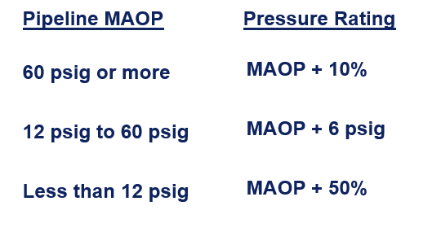
Careful consideration to setpoints, lockup, start-to-discharge, and buildup to make sure there is significant dead band between the regulator and relief valve allowing the regulator to lockup with the relief discharging and allowing the relief valve to reseat prior to the regulator operating. See figure 8 for a diagram of how all of the listed factors interact.
Fig 8
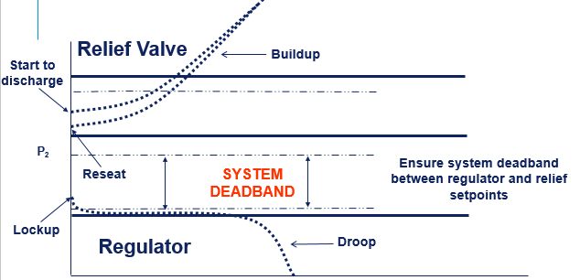
Internal Relief (IRV)
Another method of providing relief protection is the use of a regulator equipped with an IRV. The IRV allows for a relief path though the vent of the regulator to limit downstream pressure based on the inlet pressure of the regulator and the orifice size. IRV performance is limited as inlet pressure and orifice size increase, performance graphs of downstream build up are provided by manufactures for regulators that have IRV’s. As long as the build-up for your expected conditions is below your desired maximum outlet pressure, you may consider IRV’s as full overpressure protection. When the IRV is not capable of providing full protection it is still useful in preventing thermal expansion of the gas downstream causing overpressure in a lockup conditions (ie “sun gas”), or providing an indication that an overpressure condition may exist by releasing enough gas to notice the smell or sound (token relief)
Monitors
The final method of overpressure protection we will discuss is regulator/monitor arrangements. There are two main types of monitor arrangements, wide-open, and working. Both use two devices to sense the same downstream pressure. If the regulator, the device doing the final pressure control of P₂ were to fail, the monitor, set to a slightly higher pressure would take over and keep the pressure downstream at a safe value while maintaining operation of the system. The schematic below shows a typical wide-open monitor arrangement. The only thing that determines which one is the monitor and which one is the regulator is the setpoint, so these can be arranged with the monitor upstream, or downstream.
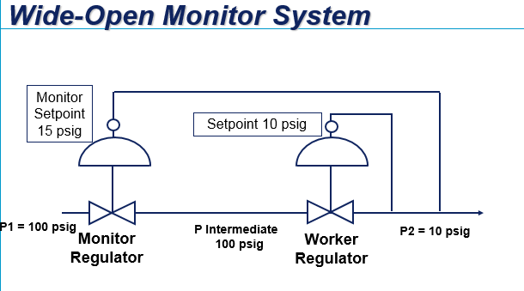
When sizing and selecting a wide-open monitor one device must be available in an external sensing option so the sensing line can be plumbed around the regulator to the final P₂ section of pipe. When sizing a wide-open monitor set the P₁ upstream of the set is used, to accommodate for the pressure drop across the wide-open monitor it is generally considered acceptable to reduce the capacity (or calculated required Cv) by 30%. In other words, the pair of regulators in this setup will have about 70% of the available capacity of the same regulator by itself.
A working monitor arrangement uses the upstream device as the monitor. It requires two pilots on the monitor, one senses the downstream pressure and acts as the monitor, the second pilot senses the intermediate piping between the monitor and the regulator and uses the monitor to regulate that intermediate pressure at a constant value. Here is a schematic of a working monitor arrangement:

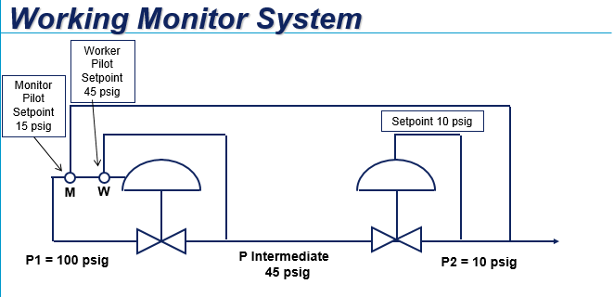

Sizing working monitors is more advanced and requires balancing the capability of the monitor to meet its normal operating requirements regulating intermediate pressure, with the capability of both devices to handle the emergency condition of one device failing. There are tools available from some manufacturers that aid in working monitor sizing.
Conclusion
Because of the wide range of available regulators sizing and selecting them may be a little overwhelming at first. With a basic understanding of the operation of a regulator, access to some tools and training to help narrow down the options, and a little practice it doesn’t take long to become proficient at it. There are a number of variables that should be considered, as well as best practices that should be considered so if you are new to regulator sizing reach out to your vendors, and seasoned application experts. A lot can be said for experience and not every application behaves the same way, there are a number of applications that can require additional considerations that weren’t covered in this paper such as noise considerations and attenuation. A lot of the more advanced topics are covered in other papers being presented and there are a number of regulator sizing and training opportunities available in the industry. If you ever have a concern consult more experienced engineers or your vendors, or product manufacturers.

References
Fisher Control Valve Handbook, 4th Edition

