**Introduction to Gas Ultrasonic Meters**

JOHN LANSING

PRESIDENT

LANSING MEASUREMENT SERVICES, LLC

## Abstract

This paper is an overview gas ultrasonic meters, which are also known as USMs. Discussion topics include principles of operation, different path configurations, basic diagnostic features, AGA Report No. 9, flow calibration issues, flow conditioning, basic piping design, routine maintenance considerations, control valve noise mitigation and a variety of other aspects to consider when using gas ultrasonic meters (USMs). It primarily discusses fiscal-quality, multi-path USMs and does not cover issues that may be different with non-fiscal meters. These are typically single path designs which can be spool-piece meters or clamp-on designs. Although today’s USMs use the same transit-time principle of operation, diagnostics for each manufacturer does vary. This will be discussed in some detail later in this document. Additionally, all brands and path configurations that are used for custody transfer applications must meet basic requirements as discussed in The American Gas Association’s AGA Report No. 9 [Ref 1 & 2].

## Introduction

In the early 1990’s, gas ultrasonic meters were being evaluated by many pipeline companies. The advent of electronic measurement in the 1980’s paved the way for accepting a measurement device that utilized electronics to compute flow. These initial USM devices were generally not used for custody (fiscal) measurement because they were new, and there were no standards that could be referenced. Many times, they were single path meters used to provide an indication of flow rate but were not accurate enough to be considered for custody transfer.

Initial gas USMs utilized analog electronics to measure time. This method of time measurement was subject to substantial errors due to ambient temperature effects. Setting up the meter was also not very robust as the pulse detection algorithms were not precise enough. In the early 1990s, manufacturers began employing digital electronics for computing transit time, and the quality of the metering significantly improved.

Seeing the significant enhancement in metering performance (accuracy, rangeability, reliability, etc.), members of the American Gas Association (AGA) began development of a USM document in 1994. The Transmission Measurement Committee (TMC) decided to first develop a Technical Note [Ref 3] document which would be an assimilation of known information and theory of operation for the USM. After this document was completed in 1996, it was decided to then develop a formal report like those previously developed for other measurement technologies such as orifice and turbine. This document was assigned the number AGA Report No. 9.

It is important to note that the Industry (end users of flow measurement devices) drove the development of this report. Only three manufacturers were represented at the meetings during the document development. They were Daniel Measurement & Control, Instromet Ultrasonics, Inc. and Panametrics. The role of the manufacturer was primarily to insure a document wasn’t written that would not permit their product from meeting performance requirements.

## Principles of Operation for Ultrasonic Flow Meters

The principle of operation for an ultrasonic flow meter is known as transit-time measurement. Two transducers, capable of transmitting and receiving ultrasonic sound pulses, are installed in the flow line (meter body) in such a way that the ultrasonic sound pulses emitted from one transducer can be received by the other transducer, thus creating an acoustic path. They are mounted at an angle relative to the gas flow. This angle is typically between 45 and 65 degrees. The transducers alternately transmit and receive pulses several times per second. Generally, meters measure all paths transit times from 10 to perhaps more than 100 times per second. The output of the meter, which is generally represented by a pulse output, is updated once per second in most cases. Most clients configure the meter to provide up to 5,000 Hz output when the meter reaches its full-scale value, but other full scale values like 2000 Hz are also used.

The ultrasonic sound pulses travel, with respect to the gas, at the speed of sound. The speed of a sound pulse along the acoustic path, traveling downstream, is increased with the projection of the gas velocity onto the acoustic path. The speed of the sound pulse, traveling upstream along the acoustic path, is decreased with a projection of the gas velocity onto the acoustic path. In other words, the sound pulse traveling with the gas flow arrives in less time than the returning pulse that is traveling against the flow of gas. This results in different travel times for the upstream and downstream directions. The difference in these transit times is directly proportional to the gas velocity (see equations below for more details). That is, if the transit time difference doubles, then this is a result of the gas velocity doubling. Thus, a gas USM is considered a linear meter, and corrected volume calculations can be computed using the traditional AGA Report No. 7 [Ref 4] linear meter corrections (P, T and compressibility).

All gas USMs are bi-directional by design. The electronics can detect which transit time signal is less, and thus can interpret this for determining flow direction. Today’s gas USMs generally provide separate frequency outputs for each flow direction, but can also provide one frequency output with a separate output for flow direction (not as commonly used as separate pulse outputs).

Today most USM manufacturers operate their transducers in the 100-350 kHz frequency range. Lower frequencies may be better for lower pressure but may also be more sensitive to extraneous ultrasonic noise inside the pipeline. Higher frequency transducers may have more immunity to this extraneous noise, but also can have lower signal strength over longer distances do to the sound being absorbed by the gas molecules. Thus, each manufacturer tries to find the best compromise for transducer frequency. Some manufactures offer several frequencies of transducers to cover a wide variety of pressures and gases not common to the gas industry. These include very low pressure applications, ones with high CO2, pure Hydrogen and Oxygen, high H2S, and other specialized gases that are not typically found in traditional transmission pipelines.

Today’s transducers are very efficient devices, and use very little power. Some designs use such low power that they are considered “intrinsically safe” for the typical pipeline application spelled out in the National Electrical Code (NEC) [Ref 5]. This means that no special wiring is required and they can be disconnected from the electronics without the need to power down the meter. With the enhancement in electronics over the past decade, some meters draw less than one watt of power and thus make it much easier for the client to solar power the meter if “mains power” is not readily available.

Figure 1 is a simple illustration of a single path meter with transducer faces sending pulses back and forth. For the sake of simplicity, only a single path meter is shown. However, the same principle applies to other designs, regardless of the number of paths employed in the meter. This example shows the transducers mounted perpendicular to the meter body with the faces creating the angle (ϕ) relative to the gas flow.



Figure 1: Principle Transducer Layout for an Ultrasonic Flow Meter

Figure 2 that follows shows another method of mounting transducers to create an angle of the acoustic path relative to the gas flow. Following is a drawing showing the mounting of the transducers relative to the flow of the gas in the meter body. This is a very common method of mounting transducers. Some manufacturers use the “alpha” symbol (α) for the angle, some use the “phi” symbol (ϕ) for the angle. This is simply a matter of preference.

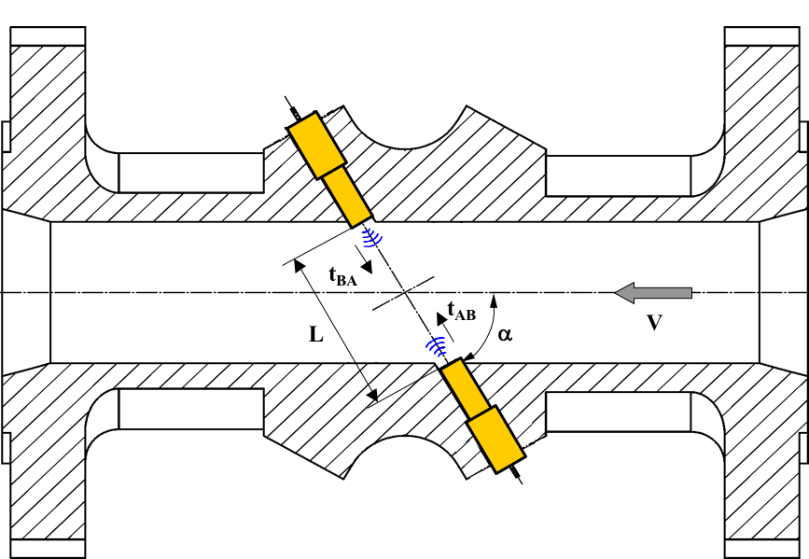

Transducer A

Transducer B

Figure 2: Simple Geometry of Ultrasonic Flow Measurement with “Angle” Measurements

Figure 2 shows a transducer with the face that generates the acoustic sound that is perpendicular to the mounting housing. Some manufactures utilize this design while other utilize a design that is shown in Figure 1.

The following equation represents the transit time measurement for the signal traveling downstream relative to the gas flow direction (in this case from Transducer A to Transducer B (depicted in the equations *tU* and *tD*, or as *tdown* and *tup*).

Equation 1

  Equation 2

where

L: Length of the acoustic path (also knows as path length)

C: Speed of sound in the medium (gas)

Vm: Velocity of the moving medium (gas) thru the meter

ϕ: Angle between acoustic path and a vector representing the direction in which the medium moves (α in Fig. 2)

**Note:** The terms *tup* and *tdown* are also represented in equations in a variety of ways including *tU* and *tD*, and Tx1 and Tx2 as shown in Figure 3 below. They all represent the same thing (transit time upstream (against the flow of gas) and downstream (with the flow of gas).

Equations 1 and 2 have two unknowns (*Vm* and *C*) and thus can’t be solved independently. However, by combining these two equations, and simplifying, each unknown (*Vm* and *C*) can be solved for. The following equations for the measured gas velocity (Equation 3), and speed of sound (Equation 4), often abbreviated SOS, can be described as follows:

  Equation 3

 Equation 4

It is important to note that the measured gas velocity in Equation 3 is independent of the gas speed of sound. Also, Equation 4 shows the SOS is independent of the gas velocity. In other words, the meter will report the same SOS regardless if the gas is flowing at 10 fps or 80 fps. The SOS is simply a property of the gas which is only affected by pressure, temperature and gas composition. These are theoretical equations, and there are minor second order effects that do show the SOS can be affected by gas velocity. These are very minor in nature for the range of gas velocities the meter is operated at, and many manufacturers provide compensation, so the user doesn’t realize there is a small effect. Also, note that the acoustic path angle is not part of the meter’s calculation of SOS. Only path length and transit times are needed to compute SOS.

For today’s gas USM to provide the level of performance required by the client, transit-time measurements require a resolution in the low nanoseconds (10-9) range (some even have resolutions in the picosecond (10-12) range). The absolute transit times vary based on meter size and gas composition. The absolute transit time, in either direction, from one transducer to the other, can range from several milliseconds to a few microseconds. This variation in transit times from upstream to downstream depend on the path length (a function of the meter diameter and path configuration), and the gas composition, pressure and temperature (which determines the absolute gas SOS).

Another method for looking at the simple geometry of the gas ultrasonic meter is discussed in the AGA Technical Note [Ref 3]. The following drawing shows this geometry.



Figure 3: USM with “X” Dimensions

This drawing show a dimension “X” which represents the axial length between the transducer faces along the length of the meter body. The equations for determining gas velocity are like those in Equations 1, 2 & 3 with the exception that they do not contain the transducer angle (Cosine ϕ). Instead of using the Cosine of the angle, the angle is replaced the by L/X (same as the Cosine angle calculation). Thus, the equation gas velocity, shown in Equation 5, is as follows:

 Equation 5

For custody measurement, multiple pairs of transducers are required (more in the section on AGA 9). The reason for multiple pairs is to lower the uncertainty of the measurement. Since gas flow is not always perfectly symmetrical and non-swirling, manufacturers utilize multiple acoustic paths and combine into one gas “bulk mean average gas velocity” which is represented as “*A*” in Equation 6. The integration of all pairs of transducers into one average gas velocity is often manufacturer proprietary and confidential and is based on the specific path configuration.

Once the average gas velocity has been determined, the meter then computes the flow rate. This is simply multiplying the average velocity times the cross-sectional area of the measurement section of the meter body. Equation 6 shows this calculation.

 Equation 6

It is important to note that the cross-sectional area (A) of the meter is determined at the location where the transducers are measuring transit times. Some meters utilize the same bore for all meter piping schedules. This means that the measurement section is a smaller diameter than the piping that it is bolted to. Typically, this taper is on the order of 5-10 degrees. AGA 9, Second Edition, specifically addresses this design and permits this if it doesn’t interfere with the meter’s performance. This is often referred to as a “tapered- bore meter” where the meter design that doesn’t have a tapered bore is said to be a “straight-bore” meter.

There are several benefits to using a single measurement section diameter. It allows for one casting for a range of meter schedules (30. 40. 60, & 80 for example). Since the inside diameter (ID) where the measurement occurs is the same for these schedules, it permits the manufacturer to have one set of coefficients for a given nominal pipe (NP) diameter. This helps improve the “out of the box” performance as the database is much larger when all meters for a given line size have the same meter bore. Some feel there are additional benefits to the taper such as less sensitivity to misalignment.

## Basic USM Acoustic path configurations

Figure 4 shows 5 types of integration techniques [Ref 6]. These were the common path configurations utilized in the 1990s and into the 2000s. The various meter configurations provide different velocity responses to varying gas profiles and are thus the electronics must analyze each differently. Also, under some conditions, the reported path to path SOS can vary at low flow rates with some designs. This is primarily the case when a meter is operated at very low velocities as thermal stratification can occur (more on this later).



Figure 4: Basic Ultrasonic Meter Path Designs

Today there are several gas USM manufacturers on the market where in the 1990’s there were perhaps only 2-3 suppliers providing 90+% of the meters used by industry. With the interest in using USMs continuing to increase over the past 10-15 years, new manufacturers have emerged. Many have chosen to develop different path configurations to not only differentiate themselves from the competitor, but to perhaps reduce the uncertainty even further. Figure 5 is an example of most of the different path configurations at are available at the time this paper was published.

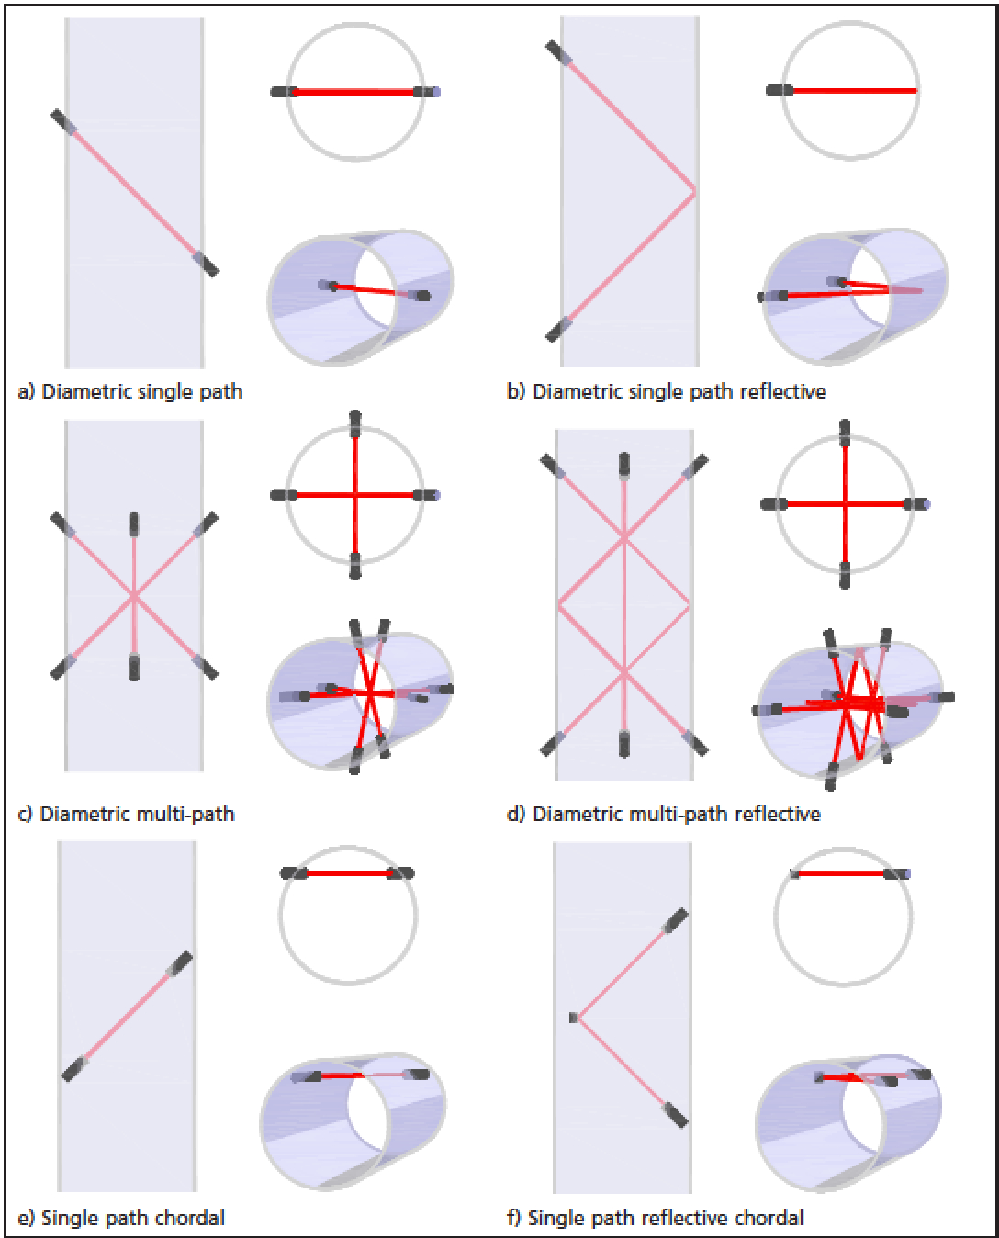 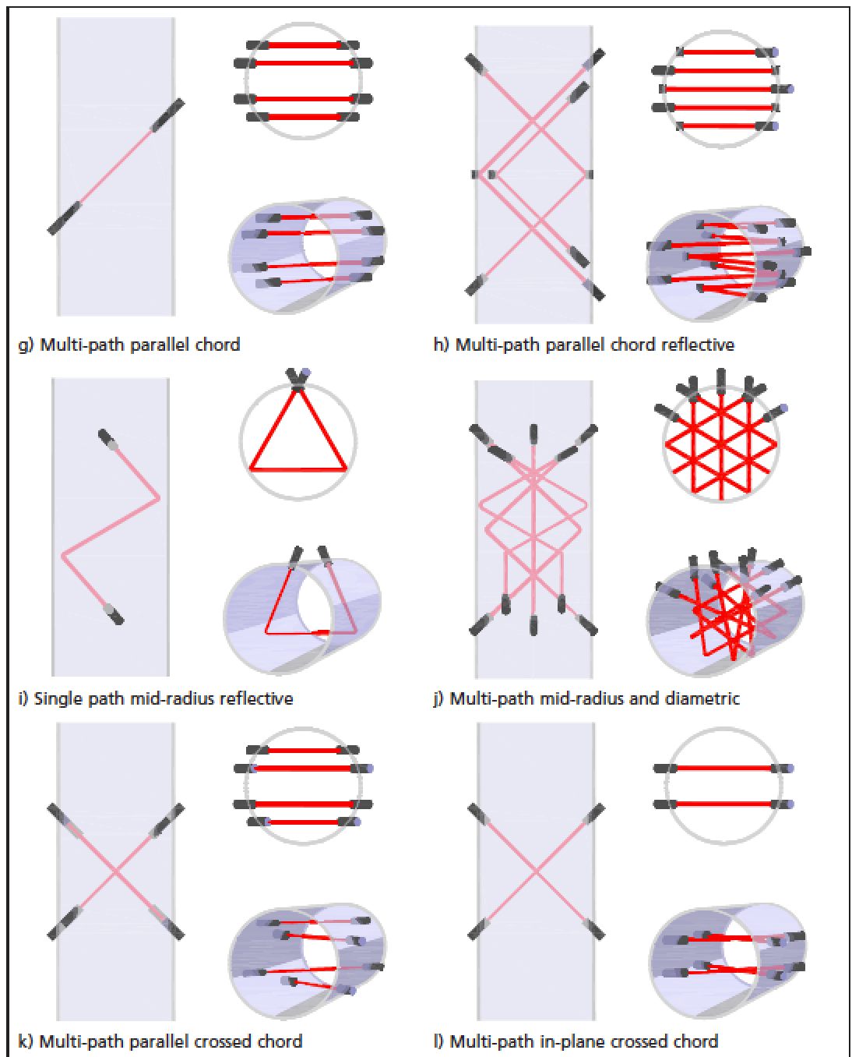

Figure 5: Expanded List of Ultrasonic Meter Path Designs

# Multipath Meter Path Designs

For custody transfer applications, as defined in AGA Report No. 9, the USM is required to use multiple acoustic path (multipath) meters. The reason is the uncertainty of the profile correction factor for a single path meter is not accurate enough to be acceptable for custody transfer applications. Multipath ultrasonic flow meters, by implementation of integration techniques, allow using data from multiple acoustic paths to improve the accuracy of the flow profile correction.

One common meter path design is called the Westinghouse configuration because it was first patented in the 1980’s by Westinghouse. This 4-path chordal design has all 4 pairs of transducers in one vertical plane. A drawing of this path configuration can be seen in Figure 5, upper left of the right-hand image and is titled [g) Multi-path parallel chord]. In the mid 1980’s British Gas developed a meter and licensed it to Daniel Measurement & Control. It is commonly referred to as the BG design. This design is shown in the lower right of the right-hand image and is titled [k) Multi-path parallel crossed chord]. As the title indicates, and the drawing shows, two-path are in one vertical plane and two in another. Both designs typically use the same weighting (multiplier for each acoustic path), and the same physical distance ratio from the center of the meter to the acoustic path.

The other popular design in the 1990’s is the Instromet Ultrasonic meter, and it is shown in the right-hand image of Figure 5 and listed as [j) Multi-path mid-radius and diametric]. Also, Figure 5, right image shows drawing [l) Multi-path in-plane crossed chord design which is still used by Daniel. These four-path configurations were the most popular designs in the 1990’s and are still in use today.

In the 2000’s other meter designs began appearing on the market for custody measurement applications. These included designs show in Figure 5, right hand image [h) Multi-path parallel chord reflective] as well as others not shown here (Honeywell 6-path configuration and the Cameron 8-path Westinghouse design meter). These products, and probably others the author isn’t aware of, are being marketed with each manufacturer believing they have a solution user’s will prefer.

## Benefits of Ultrasonic Meters

This section discusses the benefits of the USM over traditional technologies.

# Why Use Ultrasonic Meters?

Ultrasonic meters have many benefits over the traditional orifice and turbine meter which the USM typically is used to replace. Since the mid-1990s, the installed base of USMs has grown steadily each year. There are many reasons why ultrasonic metering is enjoying such healthy sales. Some of the many benefits of this technology include the following:

* Accuracy: Can be calibrated to <0.1% relative to the flow calibration facility.
* Large Turndown: Typically >50:1, but depends upon company upper and lower flow rate design criteria.
* Naturally Bi-directional: Measures volumes in both directions with comparable performance.
* Tolerant of Wet Gas: Important for production applications as liquids generally will not damage the meter.
* Non-Intrusive: Minimal pressure drop.
* Low Maintenance: No moving parts means reduced maintenance.
* Fault Tolerance: Meter remains relatively accurate even if a sensor should fail.
* Integral Diagnostics: Data for determining a meter’s health is readily available.
* Effects of Contamination: Generally lower uncertainty when contaminated compared to orifice and turbines.
* Effects from Pulsation: Much less affected by pulsation compared to orifice and turbine meters.

These are some of the many important benefits to using USMs. Perhaps the most significant is the ability to diagnose the meter’s health. The main question users want to know is whether the meter is still accurate after having been in service since the last inspection. By using the meter’s diagnostics, it is generally possible to determine if a meter accuracy has been affected due to contamination.

Other primary measurement devices, such as orifice and turbine meters, offer little insight into whether they are still operating accurately after being in service between inspection intervals. Issues such as contamination from pipeline oil and mill scale will impact the accuracy of any meter. Visual inspection is often required to validate proper operation for traditional primary measurement devices. Ultrasonic meters, on the other hand, offer electronic diagnostics that can help validate proper operation, while flow gas, and thus reduce the internal inspection requirements often required of other devices. These internal diagnostics can also be used to help identify whether the other components at the measurement station, such as temperature measurement and gas composition, are also operating correctly. For these reasons, many designers are now specifying the use of ultrasonic meters more today than ever before.

# USM Cost Comparison

No discussion about using ultrasonic technology would be complete without addressing installation and maintenance costs. Although this cost comparison with other measurement technologies is dependent upon many variables, the two most important ones are perhaps maximum and minimum anticipated flow rates. Other factors such as bi-directional requirements, operating pressure range, gas temperature, cleanliness of the gas, etc., also factor into the decision as to which primary measurement technology is best suited to the application. The benefits are difficult to quantify without knowing these conditions. However, if the operational range for a given application exceeds the capacity of a single traditional meter (orifice or turbine), using USM technology may significantly reduce the capital expense (CAPEX) associated with the installation.

One reason the number of ultrasonic applications continues to grow is the reduced long-term cost of operation (O&M) and additional diagnostics that are available from this technology as compared to other measurement devices. These benefits have been well documented in papers presented at several conferences in the past [Ref 7, 8, 9, & 10]. Certainly, one of the most significant benefits is the reduction in maintenance. Unlike other technologies, USMs can be diagnosed without taking the meter out of service. This is often done remotely using LAN/WAN networks via Ethernet, dial-up phones, radios, or automated diagnostics systems that perform 24/7/365 automated health monitoring. These benefits, and many more, often provide the user with significantly lower O&M costs.

Today there are systems implemented in the field that continuously monitor the meter’s diagnostics. Some utilize the client’s flow computer / RTU to obtain the USM diagnostics, and then push the data to the corporate system for further analysis. These are generally proprietary for the given system and often require the use of a specific brand of RTU that has the power and flexibility to collect this additional information. The client must also have sufficient bandwidth to permit pushing all this data to their host system.

Another strategy that has been utilized is implementing a separate (off the network) monitoring device that focuses on collecting diagnostics and sending to a host server via a cellular network (or another communication topology outside the corporate LAN/WAN). The advantage to this system is it is independent of the client’s flow computer, no programming is required by the client, no LAN/WAN bandwidth is utilized, and it can serve as a backup flow computer in the event the primary fails. This type of system uses a small RTU for data collection and local calculations, and can also support redundant P&T measurements to reduce site calibrations. It communicates with the gas chromatograph (GC) to insure it is operating correctly, performs a “real-time” AGA 10 SOS [Ref 11] calculation, and continuously compares this to the USM. It can also perform a variety of other monitoring functions like validating the USM configuration hasn’t changed, comparing flow rates thru series and parallel meters, and can send out alarms immediately if a problem occurs.

# Sizing of USMs

Traditional measurement devices have been limited to flow rates that were equivalent to 50-60 feet per second (fps) maximum. Although high-capacity turbines operate in the 80-95 fps range, most installations are still designed for the standard capacity meter. One of the significant advantages of ultrasonic meters is their ability to operate accurately at more than 100 fps with no damage to the meter. In replacing orifice meters, the “rule-of-thumb” is that the capacity of an ultrasonic meter is at least 1½ times that of an orifice meter.

Many users specify velocity limits in piping to minimize the potential for erosion in fittings (bends, elbows and tees) that can cause failure of the piping should the wall thickness become too thin. There have been reports of severe erosion of elbows downstream of meters that were operated above 100 fps for significant periods of time that had entrained solids. However, there are several other issues that limit high velocity operation.

Higher velocity operation increases the stress on the thermowell(s). There have been reported cases of thermowells cracking when operated at high velocities. Some work has been performed to determine how accurate the RTD element remains when the thermowell is subjected to very high velocities. Studies indicate that vibration of the thermowell may also cause the RTD to register higher due to “self-heating” that occurs when the RTD element rubs against the thermowell.

Higher velocities also create more differential pressure across today’s high-performance flow conditioners. The magnitude of this loss is somewhat dependent on the type of conditioner installed. However, typically the pressure drop at 40 fps is on the order of about 1.20 psi differential (psid). If the gas velocity through the meter is increased to say 80 fps, the differential then becomes approximately 4.80 psid. However, the pressure drop in the piping system, including headers, valves, elbows and other piping is generally greater than the loss thru the flow conditioner. Since the flow conditioners typically have the same “beta” ratio (ratio of open area to pipeline diameter), this pressure drop is relatively the same regardless of pipeline size.

For the previously mentioned reasons, most designers limit normal operation to between 70 and 85 fps. Many clients will calibrate the meter to perhaps 100 fps (and some as high as 150 fps) in the event the meter is over-ranged. This helps ensure the meter is still accurate during this abnormal flow condition.

It may be tempting to install a smaller meter and operate at higher velocities on a regular basis. For smaller line sizes, which generally use shorter thermowells, and if the gas is clean, this may be acceptable, and probably not cause any maintenance issues. However, the initial cost savings of going to higher velocities for larger meters can quite possibly be offset with increased maintenance and reliability problems that may occur later. The real benefit of the higher velocity capability is the ability to have accurate measurement at the higher flow rates which may occur during upsets or other abnormal conditions. In addition, short-term operation at high velocities will not damage the meter as may be the case with orifice and turbine meters.

## AGA 9 Ultrasonic Meter Requirements

AGA 9 includes a section that discusses a variety of requirements the USM manufacturer must meet to be considered for custody. One of the requirements is that the meter must be a multi-path design. That is, the meter must employ two or more independent paths. Following are some additional key points in that document

# Meter Firmware Requirements

The meter’s firmware (program) must be stored in non-volatile memory. In other words, the program used to compute the flow rate must be stored in memory that can’t be lost if power is removed. Most meters today utilize either a small battery or capacitor to keep an internal “real-time” clock running in the event of power loss. All meter-specific parameters, which are entered at the time of assembly (also known as Dry Calibration), must also be stored so they can’t be lost with a power outage.

# Meter Input/Outputs

Today virtually all gas USMs have a variety of outputs. Some of these are required by AGA 9 while others are considered optional. USMs generally have two or more serial communication ports. RS-485 is generally preferred because data can be transmitted over much greater distances, and more reliably than RS-282. These communication ports can be used to connect directly to the flow computer, can be terminated in the instrument building (assuming there is one) for connecting to the technician’s laptop, can be connected to modems for remote access (both cellular and land-line), and in some cases connected to the gas chromatograph to obtain real-time gas composition.

Ethernet connectivity has gained popularity over the past several years. As communication bandwidth has increased, and the cost has declined, many clients now have Ethernet at their measurement sites. This allow for much higher speed data communication, and remote access to the devices if desired. When designing the metering station, it is always good practice to consider installing Ethernet cabling to the meter junction box even if there is no immediate plan to use it. Future product enhancements are likely to include the addition of Ethernet even if the current electronics does not support it.

# Meter Power Requirements

Meters today primarily operate on either 12 or 24 VDC. Some can operate over this range with no hardware changes. Typical power consumption can be below one watt to perhaps as much as 8 watts depending upon features like Ethernet and local displays. Solar power is certainly possible for many applications, especially for meters that consume less than one watt.

# Local Displays

The cost of LCD displays now make it cost effective for most manufacturers to include as standard, or as an option. Some displays are merely there to provide the operator with local flow information. However, many USM manufacturers now have touch-screen color displays that permit much more than just viewing a few live parameters. These displays are also valuable to identify if the meter has any past or active alarms.

# Write Protection

AGA 9 requires the USM manufacturer to incorporate some type of hardware jumper, or switch, that can be used to protect against unintended configuration changes. This is often referred to as a “write protection” switch since it only permits reading data from the meter and does not allow changing any configuration parameters. To make any configuration changes, some manufacturers not only require this switch be placed in the “read/write” mode, but the meter must also be placed in the “configuration” mode via software. This provides a second level of accidental configuration change protection. This “read/write” mechanism must be located inside of the meter housing and require opening the enclosure to gain access. Manufacturers also provide for “wire sealing” the cover to identify if access to this switch has been compromised.

# Transducer Replacement

Most gas USMs permit removal of a transducer under pressure without blowdown. In the 1990s, and perhaps the 2000s, this was a desirable feature to have. Transducers were not as reliable, and clients didn’t want to always put two meters in parallel to allow one to continue flow. However, newer technology has significantly improved the reliability, so removal and replacement are not very common. Thus, many now choose to blow down the meter should a problem develop. This also allows for internal inspection of the meter run and potential cleaning of any dirty transducers, meter body and piping. Additionally, since there is always the risk of uncontrolled release of natural gas when performing this operation, many now cite safety as the primary reason to blow the meter down.

# Audit Trail

Meters today generally have one or more “audit” logs to store data in the meter. These logs can provide a history of past problem that have occurred. Most manufacturers that log items like alarms and warnings also date and time stamp them for the technician to review and collect with software. Meters also generally store configuration changes with a date and time stamp to validate if the configuration has been changed. Many meters also provide for logging flow data at the hourly and/or daily level. These “data” logs typically contain flow data along with diagnostic averages over that period. This helps identify diagnostics that are slow to change.

## Basic Diagnostic indicators

During the past 20+ years there have been numerous papers presented which discuss the basic operation of USMs [Ref 7]. These papers discuss the meaning of the five basic diagnostic features. Following is a summary of the five features available from all USM manufacturers.

* Individual path velocities
* Individual path speed of sound (SOS)
* Gains for each transducer
* Signal-to-noise (SNR) for each transducer
* Accepted pulses, in % for each pair (also known as performance)

Although these features are very important, little has been written on how to interpret them. Part of the reason is diagnostic analysis often varies by manufacturer. One of the principal attributes of modern ultrasonic meters is the ability to provide several diagnostics that can be used to monitor the meters “health,” and thus assist in diagnosing any problems that may occur. Multipath USMs are unique in this regard as they can compare certain measurements between different paths, as well as checking each path individually.

Some manufacturers provide additional diagnostic features such as swirl angle, Turbulence, Profile Factor, Symmetry, Crossflow, AGA 10 [Ref 11] SOS vs. the meter’s reported SOS, and others.

Graphs shown in this section are from Excel spreadsheets based on data generated by the manufacturer’s software that is used to communicate with the meter. Note that these graphs were not manually developed, but rather automatically generated from the data collected during calibration or maintenance procedures.

It is important for users to collect periodic maintenance log files. These log files provide a “snap-shot” of the meter’s operation at that point in time. Many utilize some of the data for entry into their company database for tracking over time. However, many users don’t perform any tracking or trending of data. Thus, one of the major benefits of the gas USM isn’t fully utilized.

Measures that can be used in this online “health checking” can be classed as either internal or external diagnostics. Internal diagnostics are those indicators derived only from internal measurements of the meter. External diagnostics are those methods in which measurements from the meter are combined with parameters derived from independent sources to detect and identify fault conditions. An example of an external diagnostic would be the calculation of the gas SOS which is computed using the gas composition, pressure and temperature, and compare to the meter’s reported SOS.

# Gain

One of the simplest indicators of a meter’s health is the presence of strong signals on all paths. Today’s multipath USMs have automatic gain control on all receiver channels. Transducers typically generate the same level of ultrasonic sound time after time. The increase in gain on any path indicates a weaker signal at the receiving transducer. This can be caused by a variety of problems such as transducer deterioration, fouling in the transducer ports, contamination on the transducer faces, or significant liquids in the meter body.

However, other factors that affect signal strength include metering pressure, path length and flow velocity. Figure 6 shows gains from a 16-inch meter at the time of calibration. These were taken when the meter was operating at approximately 20 fps. This meter utilizes the Westinghouse design that was discussed earlier.



Figure 6: Gain at 20 fps – 16-inch Meter

Note that the gains on each of the pairs are very similar, and the gains by path are higher in the middle two paths. This is due to the increased path length for the center paths on a Westinghouse design, and thus additional amplification is required. Figure 7 shows the same meter at 155 fps.



Figure 7: Gain at 155 fps – 16-inch Meter

Figure 7 show the gains for all pairs have increased. This is normal when a meter is operating at much higher velocities, and is due to signal attenuation. Gain can also be affected by changes in gas composition (for instance higher than normal CO2), contamination on the face of the sensor, electronics problems, and a transducer that has poor connections or failing for one of many reasons.

# Signal Quality – Transducer Performance

This expression is often referred to as performance (but should not be confused with meter accuracy). All ultrasonic meter designs send multiple pulses between pairs of transducers before updating the output. Ideally all the pulses sent would be received and used. However, in the real world, sometimes the signal is distorted, too weak, or the received pulse does not meet certain criteria established by the manufacturer. When this happens, the electronics rejects the pulse rather than use something of questionable quality that might affect the results.

The level of acceptance (or rejection) for each path is generally considered as a measure of performance and is often referred to as signal quality. Unless there are other influencing factors, the meter will normally operate at 100% performance until it approaches the upper limit of its velocity rating. Here the transducer signal becomes more distorted and some of the waveforms will ultimately be rejected since they don’t fit the required pulse detection criteria. At this point the meter’s individual path performance will decrease from 100% to something less. Figure 8 shows the performance of a 16-inch meter at a velocity of about 20 fps. In this case, all signals transmitted are being received and used (100% performance).



Figure 8: Transducer Performance at 20 fps

Figure 9 shows the same meter now operating at 155 fps. The individual path performance has fallen from 100% on each of the paths to the 90+% range. This is normal at high velocities as signal distortion will have some impact on waveforms at these high velocities. Other causes for low SNR include control valve noise, bad wires and defective electronics.



Figure 9: Transducer Performance at 155 fps

# Signal-to-Noise Ratio

Signal-to-noise (SNR) provides information that is also valuable in verifying the meter’s health. Each transducer can receive noise information from extraneous sources (rather than the signal from the opposite transducer). In the interval between receiving pulses, the meter monitors for extraneous noise to provide an indication of the “background” noise. This noise can be in the same ultrasonic frequency spectrum as that transmitted from the transducer itself.

The measure of signal strength to the level of “background” noise is called the Signal-to-Noise Ratio, or SNR for short. Typically, technicians do not put much emphasis on SNR nearly as much as gains and performance. SNR is generally not an issue unless there is a control valve or other noise generating piping component present. When that occurs, the SNR values will be reduced. The normal magnitude of the SNR is a function of the manufacturer’s methodology of expressing the value, and the ability to handle external ultrasonic noise. The lower limit for SNR before pulses start being rejected also depends upon factors that will vary from one manufacturer to another.

Figure 10 shows the SNR from a 16-inch meter flowing 20 fps at the time of calibration. Here the SNR is about 40 dB, which is the upper limit based on the electronics (higher SNR is means a strong signal and not much extraneous high frequency noise).



Figure 10: SNR at 20 fps Meter Velocity

Figure 11 show the same meter operating at about 155 fps. The SNR values have decreased between 5 and 13 dB, depending upon whether they are upstream or downstream. This is because ultrasonic noise is being generated inside the piping created by the gas turbulence and can be caused by flow conditioners. As the downstream transducers face the upstream direction, the increased level of ultrasonic noise from the higher velocities has more impact on these transducers when compared to the upstream transducers that are facing away from the noise source. Also, note that the SNR for the middle pairs has decreased more than the outer pairs. This is due to the path length being longer, and thus attenuating the signal more.



Figure 11: SNR at 155 fps Meter Velocity

Noise levels can become excessive if a control valve is placed too close to the meter, and the pressure differential is too high. When this occurs, the meter may have difficulty in differentiating the signal from the noise. By monitoring the level of noise, when no pulses are anticipated, the meter can provide information to the user, via the SNR, warning that meter performance (signal quality) may become reduced. In extreme cases, noise from control valves can “swamp” the received signal to the point that the meter becomes inoperative.

Today’s new generation of transducers can handle significant levels of control valve noise. By using transducers that have a higher frequency, combined with higher efficiency and stronger sound pressure levels, the effects of control valve noise have been significantly reduced as compared to past generations of USMs. Figure 12 shows a picture of a meter and a control valve located immediately downstream of the USM.

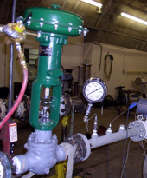

Figure 12: Control Valve near 2-inch USM

In the test shown in Figure 12, the meter was being operated at 600 PSIG, and the regulator was producing about 200 PSIG differential pressure. The meter’s SNR went from a normal of 40 dB to 24 dB. For this meter, when the SNR approaches 13 dB, the meter would begin to reject waveforms. Figure 13 shows the waveform during this test. Figure 14 shows the same pair of transducers when there is no regulator noise.

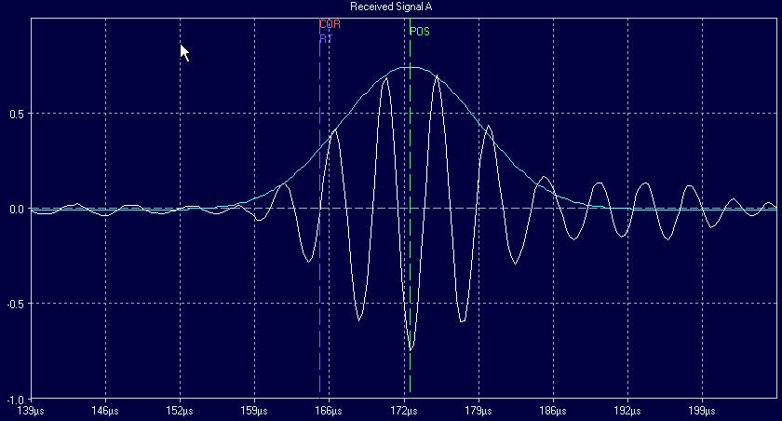

Baseline with Regulator Noise

Figure 13: Waveform with Control Valve Noise

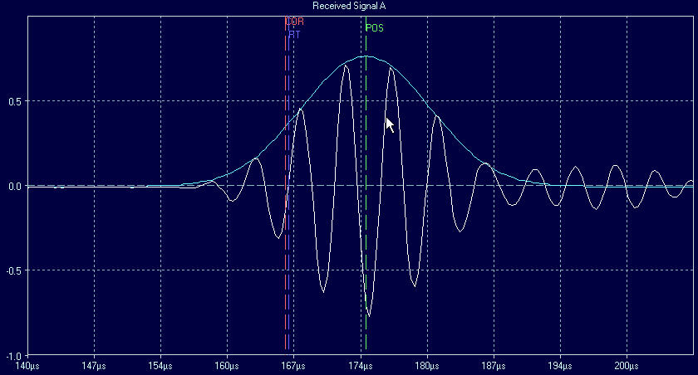

Baseline with no Regulator Noise

Figure 14: Waveform with no Control Valve Noise

Figure 13 shows there is a little noise on the baseline preceding the major waveform. The baseline in front of the received signal is not perfectly flat as it is in Figure 14. The SNR values for the waveform in Figure 13 are above 24 dB for this condition on the downstream transducers (one that faces the source of the noise). The upstream transducer has a SNR of 30 dB because it is facing away from the noise source. Figure 14 shows the waveform when there is no noise from the regulator. This waveform was obtained when there was no differential pressure.

SNR can also be low if the electronics has a problem, or there is a poor connection between the transducer and the electronics. Figure 15 shows the SNR graphed when there is a problem.



Figure 15: Poor SNR on Path 4

Here the SNR from upstream to downstream is not consistent. All SNR values of AB (light blue) are lower than BA (dark blue). This was due to a problem with the electronics. Figure 16 shows the results of the same meter after the electronics was replaced.



Figure 16: Normal SNR on all Paths

Figure 16 shows that all the SNR values are now close to 40 dB. This is the normal for this meter. Even though the SNR was poor in Figure 15, the meter’s performance was still about 98%, and the gains were also normal. Thus, it is possible to have low SNR and all other diagnostic indicators are normal.

# Speed of Sound (SOS)

Probably the most discussed and used diagnostic tool of an ultrasonic meter is the speed of sound (SOS). The reader may recall that speed of sound on an individual path is basically the sum of the transit times divided by their product, all then multiplied by one half of the path length. A more detailed discussion on this can be found in a previously presented paper [Ref 7&10].

Speed of sound is a property of the gas flowing thru the meter. It can be calculated (theoretical value) using programs like the AGA Report No. 10. The calculation depends on the flowing gas temperature, pressure and gas composition. Of these three, gas temperature affects the SOS much more than pressure. An example of SOS sensitivity can be seen by computing the change in SOS for a one degree F temperature change, and for say a 50 PSIG change in pressure.

For this example, let’s assume a flowing gas pressure of 1000 PSIG, and a temperature of 70 degrees F. Gas composition is a typical 1040 Btu with about 90% methane. The baseline SOS for this condition is 1333.87 fps. Let’s change the pressure to 950 and now the SOS is 1334.12 fps. This represents a change from baseline of only 0.25 fps. Going back to 1000 PSIG, and changing the temperature by one degree to 69, the computed SOS is now 1332.05, or a difference of 1.82 fps. This equates to a percent change of 0.14%. In other words, when computing SOS in the field, if the gas temperature value is wrong by one degree F, this will affect the computed AGA 10 computed SOS by 0.14%.

Since most companies compute SOS and compare to the meter and expect this comparison to be within ±0.25%, should the comparison be off significantly, there is no reason to be looking for a gas pressure issue. It is rarely the fault of the meter, and the most likely cause is either the temperature is wrong, or the gas composition is wrong.

There are at least two ways of analyzing the meter’s per-path SOS. The first would be to graph all path’s SOS relative to time. Figure 17 shows a graph of each path’s SOS for a 10-inch meter at the time of calibration.



Figure 17: SOS by Path at Calibration

This data was taken from the meter operating at 23 fps and shows a very stable reading over the 120 seconds. Here the graph shows all the meter’s SOS values are very close together. This graph format is important because it shows all the path SOS values are changing very little over this time, indicating the temperature and gas composition are stable.

Perhaps an easier way of looking at the SOS values is by comparing each path’s SOS to the meter’s average value. Doing this is makes it easier to spot individual path problems. Figure 18 shows the percent difference of each path relative to the meter’s reported average SOS.



Figure 18: Path Percent Difference in SOS

Each of the path’s SOS value is within about is ±0.05%. This indicates good correlation between each path, and that there is no temperature stratification within the meter (significant SOS spread from path to path).

When a meter is operated at lower velocities, typically less than 3 fps, and there is a large difference between the gas and atmospheric temperature, heat transfer can become noticeable. As the heat transfer occurs, internal gas temperature gradients can develop (thermal stratification). When this happens the hotter gas inside the pipe rises to the top of the meter run. Since the speed of sound in the gas is relatively sensitive to temperature, this will be represented by a SOS difference between the paths. This is often called thermal stratification.

Figure 19 shows the SOS values of the same 10-inch meter when it is operated at 1.8 fps at the calibration lab.



Figure 19: Thermal Stratification Effects

Figure 19 shows the average per-path percent SOS difference, compared to the meter, has increased to perhaps ±0.12%. This is due to a slight thermal gradient, from top to bottom, within the meter. That is, the gas at the top of the meter the gas is slightly warmer than that at the bottom. Path 1 color is blue, path 2 is red, path 3 is green and path 4 is gold in color. Figure 19 shows upper paths have increased, and the ones at the bottom decreased. Also, note that over the 120 seconds the trend is increasing slightly.

This difference in SOS may be thought to impact the accuracy of the meter. The benefit of showing thermal stratification is to verify there is no difference in gas temperature at the top and bottom of the meter run. Since the thermowell is inserted a fixed distance from the top of the pipe, it will record the temperature at that vertical location. The concern is that this temperature does not truly represent the average gas temperature since it isn’t uniform from top to bottom. For every degree of gas temperature change, there is about 2 fps difference in SOS. Thus, it is relatively easy to estimate the impact on meter error. For this example, the impact is relatively insignificant on corrected volume calculations (certainly less than 0.1%). Figure 20 shows the results of this 10-inch at the time of calibration.



Figure 20: 10-inch Calibration Results

Note that the “as found” error at 20 fps is virtually the same as the “as found” at 1.8 fps. Thus, there was very little impact in the uncorrected performance of the meter even though there was some thermal stratification.

# Velocity Profile

Monitoring the velocity profile is possibly one of the most overlooked and under-used diagnostic tools of today’s ultrasonic meter. AGA Report No. 9 requires a multipath meter provide individual path velocities. These velocities can provide many clues as to the condition of the metering system, as well as the meter.

Once the USM is placed in service, it is important to collect a baseline (log file) of the meter. That is, record the path velocities over some reasonable operating range, if possible. These baseline logs can also be obtained at the time of calibration. However, as the piping in the field will likely be different than that at the calibration facility, there could be some minor changes in profile. Good meter station designs produce a relatively uniform velocity profile within the meter. The baseline log file may be helpful in the event the meter’s performance is questioned later.

Figure 21 shows the velocity ratio of each path relative to the meter’s average velocity. This ratio is computed by taking each path’s average velocity during a test period and dividing it by the average velocity reported by the meter over the same period. The ratio for each path remains essentially constant at all meter velocities above approximately 5 fps. Thus, changes in the meter’s operation are easier to detect than by looking at the actual velocity on each path.



Figure 21: Path Ratios at 23 fps

Typically, for a Westinghouse and British Gas design meter, the ratio for a chordal design meter is about 0.89 to 0.91 for paths 1 and 4, and about 1.02 to 1.04 for paths 2 and 3. The differences are due to things like port size, meter body size and to some degree transducer location (whether they are recessed or protruding).

The difference in ratios from the outer pairs (1&4) to the inner pairs (2 &3) is because the outer paths are closer to the pipe wall, and thus the velocity of the gas there is less than the gas that is closer to the center of the pipe. This is due to the friction of the pipe wall slowing the gas down. When the velocity falls below approximately 3-5 feet per second, depending upon meter size and station design, the velocity profile ratios may change and become unstable. Figure 22 shows the same meter’s velocity profile when the velocity is at 2.8 fps.



Figure 22: Path Ratios at 2.8 fps

When comparing Figures 21 and 22 the velocity profiles are very different. Both graphs were generated from a 16-inch meter at the time of calibration. Even with the significant difference in path ratios, the meter’s performance was not impacted. This can be seen in Figure 23.



Figure 23: 16 inch As-Found Results

Figure 23 shows the meter “as found” data from the calibration. The meter’s linearity did not change even though path ratios were different as shown in Figures 21 and 22. The minor shift in the meter’s accuracy shows the ability of this technology to handle some distortion in gas velocity profiles. This is the same meter discussed earlier that was calibrated to 155 fps, but the x-axis has been adjusted to better show the low velocity performance.

## Meter Rangeability Considerations

This section discusses meter range considerations including low flow performance, over-ranging and multiple meters operating in parallel.

# Low Flow Performance Issues

Traditionally USMs have been sized to operate so that the lowest velocity expected is between 2 and 5 fps, with some companies still using 10 fps for the low flow design. Using 5 fps as the lowest velocity provides a rangeability of 16-1 if the maximum velocity expected is 80 fps. Comparing this to traditional devices such as orifice and turbine meters, this rangeability is generally greater, and in the case of the orifice meter, significantly better. Larger turbine meters can approach this rangeability (and in some cases, exceed this). The advantage the USM has over the turbine meter here is the linearity after flow calibration. The turbine meter can be linearized in the flow computer, but generally this isn’t done. Thus, the uncertainty of the USM is often lower due to the multi-point factors that are generally implemented at the time of calibration.

Users are always seeking way to increase the rangeability to help reduce CAPEX (capital expense) cost and operation maintenance cost (O&M, or OPEX) of the meter station. Since most users limit their maximum velocity to 70-85 fps, the only area left to expand rangeability is to operate the meter at lower velocities.

Many users have come to see the value in calibrating meters to velocities as low as 1 fps (and sometimes even lower). Calibrating a meter to below 5 fps is often referred to as a “low-flow calibration.” Generally, 6-8 data points are used for calibrations with a 5-80 fps operation, and 2 additional data points, often 1 and 3 fps, are added for the low flow calibration. By lowering the minimum velocity to 1 fps the user has essentially multiplied the rangeability by a factor of 5!

A typical installation for a gas-powered electric generation plant might include a 12-inch meter for the main flow rates, and a 6-inch USM for the lower flow rates. Assuming the lowest flow rate the 6-inch would be operated at is 5 fps, this would be equal to about 1 fps for the 12-inch meter. This translates into a rangeability of approximately 80-1 by using both meters. But suppose a single 12-inch meter is operated at this low velocity. What would be the capital cost savings? What would be the added risk due to potentially increased uncertainty?

If the designer uses a low flow meter (say a 6-inch USM) with a 12-inch meter, in lieu of installing a single 12-inch meter, the additional cost is likely more than $150K. By purchasing only one meter, and not having to do run switching with all the associated piping and control systems, and have a header that increases the facilities footprint, the measurement station becomes much easier to maintain and is more reliable due to fewer components. The capital cost saving is only the beginning. The benefit of less equipment translates into lower O&M costs for the life of the station. One hidden benefit is with no run switching, the possibility of the main run not activating is eliminated since there are no automated actuators required to open a valve. When a power plant goes online, and they can’t get the natural gas they need, this generally causes a loss in revenue, and there could be penalties imposed on the gas provider.

There are probably two major concerns about operating a USM at these low velocities. One is accuracy and the second is repeatability. The accuracy concern is from the absolute performance of the meter. That is, how accurate can the meter be after flow calibration at very low velocities? Another accuracy concern is how accurate will the meter be if there is thermal stratification (gas hotter at the top of the meter than at the bottom) within the pipeline. That is, if the gas temperature at the top of the pipe is hotter than the bottom, the measured temperature from the RTD will read higher, and thus under-registration is likely. Thermal stratification can also contribute to flow profile problems (distortion of the velocity profile) which may increase uncertainty.

Both are valid concerns. However, with today’s technology, these can be solved very easily. The key questions on accuracy are: “Does the meter provide a method of correction to reduce uncertainty at these very low flow rates, and can thermal stratification be identified? First, let’s look at how to improve accuracy at very low flow rates.

Regarding the accuracy of a meter, a calibration technique called piece-wise linearization (PWL), commonly used for optimizing turbine meter performance, can be applied within the USM. PWL has also been referred to a multipoint linearization. This technique permits substantial reduction of the uncertainty at low flow rates. That it, assuming the meter is calibrated at the very low flow rate (velocity), the resultant uncertainty will become very small since any errors at these lower velocities have been corrected for. Thus, the meter’s accuracy can be exceptional once calibration is complete, and the PWL technique has been implemented. Following is an example of a 12-inch meter that was calibrated from 2 fps to 118 fps.



Figure 24: 12-Inch Meter Calibration Results

As can be seen from this calibration result in Figure 24, the meter’s performance at 2 fps deviated approximately 0.3% from the average of all the other flow rates prior to adjustment. It is important to note that even before adjustment, the USM can easily provide accuracy values much greater than previously thought possible. This is due, in part, to the improvements in manufacturing and dry calibration that have been achieved during the past 20+ years, and to technology improvements in electronics.

After implementation of PWL meter calibration factors, all errors are reduced to zero, relative to the flow calibration facility. Thus, the resulting uncertainty is essentially that of the lab plus the meter’s repeatability. There is an additional uncertainty when operating between calibration points. This is because the PWL technique assumes the error between calibration points is a straight line. However, due to the typical linearity of the un-calibrated meter by using an appropriate number of data points at the low velocities, this added uncertainty should not exceed ±0.1%.

The second accuracy concern comes from the possibility of thermal stratification at lower velocities. A previously published paper discussed a 10-inch meter that had thermal stratification on the order of 2 degrees F [Ref 12]. This stratification occurred because the gas in the upstream piping was flowing at velocities below 3 fps, and more than 100 feet of the upstream piping was subjected to a bright sun. This is probably not a very typical installation since most upstream piping is below grade prior to entering the metering equipment.

Most designs have the meter station’s upstream piping below grade (underground). Piping emerges above ground and then makes a 90-degree direction change into the meter or header in the case of multiple meters. With a 10-inch meter, this typically means 20-25 feet of piping may be exposed to the sun and ambient temperature. In this condition, even when operating at 2 fps, the gas takes less than 15 seconds from the time it exits the elbow or tee to enter the meter run before it reaches the meter. In 15 seconds, there probably is not sufficient time for any significant heat transfer to occur and cause stratification within the flowing gas stream. Thus, the possibility of thermal stratification of the gas at these low velocities is typically minimal.

If significantly more upstream piping is exposed to ambient and solar effects than in the previous 10-inch meter design example, there is a possibility of thermal stratification. However, this can be easily detected by looking at the speed of sound reported by a meter that samples transit times horizontally. That is, if the gas temperature is hotter at the top, the SOS on the top path will read higher than the lower chord’s SOS when compared to a metering gas velocity of 5-10 fps. By being able to see there is no deviation in SOS at the lower velocities, the user can have confidence that there is no thermal stratification, and thus temperature measurement is accurate. If thermal stratification is present, piping insulation can be installed to eliminate this issue. The caveat is that not all USM designs can provide this type of information.

To test the theory of thermal stratification, let’s look at the change in the meter’s path SOS over a range of calibration velocities for another meter. Figure 25 below shows the results of a 10-inch meter calibrated from velocities of about 1.8 fps to 118 fps.



Figure 25: 10-Inch Meter Calibration from 1.8 to 118 FPS

After the meter factors are implemented at the flow calibration lab, the uncertainty of the meter would be that of the lab (about 0.2%) plus the repeatability of the meter (probably on the order of 0.1% or less). At the lower velocities, there could be some thermal stratification. Let’s look at the path SOS values at two velocities to see how much stratification may have occurred.



Figure 26: Path SOS at 23 fps



Figure 27: Path SOS at 1.8 fps

Figure 26 shows the SOS of each path over 120 seconds. This provides a good look at how consistent the individual SOS values are. This figure shows that the spread of path SOS values is on the order of about 0.7 fps. Figure 27 shows the same meter at 1.8 fps and indicates the spread in SOS has increased slightly. Now the maximum deviation in SOS is on the order of 0.1%, or about 1.4 fps. Thus, there is a little thermal stratification occurring since the path at the bottom of the meter (indicated by the gold colored line) is reading lower than shown in Figure 26, (relative to the average – purple line), and the path at the top of the meter (shown by the blue line) is now reading higher than in Figure 26. Since higher temperatures increase the SOS of the gas, the path at the top now increases compared to the path at the bottom. This is an indication of thermal stratification, but the magnitude is relatively small, and thus there is no significant impact on the meter’s uncertainty.

When a meter is operated at lower velocities, and thermal stratification is possible, there may also be a change in the velocity profile of the meter. Figures 28 and 29 show path velocity ratios from this meter at the same two velocities.



Figure 28: Path Ratios at 23 fps



Figure 29: Path Ratios at 1.8 fps

When this meter was operating at 23 fps, the path velocity ratios are symmetrical and normal. As the meter’s velocity is reduced, we can see some change in the ratios. The values for Paths 1 and 4 are no longer very close (about a 4% change), and the ratios for Paths 2 and 3 also show some minor change (about a 3% change). This is normal at lower velocities and does not have any significant impact on accuracy. This can be validated by viewing the “as-found” calibration data that is shown in Figure 25.

Let’s use this 10-inch meter as an example for cost savings based upon low-flow performance. Suppose a site had an operational range of 225 MMSCFD to 5 MMSCFD at 750 PSIG. If the user selected an operational range of 5-80 fps, this would require a 6-inch meter to handle the lower flow rate at 5 fps. At 5 fps, the 10-inch meter could handle approximately 14 MMSCFD. However, the engineer might decide to install a smaller meter since the lowest expected flow rate is 5 MMSCFD. If the 5 fps minimum operation is followed, the designer would select a 6-inch meter to handle the low flow rate. The 10-inch meter would operate at 2-fps if no low flow meter were used. This is well within the accurate operation of the meter as shown in Figure 25.

Looking at the economics of adding the additional smaller 6-inch meter in this scenario, the added cost could easily exceed $125,000 when including the headers, additional valves, meter run, RTU and actuators needed to sequence the 6 and 10-inch meters. A single 10-inch meter could be used for this example by operating it at 2 fps (instead of the typically lower limit of 5 fps), substantially reducing CAPEX, and certainly reducing the long-term O&M (OPEX) costs. Perhaps there might be some increased uncertainty. However, even if the uncertainty were assumed to be 0.2%, this would translate about $2.30 per hour based on $5 per thousand cubic foot gas price. Thus, there is probably not enough potential reduction in measurement uncertainty to justify spending more $125,000.

# Over-ranging (High Velocity Operation) of USMs

Most designers of USM meter stations put limits on the maximum gas velocity when designing the station. USMs can operate at much higher velocities than most other traditional metering devices. For this reason, companies have chosen to limit gas velocity somewhere between 70 and 85 fps, with some looking to increase to 100 fps. The reason for the limit is added stress on the thermowell, potential for pipeline erosion if there are particulates in the gas stream, potential for increased noise and added pressure drop.

One of the benefits of the gas USM is the lack of moving parts and no pressure drop. Should the USM be over-ranged, there is no damage. In the event of a pipeline break, or un-expected high flow rate, it has been demonstrated that some gas USMs will continue operating to beyond 225 fps. If the designer has requested two meters for maintenance and redundancy, they may also ask for a calibration that is higher than the typical design to permit over-ranging for a short period. Then if a meter is removed from service, the second meter will still be accurately measuring the flow even if over-ranged. For these reasons, some companies will calibrate their meters to perhaps 150-fps to insure the meter will operate there and will apply calibration coefficients that will reduce the meter’s uncertainty should this occur.

# Dual or Multiple Meter Runs

For larger applications, many designers choose to use two similar sized meters in parallel. The break point often comes when the flow rate dictates a meter size of 12 or 16-inch, and above. There are many variables to consider before choosing whether one meter is a better solution, or if two might be the best choice.

Two meters provide some redundancy. This might be important if company policy dictates removal and periodic re-calibration. Also, if maintenance policy requires periodic internal inspection, having two runs makes it much easier to perform this task without having to bypass the meter and estimate volumes. Additionally, should one meter develop an operational problem, having a second meter may help identify the problem(s). Of course, the meters must be sized to can handle the entire capacity should one be taken out of service, or this benefit may not be available.

The disadvantage of using two meters is the capital cost and additional maintenance required. Two smaller meters will require more capital expense in the beginning, and most likely more long-term O&M cost. Which design is best for any given application somewhat depends upon the operational requirements, space limitations, flow rangeability, company practices, and other factors.

Designers that choose to use two or more meters in parallel don’t do it only for rangeability requirements. Today’s USM easily provides at least 30-1 rangeability, and many are flow calibrating to achieve more than 80-1 rangeability. The primary reason is for redundancy, and to permit removal of a meter for maintenance while measuring all station flow through the other meter(s). Also, having two meters flowing in parallel provides secondary checks as the flow rate and SOS for each meter can be compared and used as an additional meter station diagnostic.

## Basic Piping Issues

As with any other technology, ultrasonic meters require adherence to basic installation guidelines. Recommendations related to the installation of primary metering elements, such as the orifice and turbine, have been in place for a long time. These are provided through a variety of standards (API, AGA, ISO, etc.) to insure accurate performance (within some uncertainty guidelines) when installed in the field. The reason for these guidelines is that the meter’s accuracy can be affected by profile distortions caused by upstream piping and proximity to noise generating control valves. One of the benefits of today’s USM is that it can handle a variety of upstream piping designs with less impact on accuracy than other primary devices.

Installation effects on measurement devices have been studied in much more detail than ever before. This is due in part to the available technology needed for such evaluation. Much of this research has been focused on ultrasonic meters. Reducing uncertainty has also become a higher priority for pipeline companies today due to the cost of natural gas and the fact the pipelines are simply transporting the gas and do not own it. If they have a net loss on their system, it comes out of their transportation costs. Designing an ultrasonic meter station that provides the same installed accuracy, as that at the time of calibration, is very important.

Research work performed at Southwest Research Institute (SwRI) by Terrance Grimley has shown it would take a minimum of 100D of straight pipe for the profile to return to a fully symmetrical, fully developed, non-swirling velocity profile [Ref 13]. Complex upstream piping, such as two elbows out of plane, create even more non-symmetry and swirl than what was initially tested by SwRI in the late 1990’s. Today’s USM must handle more profile distortion and swirl than most other traditional primary elements. However, just as with orifice and turbine meters, installation guidelines must be followed to achieve a predictable accuracy.

In 1998 AGA released AGA Report No. 9 – Measurement of Gas by Multipath Ultrasonic Meters [Ref 1]. This report was updated and revised in April 2007 [Ref 2], and a third edition will be released in 2017. This document discusses many aspects and requirements for installation and use of ultrasonic meters. In the 2007 Edition, Section 7.2.2 specifically discusses the USMs required performance relative to a flow calibration. It states that the manufacturer must “Recommend at least one upstream and downstream piping configuration without a flow conditioner or one configuration with a flow conditioner, as directed by the designer/operator, that will not create an additional flow rate measurement error of more than ±0.3% due to the installation configuration.” In other words, assuming the meter were calibrated with ideal flow profile conditions, the manufacturer must then be able to recommend an installation which will not cause the meter’s accuracy to deviate more than ±0.3% from the calibration once the meter is installed in the field.

During the past several years a significant amount of testing was conducted by various organizations like CEESI and PRCI. Funding for some of these tests in the past has come from the Gas Technology Institute, formally known as the Gas Research Institute (GRI). Much of the testing was directed at determining how much error is introduced in a USM when a variety of upstream installation conditions are present. The results of the testing were presented in a report at the 2000 AGA Operations Conference in Denver, Colorado [Ref 14].

The client has much more information available today to help design a better metering station, one with lower metering uncertainty due to field piping. Thru the efforts of companies like CEESI, PRCI, SwRI and TCC, much more is known about the potential for added uncertainty created by complex piping that may be part of the field installation. From all this additional research data, one can conclude that upstream piping (elbows, tees, etc.) does influence the meter’s performance.

Virtually all testing over the past decade has been with piping that included a flow conditioner. The typical field piping upstream of the meter creates two “non-idea” flow conditions. These are swirl and asymmetrical gas velocity flow profiles. The flow conditioner used in most installations today is designed to significantly reduce, if not eliminate, both swirl and asymmetrical profiles. No device is perfect, so let’s say the flow conditioner must remove as much of these unwanted conditions as is possible. The calibration laboratory will generally provide an ideal, non-swirling, symmetrical gas velocity profile. The main purpose of the flow conditioner is try and replicate the same profile in the field that was presented to the meter at the time of calibration. This minimizes any added uncertainty which can be caused by these distorted flowing conditions.

Figure 30 shows an ideal velocity profile for a 12-inch, 4-path meter with significant diameters of straight pipe upstream and a flow conditioner installed 10D upstream of the meter. Figure 31 shows the same meter with an installation effect of three elbows and a tee upstream of the piping (10D upstream of the flow conditioner).



Figure 30: 12-inch Path Ratios – Ideal



Figure 31: Path Ratios with Installation Effect



Figure 32: 12-Inch Meter Upstream Piping Disturbance

Figure 32 above shows a pictorial drawing of the upstream piping disturbance that was used to create the less-than-ideal profile in shown Figure 31. Figure 33 shows the impact on   
  
accuracy the three elbows and one tee had on the 4-path meter. The table inside of Figure 33 shows the effect on accuracy was less than 0.1%. Figure 34 shows what the profile looks like with no flow conditioner.

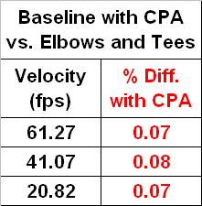

Figure 33: Accuracy Impact on 12-inch Meter



Figure 34: Path Ratios w/No Flow Conditioner

The effect on accuracy for the very distorted gas velocity profile in Figure 34 was approximately 0.15%. Even though the error was small, having a profile this distorted makes understanding whether the meter is still operating correctly very difficult. Thus, most customers prefer to install a flow conditioner to have a profile that is much more like the baseline one shown in Figure 30, or the field path ratios shown in Figure 31. A stable gas profile makes it easier for clients to understand if their meter is operating correctly, and certainly helps reduce uncertainty.

## Other Installation & Operational Considerations

This section discusses other aspects of operating a USM in less than ideal conditions. This includes pulsating gas flow, potential effects on meter accuracy when operated at different pressures, and the impact on meter accuracy when the facility becomes contaminated.

# Pulsation

One problem for just about any measurement device is how accurate it performs when subjected to pulsation. The effect of pulsation on orifice meters has been studied for years, and many reports have been written [Ref 16]. As the USM is a non-intrusive device, it might be assumed there would be little effect on its accuracy. However, this may not always be the case. Some independent testing has been performed on several brands of USMs. To date very little has been published. However, it is safe to say that pulsation, given the right conditions, will impact the accuracy of an USM.

In 2007 a series of tests were conducted at the Nova Didsbury test facility on a chordal meter that provides a diagnostic called Turbulence. During the testing a wide range of pulsation frequencies, two different velocities and two different pulsation levels were introduced upstream of the meter. Three brands of meters were tested, and the results were provided to each manufacturer. Since this was a consortium of gas companies that were paying for the testing, all data was presented to the member companies.

Figure 35 shows the pulsation generator used for this testing. Essentially it is a rotating disc that is driving by a hydraulic motor at different speeds to obstruct the flow through the center of the assembly (see the red arrow in Figure 35). To create different frequencies, the speed of the motor is changed. To create different levels of pulsation, the bypass valve, identified by the red arrow, is throttled. To create more pulsation, the bypass is throttled thus forcing more gas to flow through the pulsation generator.

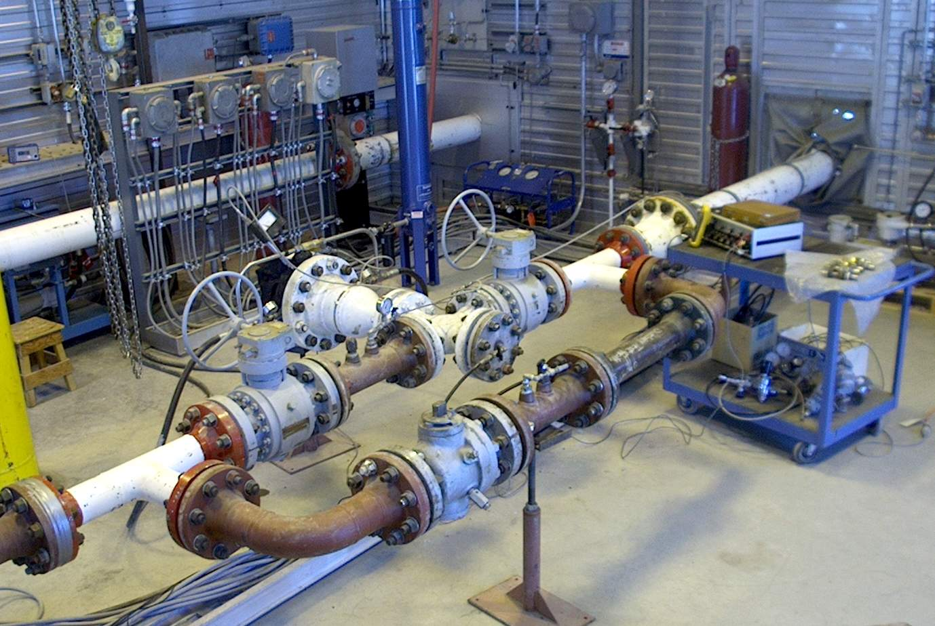

Bypass Valve

Figure 35: Nova’s Didsbury Pulsation Generator

The equipment in Figure 35 was located downstream of the meter under test. Figure 36 show the meter upstream of the building where the pulsation generator was installed. This meter was not part of the original testing, but the same test protocol was used. The purpose was to present data on a fourth meter and was paid for by the manufacturer [Ref 17]. The piping included the typical 10D + flow conditioner + 10D and then the meter. The meter tested included a 4-path and single-path meter in one meter body.

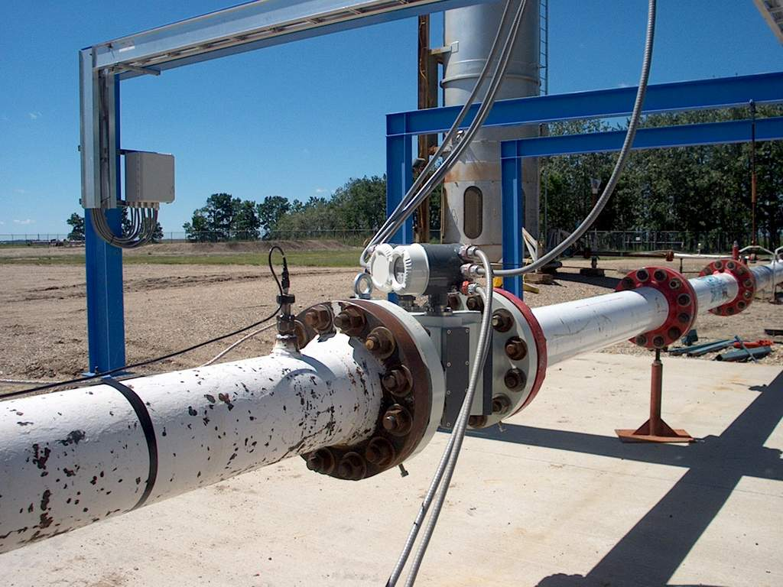

Figure 36 – Meter Pulsation Testing at Nova’s Didsbury Facility

A wide range of testing was performed and included 3 gas velocities and a range of frequencies were tested that ranged from 7 to 31 Hz. This was the same range of frequencies tested for the consortium years prior. Based on the results of that testing, it was decided to focus on four frequencies, 9, 12, 16 and 23 Hz, two gas velocities (15 and 28 fps), and two levels of pulsation (low and high). Figures 37 & 38 show the results of this testing.



Figure 37: Accuracy Effect at 15fps



Figure 38: Accuracy Effect at 28 fps

These results are meter accuracy deviations relative to the baseline with no pulsation. At the lower flow rate of 15-fps. the meter exhibited more error for the same level of pulsation when compared to the 28-fps velocity. The low level (LL) pulsations showed relatively small errors except for the 15 Hz frequency. These errors were on the order of 0.3% or less (except for the 15 Hz test). It is important to note that the high level (HL) of pulsation was quite excessive, and in fact the facility limited testing to a very short period to help reduce the potential damage to piping. Thus, it is probably safe to say that the HL testing significantly exceeded any that would be seen in the field.

# Pressure Effect Issues

No discussion on calibration of USM would be complete without bringing up the issue of calibrating at one pressure and operating at another pressure. Testing conducted at SwRI, under the funding of the Gas Technology Institute (GTI), has shown some potential for a meter’s performance to shift with pressure [Ref 15]. Additional testing has been performed at various other calibration facilities and generally has not support this conclusion.

Currently USM manufacturer’s state there is virtually no pressure effect (change in meter accuracy when the pressure changes). Each has conducted testing at other facilities to show there is little, if any, effect. At present the pressure effect, if there is one, is probably not more than 0.1-0.2% for meters calibrated at 1000 PSIG and operated at 200 PSIG. Since most transmission companies typically operate above 600 PSIG, calibrations done at the high-capacity facilities probably don’t introduce any significant bias.

If an ultrasonic meter is operated at lower pressures, say 45 PSIG, then most certainly there will be an effect if this meter had been calibrated at say 500 PSIG. The change in accuracy comes from a change in profile that can be related to a dimensionless number called Reynolds number. For a USM to operate over extremes in pressure like this example, it would experience an accuracy shift it the meter didn’t employ a real-time Reynolds Number correction.

# Dirty Meter Considerations

Just like any measurement technology, if the meter is not properly maintained, performance will suffer. Today’s pipelines are generally relatively clean. However, there is always the potential for mill-scale and oil to coat the inside of a meter. This coating will impact the accuracy. The magnitude and impact on accuracy appears to be somewhat dependent upon meter design. Several papers have been published on this issue [Ref 5, 13 & 17]. The good news here is that USMs are probably less sensitive to performance changes due to contamination than other technologies. Maintaining a clean primary measurement element is just as important as calibration of ancillary devices. Many users have regularly scheduled inspections to insure optimum performance.

Today’s USM software also makes it much easier to identify potential dirty meter conditions. By collecting the data from the USM, indications of pipeline buildup can often be identified. Other issues, such as partial blockage of a flow conditioner, can easily be seen using the proper diagnostic techniques. The ability to diagnose potential problems, even remotely, is certainly one of the major benefits in using USMs and should not be under-estimated when designing a station.

Several papers have been published showing examples on how a meter’s performance can be diagnosed using software [Ref 5]. The ability to recognize when problems are developing has helped many users to reduce their measurement uncertainty over the past several years, and thus lower their Lost and Unaccounted For (LAUF) volume. In many cases this has translated into a significant increase in a company’s “bottom-line” revenue.

## Basics of AGA 9

# Introduction

The American Gas Association (AGA) Report No. 9 is the document the industry looks to as a to the user of gas ultrasonic meters. Members of the AGA Transmission Measurement Committee (AGA TMC) developed AGA 9. It started in 1994 with the development of Technical Note M-96-2-3, *Ultrasonic Flow Measurement for Natural Gas Applications* [Ref 3]. This technical note was a compilation of the technology known at the time, and discussed USM principles of operation. Phil Barg of Nova Gas Transmission was the chairman when the document was published in March of 1996. During the two years it took to write the technical note, Gene Tiemstra and Bob Pogue, also of NOVA, chaired the committee.

This Technical Note has sections on the principle of operation, technical issues, evaluations of measurement performance, error analysis, calibration and recommendations, along with a list of references. It is important to note that the TMC members (end users) were primarily responsible for the development of this document. Three USM manufacturers, Daniel, Instromet and Panametrics, contributed information, but in the end the industry members were leading its development.

After competition of the Technical Note, the AGA TMC began the development of a report. John Stuart of Pacific Gas and Electric (PG&E), a long-standing member of the TMC, chaired the task group responsible for the report. There were more than 50 contributors that participated in its development, and included members from the USA, Canada, The Netherlands, and Norway. They represented a broad cross-section of senior measurement personnel in the natural gas industry.

AGA 9 incorporated many of the recommendations in the GERG Technical Monograph 8 [Ref 21] and certain related OIML [Ref 22 & 23] recommendations. Much of the document was patterned around AGA 7, *Measurement of Gas by Turbine Meters* [Ref 4]. After two years of technical discussions, balloting, and revisions, the document represented the consensus of several dozen metering experts at that time.

It is important to note that in 1998 little was known about the USMs installation effects, long-term performance and reliability. Most of the performance requirements in AGA 9 were chosen based upon limited test data that was available at that time. Also, if no data was available to support a specific requirement, AGA 9 was silent, or left it up to the manufacturer to specify. Additionally, flow calibration was not required in the first release of AGA 9. It was believed, which later was proven wrong, that the manufacturer could build a meter and validate the accuracy simply by dimension and SOS information. As clients began calibrating meters, it was evident the uncertainty was greater than expected.

The second revision of AGA 9 was released in April 2007. This version had many changes including the requirement of flow calibration for fiscal (custody) applications. Work began at the Winter AGA TMC meeting in 2001. This second release went thru several chairmen due to retirements, industry participation changing in AGA committees, and company acquisitions. It was finally decided that two members should co-chair so that at least one person could be present in the event of travel issues. Paul LaNasa of CPL & Associates, and Warren Peterson of TransCanada Corporation, co-chaired the document until competition. The first ballot was sent out in late 2005 and came back with significant suggested changes. After reviewing and addressing these, the committee decided to re-ballot the updated version. The second ballot version was sent out in 2006. Once all the comments were reviewed and addressed, which was performed by nine committee members, the document was sent to AGA late in 2006. It was released in April 2007.

The third edition of AGA Report No. 9 will be released sometime in 2017. Work began on this version at the Winter 2013 meeting. The new version incorporates quite a few changes that reflect the information obtained over the previous 9+ years. The working committee was comprised of more manufacturers than was the case in the past. There were also fewer Industry personnel in attendance. Both probably created more suggested changes than had been dealt with in the past.

One of the most significant changes is the removal of any reference to piping that includes tees upstream and downstream. The drawings have been replaced with recommendation of piping for three different scenarios. One is the traditional 10D + flow conditioner + 10D + the meter. The second one is the same drawing, but the length of both upstream spools can be determined by the manufacturer. The third is a single spool piece, and now flow conditioner, with a specified length provided by the manufacturer. All recommendations must be supported by independent test data and meet the testing requirements spelled out in the OIML R137-1&2 Edition 2012(E) [Ref 24].

Other notable changes are improved definitions, modification to the wording on thermowell insertion depth, the addition of a third meter size class specifically addressing smaller meters (less than 4-inch), a discussion on redundant integral and “back-to-back” metering, new Sections on Commissioning, Field Verification, Maintenance and Recalibration, and a discussion on uncertainty. A paper was presented at the AGA Operations Conference that validated this was a viable solution, and there was little, if any, influence of one meter relative to the other [Ref 27]. As has been the case in the past, the new version of AGA 9 will not require re-calibration at any fixed interval, but instead will remain silent on this topic.

The Scope of the 2017 AGA 9 document has been updated and is as follows: “This report is for multipath ultrasonic transit-time flow meters used for the measurement of natural gas. It may be used for the measurement of other gases after consulting with the meter manufacturer. Multipath ultrasonic meters have at least two independent pairs of measuring transducers (acoustic paths). Applications include measurement of single-phase gas flow through production facilities, transmission pipelines, storage facilities, distribution systems and end-use customers.”

## Flow Calibrations Issues

This section discusses basics of USM flow calibration, an overview of calibration facilities, methods of adjusting the meter after the initial testing and further discussion on re-calibration.

# Flow Calibration Basics

The primary use for USMs today is custody measurement applications. As discussed earlier, the introduction of AGA Report No. 9 has helped spur this growth. Section 5 of AGA 9, 2007 Edition, discusses performance requirements, including flow calibration. Initially the 1998 release of AGA 9 did not require meters be calibrated for fiscal use. However, with the publication of the Second Edition, it is now a requirement for all fiscal (custody) applications.

The basic accuracy requirement, prior to any adjustment, is that 12-inch and larger meters must be within ±0.7%, and 10-inch and smaller meters to be within ±1.0% for the flow range of qt to qmax (low flow rate to maximum flow rate). This is often referred to as “out of the box performance.” Below qt, the error limit is ±1.4%. If the meter is outside these values and is calibrated with upstream piping and a flow conditioner (considered the package), then the user is permitted an additional 0.3% tolerance on the “as-found” of the meter. Even though the meter may still be outside of this, the User now has the option to accept if they want.

Initially USMs were installed without a flow conditioner. However, today virtually all clients are using flow conditioners for their fiscal applications. Even though data exists to support the supposition that some USMs perform quite well without flow conditioners, the added pressure drop and cost is often justified by the reduction in uncertainty. One thing that most everyone does agree upon is that if a flow conditioner is used with a meter, the entire system should be calibrated together. With the new 2017 Edition of AGA 9, if a flow conditioner will be used, it must be calibrated with the meter.

It should be noted that one of the benefits of the ultrasonic meter is that it does not create significant pressure loss. The pressure drop resulting from the flow conditioner is offset by the lack of pressure drop across the meter (when compared to orifice or turbine meters). As such, total pressure loss across the metering facility, when flow conditioner is utilized, is probably no greater than with other primary devices for the same given flow rate.

Most companies have standard designs for their meters that typically specify piping upstream and downstream of the flow conditioner(s) and meter. This is referred to as “the metering package” by AGA 9. USMs are calibrated as a unit with the customers upstream and downstream piping spools. Calibrating as a unit helps insure that the accuracy of the meter, once installed in the field, is as close as possible to the results provided by the lab. The 2017 Edition of AGA 9 required all piping that is considered as part of the metering package, be included in the calibration.

In the past most customers felt their applications deserved, and required, less uncertainty than the minimum requirements of the original AGA 9 (where flow calibration was not required). To ensure these higher standards were met, virtually all users began flow calibrating their USMs used in custody transfer applications since the late 1990s. At the 2002 AGA Operations Conference a paper was presented that discussed the benefits of flow calibrating ultrasonic meters [Ref 25]. Summarizing from that paper, there are three main reasons users are calibrating meters:

* Reduce uncertainty
* Verify performance
* Improve rangeability

The new “fourth reason” for flow calibrating the USM is the requirement by AGA 9 when used for fiscal applications. That was first required in the 2007 Second Edition. This wasn’t the case in 2002.

# Calibration Labs

There are several flow calibration labs in North America that provide gas calibration services. The two largest facilities use a method of “slip-streaming” the gas from a large transmission pipeline. That is, they build a bypass around a regulating device that allows for gas to flow through the calibration facility. These two facilities became operational around 2000 and were not in operation at the time of the first release of AGA 9 in 1998.

Most of these systems operate between 900-1200 PSIG. By creating a differential pressure across a mainline valve, gas is forced to flow thru the laboratories’ reference standards, and then to the meter under test (often referred to as the MUT). Gas is then re-introduced into the pipeline downstream of the mainline valve that created the differential pressure. Thus, there is no gas vented to atmosphere (except when the meter run is de-pressurized). The meter being tested must be capable of ANSI 600 class to meet the needed pressure rating of the facility. Gas composition and temperature are also whatever the pipeline operation has at that time. The big plus for these facilities is capacity. They can easily calibrate meters of 30-inch to full capacity.

There are facilities that are “closed-looped” which move gas via a compressor. These systems can generally vary their pressure and temperature to meet any specific client needs. Some facilities can also vary the gas from natural gas to other gases like nitrogen or high CO2. A paper was presented that discussed calibrating USMs on gases other than natural gas [Ref 26]. This was om response to concerns that gas composition had an effect on calibration results. No evidence to this claim was identified. Due to the energy cost to move gas in a loop system, these facilities generally don’t have the capacity that the “slip-stream” often being limited to less than 12-inch line size.

A third type of calibration facility is known as a “blow-down” design. Here typically air is used to flow thru reference standards and then thru the meter under test. First air is compressed to a high pressure and stored in large receivers. During the test air is drawn from storage and reduced to the desired test pressure. This creates a reduction in temperature (Joule-Thompson effect) so the air is then run thru a heat exchanger. This not only brings the temperature back to more normal conditions, but also helps maintain a stable air temperature during the entire test. One benefit of this type of calibration lab is the wide range of pressures that can be provided to the client. Thus, there is no requirement for an ANSI 600 type of meter that is typically required by the “slip-stream” type of facility.

Regardless of the facility type, each will calibrate to any number of points the designer feels are necessary. Typically, most designers are requesting 6 to 8 data points over the range the meter is expected to operate, with some specifying up to 12 data points. Once all the “as-found” data points have been determined, an adjustment factor (or factors) is (are) computed. Facility personnel enter the value(s) into the meter. Usually one or two verification points are used to validate the predicted “as-left” performance. That is, the lab will select one, two or more flow rates to verify the meter error is now very close to zero. The USM will generally repeat to within ±0.1% of the predicted value, with more recent results showing verifications are often on the order of ±0.05%.

# Meter Calibration Adjustment Techniques

All ultrasonic meters today support more than one adjustment technique. The initial and basic adjustment method was simply applying a single correction factor and is also known as an “adjust factor.” This was the normal method of adjustment in the 1990s. The correction factor is a direct multiplier to the meter’s output and can be thought of as “electronic change gear.” Typically, it has a default value of 1.0000 from the factory, and is then adjusted to minimize the meter error, based on the results of a flow calibration.

All meters today have separate adjust factors for forward and reverse. Initially it was assumed that the uncertainty would be identical for both forward and reverse. However, early in the 1990s, it was determined during calibrations that there were differences on the order of 0.1-0.2% between forward and reverse flow. The theory indicated there should be no difference, but manufacturing tolerances and acoustics have some small effect on the uncertainty. Thus, today all manufacturers provide separate adjustment parameters for forward and reverse flow.

AGA Report No. 9 discusses the various methods for adjusting the meter’s output once flow calibration results have been obtained. In the 1990s, a single meter factor was the primary method of adjustment. This method changes all flow rate results (errors relative to the flow calibration laboratory) equally. In other words, if a meter factor were entered that was 1.0012, the output of the meter would be increased throughout the range of operation by 0.12%. If the meter were perfectly linear, then this method would yield a meter with zero uncertainty relative to the lab. However, after a few years of calibration results, clients realized that the USM wasn’t perfectly linear over the entire range of flow calibration. Although these non-linearities were within the AGA 9 guidelines, clients wanted to reduce the uncertainty even further.

In 2002 the use of a multi-point meter factor technique, often called “piece-wise linearization” (or PWL for short), was introduced to the gas USM market. This technique had previously been commonly used in flow computers to correct for the non-linearity of gas turbine meters. Since the gas USM was essentially a computer, it was easy to implement this technique in the meter electronics rather than implementing in the client’s flow computer later during commissioning. This also allowed the client to verify that the adjustments to the meter worked correctly by performing what is called “verification points”. Essentially the calibration facility repeats one or more flow rates after implementing the coefficients in the meter to ensure the uncertainty, relative to the laboratory, is within the repeatability of the meter and the facility.

Today most manufacturers support up to 12 different flow rates (and thus corresponding meter factors) for each flow direction. The USM software generally provides a function that allows the calibration facility to enter the flow rates and errors, and the software then will write the correction values to the meter. This piece-wise linearization technique is the preferred method of adjustment in the North American market by virtually all clients.

Another method that is used by some in other parts of the world is called a “polynomial” correction method. This technique uses an equation, built into the meter electronics, that utilizes several coefficients to adjust the output over the entire range. The equation would look something like the following (which is discussed in the appendix of AGA 9): Meter adjusted output = a0 + a1 x q + a2 x q2 where “q” is the meter’s calculated flow rate prior to adjustment, and the “a” coefficients are computed externally, and then entered in the meter. The example here is considered a “second order” correction (q2 is the value that determines the order). Some manufacturers provide up to a “fifth order” (q5) to provide a more linear output relative to the laboratory, thus reducing the meter’s uncertainty.

# Re-Calibration

AGA 9 does not require ultrasonic meters to be re-calibrated and will not require this in the upcoming 2017 Edition. As USMs have no moving parts, and provide a wide range of diagnostic information, many feel the performance of the meter can be field verified. That is, if the meter is operating correctly, its accuracy should not change, and if it does change, it can be detected.

The use of USMs for custody transfer applications began increasing rapidly in 1998. Now, with more than 9 years of installed base, there is significant information to conclude USMs may not require re-calibration. Many companies are not certain as to whether they will retest their meters in the future. They are waiting for additional data to support their decision. Manufacturers are also trying to show the technology may not require re-calibration.

During the past several years, many meters have been re-calibrated in Canada. Their governmental agency, Measurement Canada, requires USMs to be re-tested every 4 years [Ref 28]. The data obtained from these meter re-calibrations, from random re-testing by customers, and long-term data from meters at calibration labs typically shows the meter to be within ±0.3% of the original calibration assuming the meter is clean and operating correctly.

Several users in the United States have removed meters in the past year and returned them to the calibration facility for a quick verification. If the meter is clean, the performance on these has typically been within ±0.1-0.3%. Unfortunately, there is very limited published information to date. Over the next several years, the industry’s knowledge base with respect to the long-term accuracy of the ultrasonic meter will continue to grow.

## Redundant (Series) Measurement

Many clients today would like to have some method of verifying the flow reported by the custody meter is still accurate. This is sometime referred to as redundant or check measurement. There are a couple of methods that are commonly used today.

One method that is used by some designers incorporates a separate “check” meter in their larger stations [Ref 18]. This meter is typically the same brand and path configuration as the primary custody meter. The purpose of this meter is to provide an in-situ verification against all the other fiscal meters at that location. The validation process routes all the gas from a given operational meter periodically through the “reference” meter. These designs are sometimes referred to as “Z” or “Zed” configuration. The piping is such that the gas from the fiscal meter is routed in a “Z” pattern to enter the check meter. Valves are utilized to re-route the gas to the check meter which is downstream during the test. In many ways this is exactly what the calibration facility is doing. However, this technique has several issues that must be addressed.

First, if there are any installation effects on the reference meter, a bias could be introduced in the results. The installation effect could come from the upstream piping or pipeline contamination. Second, the addition of a reference meter adds significantly to the cost of the station. Not only is the designer paying for the additional reference meter, there is an additional cost for each meter run as a separate ball valve must be included to permit diverting the gas through the reference meter. Additionally, the extra reference run requires more space on the skid that adds to the cost. Also, using a reference meter on location somewhat limits the ability to verify performance over the entire range of operation. Finally, removing a meter and having its performance verified at a calibration facility provides an independent analysis of the meter’s performance. This would most likely be required in the event of a dispute by the purchaser of the gas.

Another method of providing redundant, or check metering, is to utilize two separate meters in series. Here both meters are in service all the time. The corrected volumes for each meter are then compared either manually or by one of the flow computers. This provides a “real-time” comparison as opposed to the “Zed” which is only tested periodically (typically every 3-6 months). The negative to this design is any contamination that occurs in the pipeline will affect both meters. To reduce the “common-mode” affect (that is contamination on one meter causes the same effect on the check meter), designers typically use different brands of meters and often ones with different path configurations. Data has shown that meters with different path configuration will respond differently when contamination occurs.

This type of redundant metering provides a “real-time” test on the primary meter but does come at a significant cost. Since these systems are typically mounted on skids, two complete metering systems are required which doubles the cost of the facility. This also requires more than double to space which for some applications is not an option.

A third method of providing redundant, real-time check measurement, is to utilize a meter with two different electronics and two different path configurations all-in-one meter body [Ref 30]. This is like having two separate meters, but the real savings is that there is only one meter piping assembly. This saves space and significantly reduces cost. The downside to this design is not all manufacturers have a meter design that permits redundancy.

Some designers, rather than use a specific brand of meter that provides both path configurations and separate electronics, have chosen to buy two brands of meters and bolt them “back-to-back”. This way the designer can choose meters that otherwise don’t have the capability of integrated redundancy. There can be issues with this such as transducer interference between the two different brands meters. Also, for bi-directional applications, the custody meter, which is generally the first meter in the package after the flow conditioner, is now downstream of the check meter. Since different meters may have different inside diameters, due to a tapered bore, there can be some variations in performance.

This option has been tested with a couple of brands of meters and a paper was published at the AGA Operations Conference in 2011 [Ref 27]. As this method is a viable alternative to the integrated redundant meter, AGA 9 has addressed this in the 2017 Edition to insure designers are aware of this and are permitted to implement in their design.

## What Causes USM Measurement Error?

Ultrasonic meters have many benefits over other gas measurement technologies. Certainly diagnostics can generally provide the necessary information to determine if the meter is still accurate. This is only true if the client understands the diagnostics and monitors them over time. This requires trending many variables, and a thorough understanding not only of how the USM works, but the specifics for that meter brand. The client must also understand how to utilize the manufacturer’s software since it is the key to obtaining the diagnostic information. For these reasons, and perhaps others, it is not uncommon for the client to not recognize when measurement problems occur. This section discusses some of the issues that will affect the accuracy of the gas USM.

The transit-time USM relies on accurate measurement of the sound pulse in both directions for all paths. Perhaps the easiest way to validate this is by comparing the SOS by path. They should all be providing the same SOS within the design tolerances of the meter manufacturer. Typically, this means that all path SOS readings are within ±0.1% of each other. Monitoring these over time is very important since even a slight change in one path, relative to the others, may indicate a problem with that path. This could mean there is contamination on the face of the transducer, the transducer has a problem with the position of the face that emits the sound (starting to eject), or other issue that causes the sound to travel at a different speed relative to the others.

The meter sends sound pulses from one transducer to another and is looking for a “signature” in the received sound wave. If this pulse signal becomes distorted, and the meter becomes confused as to when the sound pulse arrived, it may pick up on the wrong peak, and thus provide an incorrect transit time measurement. This in turn creates an error in gas velocity calculation for that path, and there will be an effect the meter’s accuracy. Again, gas velocity has virtually nothing to do with the comparison of the SOS relative to the meter’s reported SOS.

Today most clients compute the theoretical SOS of the gas by using pressure, temperature, and gas composition, and programs like AGA 10, to compare it to the meter’s reading. Initially many thought if these two agreed, then the meter is accurate. However, this is not the case. The most important diagnostic to monitor, assuming all paths are working correctly (SOS, Gains, and Performance), is the gas velocity profile. Here most clients use the diagnostic called Profile Factor and Symmetry. These two describe (summarize into a single number) the gas velocity profile the meter is seeing [Ref 10 & 32].

Changes in the gas profile over time will increase measurement uncertainty. The baseline gas velocity profile, when the meter is commissioned in the field, is very important since the profile may be a little different compared to the calibration data. Trending this over time can identify issues like contamination, blocked flow conditioners (debris in front of the flow conditioner), partially open valves, liquids in the gas stream and many other non-ideal issues [Ref 12]. This is the single most important meter diagnostic to answer the question “is my meter still accurate today?”

Other meter diagnostics help validate that each pair of transducers is working correctly. Each transducer pair may not be not operating at close to 100% but this will have little, if any, effect on accuracy until performance is so low that failure is eminent.

Other diagnostics, like Gain, indicate the health of the given pair of transducers. Increased gain is an indication of an issue with signal strength (the acoustic sound pressure level that is received), but it generally will not affect the meter’s accuracy until failure is eminent. Signal to Noise (SNR) is an indication of potential ultrasonic noise from say a regulator that is starting to interfere with the sound pulse the meter is looking for. However, lower SNR does not mean the meter’s accuracy is being compromised. This only occurs when the SNR is so low that the path performance(s) issues become significant.

All diagnostics are important to help validate the USM is working properly, but the gas velocity profile, assuming all other diagnostics are within acceptable tolerances, is by far the most important diagnostic to help validate the meter’s accuracy.

## Other Design Considerations

# EMI/RFI

The USM utilizes electronics, and essentially is a computer. As such, manufacturers have designed their housings to virtually eliminate the influence of electro-magnetic interference (EMI) from high voltage power lines. Today, manufacturers enclose electronics in well-shielded metal housings that are virtually immune to any typical field EMI problems. Installations have been done where 200,000+ volt AC power lines near of the meter with no effect on operation.

Radio Frequency Interference (RFI) can also affect electronic devices. All manufacturers provide a high degree of protection by enclosing the electronics in grounded metal housings. However, the designer is cautioned to ensure that all the wiring that is attached to the meter is also grounded. By installing shielded wiring, and following proper grounding recommendations, this potential problem can be eliminated. Also, if a cover has been removed for service, the protection from RFI and EMI will be substantially reduced, so care must be taken to insure there is no effect on the meter’s operation.

Metering stations should also consider isolating the measurement from the pipeline’s cathodic protection system. This can be done with insulating gasket and bolting kits at the inlet and out of the meter run. This is important for grounding all measurement equipment since not isolating the meter run would “short out” the cathodic protection which would significantly reduce its benefit.

# Communication issues

Most USMs communicate with external devices like flow computers and the manufacturer’s software using either RS-232 or RS-485. The general recommendation for serial communication varies by designer. Generally, most clients use half-duplex RS-485 because it is rated for much greater distances than RS-232. If the manufacturer requires full-duplex communication with their software, then the choice is either RS-232 if the distance is perhaps less than 50 feet, or full duplex RS-485. Using a low-capacitance cable, specifically designed for data communication, is very important to insure quality data, especially when RS-232 communication data rates exceed 9,600 BAUD.

Most gas USMs today come with an Ethernet connection. This can be directly connected to the client’s LAN/WAN or terminated in the instrument building (assuming the client is using a building to house ancillary equipment like the flow computer, remote communication equipment, UPS, etc.). Connecting the USM to the client’s WAN allows for off-site access to the meter’s diagnostics. Even if the meter doesn’t have Ethernet capabilities at the present, it is always a good idea to install cabling as manufacturers are always upgrading their meter’s electronics.

A common remote access strategy is to attach a USM serial port to a wireless modem (cellular data link) or utilize the traditional POTS modem. Although slower than the Internet, it does permit remote monitoring and troubleshooting without the need to for a site visit. When designing an ultrasonic meter installation, consideration should always be given to utilize remote access as it can often provide substantial savings for a small monthly investment. Since other equipment at the measurement site, such as gas chromatographs and flow computers, also support remote access, either via Ethernet or serial communications, it is not uncommon for all three to provide via the same modem.

# Ambient Temperature

Today’s USM is designed to handle a wide range of ambient temperature conditions. Electronics typically can operate from a minimum of –40 °F to a maximum of +140 °F (or higher). Thus, the meter can be installed in most applications without the need for a shelter or building. Typically, if the designer has an application where temperature extremes are present, they may include a shelter more for the technician’s benefit than the meter’s requirement. For sites that experience a lot of precipitation, installation of a shelter is common.

# Power

Most applications today utilize remote AC power to operate the USM rather than solar or thermal electric generators (TEG). Although solar and TEG are feasible, the typical installation also has other “higher-power” consumption components such as flow computers, gas chromatographs and communication equipment.

As with all electronic devices, providing a reliable power source is important. Designers typically utilize an uninterruptible power supply (UPS) to insure reliable service. Some USM manufacturers provide power loss alarms in the meter’s audit history. This can be very helpful in the event of intermittent power problems. First, it indicates there is a problem by logging an alarm. Second, by knowing the date and time of the event, determining the amount of downtime can assist in estimating the volumes missed.

# Shelters

When clients are designing a metering facility for gas USMs, the question “do I need a shelter for my USM?” is a common question asked. The simple answer is “it depends!” There are many variables that must be considered to answer the question. The concern is generally whether solar radiation (the sun shining on the meter and upstream piping) influence the meters. The simple answer is that the USM is no more sensitive to this issue than orifice or turbines. The effects of solar radiation on an orifice or turbine meters was not well understood because there were no diagnostics to show the effect.

When the USM installed base grew, clients started seeing SOS changes in the meter at low flow rates. Heat transfer, in or out of the upstream piping, will occur when the ambient temperature is different than the gas temperature [Ref 12]. It makes no difference if the ambient is 30 degrees warmer or cooler, there will be heat transfer. This is due to the steel being a very good conductor of heat, so when the ambient is different than the gas temperature, some heat transfer will occur. Certainly if the sun is shining on the upstream piping, there is additional heat energy being imparted into the steel. If the ambient is higher than the gas temperature, the solar effects will add to the heat transfer. Of course, if the ambient less, then the effect of the solar may become less significant.

When a meter is operating at a high enough velocity to cause good mixing of the gas, this effect is not apparent. When the gas velocity becomes low enough, and there is a sufficient temperature difference, there isn’t enough turbulence (or mixing) of the gas to maintain a uniform temperature of the gas from the top to the bottom of the meter. Since hotter gases raise to the top, at low velocities the chordal meter will show higher SOS on the upper path relative to the bottom of the meter. This is known as thermal stratification (discussed earlier in this document).

The meter doesn’t care if the gas is warmer at the top than the bottom. The effect on its accuracy is generally little (discussed before in the thermal stratification section). The big issue is knowing what the bulk average gas temperature is since the temperature is not uniform from top to bottom. Thus, the thermowell, at whatever insertion depth it is, sees the temperature at that vertical location. If the temperature is wrong, then the corrected volumes (and of course the computed SOS) will be wrong.

So, the installation of solar protection, or enclosing the meter in a building, depends on how extreme the weather is. Many clients in rainy climates put a structure up that shields the sun from the meter run but allows for air to flow (not fully enclosed). In very cold climates, where the ambient can be below zero, most clients put the meter in a building with heating, not only to protect it from the elements, but also to make maintenance easier for the technicians. Thus, whether to shelter the meter comes down to a lot of variables that is usually determined by company policy.

## Conclusions

During the past two decades, the industry has learned a lot about USM operational issues. The traditional 5 diagnostic features, Gain, signal-to-noise (SNR), Performance, Path Velocities and Path SOS have helped the industry monitor the USM’s performance (accuracy). These 5 features provide a lot of information about the meter’s health. Getting an initial baseline on the meter at the time of installation and monitoring these features on a routine basis can generally identify metering problems in advance of failure.

The industry has learned a great deal more about how to benefit from USM’s diagnostics. Being able to identify when conditions change in the pipeline are one of the many key strengths of today’s technology.

Today more companies are looking towards using automation to validate the USM’s performance on a real-time continuous basis. These systems can not only monitor the meter’s diagnostics, and alert the user of problems, but also monitor the health of the GC, validate the flow computer calculations, provide for redundant pressure and temperature checks, and simplify answering the question “Is my metering facility operating correctly.”

## References

1. AGA Report No. 9, Measurement of Gas *by Multipath Ultrasonic Meters*, June 1998, American Gas Association, 1515 Wilson Boulevard, Arlington, VA 22209
2. AGA Report No. 9, *Measurement of Gas by Multipath Ultrasonic Meters*, April 2007, American Gas Association, 1515 Wilson Boulevard, Arlington, VA 22209
3. *AGA Operating Section Transmission Measurement Committee Engineering Technical Note M-96-2-3*, American Gas Association, 1515 Wilson Boulevard, Arlington, VA 22209
4. AGA Report No. 7, *Measurement of natural Gas by Turbine Meters*, February 2006, American Gas Association, 1515 Wilson Boulevard, Arlington, VA 22209
5. NFPA 70, *National Electrical Code*, 1996 Edition, National Fire Protection Association, Quincy, MA 02269
6. BSI 7965:2000, Guide to the Selection, Installation, Operation & Calibration of Transit Time Ultrasonic Flowmeters for Industrial Gas Applications
7. John Lansing, *Basics of Ultrasonic Flow Meters*, Appalachian Gas Measurement Short Course, August 2003, Coraopolis, PA
8. John Lansing, *How Today’s USM Diagnostics Solve Metering Problems*, North Sea Flow Measurement Workshop, October 2005, Tonsberg, Norway
9. Klaus Zanker, *Diagnostic Ability of the Daniel Four-Path Ultrasonic Flow Meter*, Southeast Asia Flow Measurement Workshop, March 2003, Kuala Lumpur, Malaysia
10. John Lansing, Advanced Ultrasonic Meter Diagnostics, Western Gas Measurement Short Course, May 2007, Seattle, WA
11. AGA Report No 10, *Speed of Sound in Natural Gas and Other Related Hydrocarbon Gases*, 2003, American Gas Association, 1515 Wilson Boulevard, Arlington, VA 22209
12. John Lansing, Smart Monitoring and Diagnostics for Ultrasonic Meters, North Sea Flow Measurement Workshop, October 2000, Gleneagles, Scotland.
13. T. A. Grimley, Performance Testing of Ultrasonic Flow Meters, AGA Operations Conference, May 1997, Nashville, TN
14. T. A. Grimley, Ultrasonic Meter Installation Configuration Testing, AGA Operations Conference, May 2000, Denver, CO.
15. Metering Research Facility Program: *Additional Studies of the Effects of Line Pressure Variation on Ultrasonic Gas Flow Meter Performance*, by Tom Morrow, Topical Report No. GRI-03/0086, GRI Contract No. 8346
16. Dr. Robert McKee, *Pulsation Effects on Orifice Metering Considering Primary & Secondary Elements*, American School of Gas Measurement Technology, September 2007, Houston, TX
17. John Lansing, *How Today’s Gas Ultrasonic Meter Handles Compressor Pulsation*, AGA Operations Conference, April 2011, Nashville, TN
18. James N. Witte, Ultrasonic Gas Meters from Flow Lab to Field: A Case Study, AGA Operations Conference, May 2002, Chicago, IL.
19. John Lansing, Dirty vs. Clean Ultrasonic Flow Meter Performance, AGA Operations Conference, May 2002, Chicago, IL.
20. John Stuart, Rick Wilsack, Re-Calibration of a 3-Year Old, Dirty, Ultrasonic Meter, AGA Operations Conference, May 2001, Dallas, TX
21. GERG Technical Monograph 8 (1995), Present Status and Future Research on Multi-path Ultrasonic Gas Flow Meters, Christian Michelsen Research AS, the GERG Project Group and Programme Committee No. 2 - Transmission and Storage, Groupe Européen De Recherches Gazières
22. OIML R 6 General provisions for gas volume meters, 1989 (E), International Recommendation, Organization Internationale de Métrologie Légale, Bureau International de Métrologie Légale, 11, rue Turgot - 75009 Paris - France
23. OIML D 11 General requirements for electronic measuring instruments, 1994 (E), International Document, Organization Internationale de Métrologie Légale, Bureau International de Métrologie Légale, 11, rue Turgot - 75009 Paris - France
24. OIML R137-1&2 Edition 2012 (E), Organization Internationale de Métrologie Légale, 11, rue Turgot - 75009 Paris - France
25. John Lansing, Benefits of Flow Calibrating Ultrasonic Meters, AGA Operations Conference, 2002, Chicago, IL
26. Dr. Jim Hall, William Freund, Klaus Zanker & Dale Goodson, Operation of Ultrasonic Flow Meters at Conditions Different Than Their Calibration, NSFMW 2002, St. Andrews, Scotland.
27. Matt Byford, *Accuracy & Performance Effects of Two Ultrasonic Meters in Series*, AGA Operations Conference, 2011, Nashville, TN
28. *Provisional Specification for the Approval, Verification and Installation and use of Ultrasonic Gas Meters*, Measurement Canada PS-G-E-06, 1998-03-05 (Rev 2, 2008-10-09)
29. John Lansing, *Features and Benefits of the SICK Maihak USM*, CEESI Ultrasonic Conference, June 2006, Estes Park, CO
30. John Lansing, *Ultrasonic Meter Condition Based Monitoring – A New and Simplified Solution*, AGA Operations Conference, April 2007, Dallas, TX
31. John Lansing, *Basics of Ultrasonic Flow Meters*, Appalachian Gas Measurement Short Course, August 2003, Coraopolis, PA
32. John Lansing, *Advanced Gas Ultrasonic Meter Diagnostics, International School of Hydrocarbon Measurement*, May 2016, Oklahoma City, OK
33. Randy McDaniel, John Lansing, *Identifying Gas Ultrasonic Meter Problems Using Advanced Techniques*, AGA Operations Conference, May 2015, Grapevine, TX