**INTRODUCTION TO GAS REGULATORS**

ROBBIE SWIGERT

PRODUCT MANAGER – NAM REGULATORS

ITRON, INC

**Itroduction**

A gas regulator is a device designed to reduce inlet pressure, which may vary, to a constant lower outlet pressure. It controls the flow of gas to meet downstream demand. The regulator will shut off bubble tight between the inlet pressure side and the outlet pressure side when there is no downstream demand. Safeguards against downstream over pressurization, such as an internal relief valve or internal monitor orifice, are built into many regulators.

The ideal regulator would reduce widely varying inlet pressure to a perfectly constant outlet pressure. It would do this from zero flow to the maximum flow capacity of the regulator.





## (Author’s Photo Placeholder)

The regulator is composed of a restricting element, or valve, a measuring element and a loading element. The restricting element includes the orifice and valve seat. It allows gas to flow through the regulator at a constant reduced pressure, repositioning itself to accommodate changes in demand. The measuring element is the diaphragm assembly which continuously senses change in downstream pressure caused by changes in demand and transmits an open or close signal to the restricting element through the valve linkage. The loading element is an adjustable force that is compared to the downstream pressure by the measuring element to determine what signal (open/close) to transmit to the restricting element. The loading element in Itron regulators

with a model designation beginning with the letter “B” is a compression spring. In Itron regulators with a model designation prefix of “CL”, the loading element is constant gas pressure supplied by a second regulator connected to the upper side of the diaphragm case. The second regulator is a spring loaded regulator.

**Spring Loaded Regulators**

A regulator is always trying to achieve a balance between opening forces and closing forces. In a spring loaded regulator the opening forces are the inlet pressure multiplied by the area of the orifice and the adjustment spring force. The closing force is the outlet pressure present in the lower half of the diaphragm case multiplied by the effective area of the diaphragm times the lever ratio.



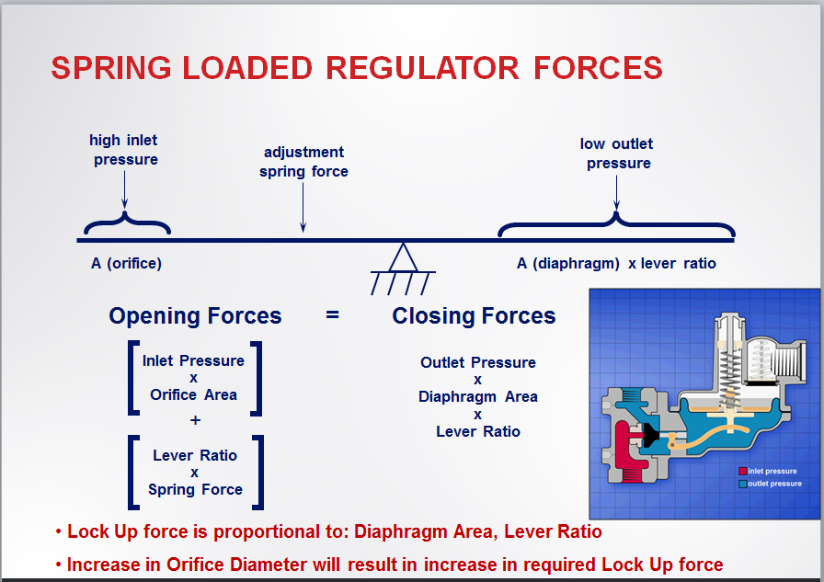

Inlet (upstream) pressure is present in the regulator only in the inlet side of the valve body and through the orifice to the juncture of the orifice and valve seat. Outlet (downstream) pressure is under the diaphragm and in the outlet half of the valve body.

When there is a demand downstream, such as a furnace or water heater coming on, pressure will drop under the diaphragm as gas begins to flow. Inlet pressure pushing against the valve seat and force from the compressed adjustment spring will open the valve as gas begins to flow downstream, lowering the pressure under the diaphragm. As the diaphragm drops, it operates the valve linkage, moving the valve seat away from the orifice. This allows gas to flow from the inlet side of the regulator to the outlet side in response to demand.

* Increase in Downstream Demand
  + Outlet pressure drops
  + Diaphragm moves downward
  + Valve seat moves farther away from the orifice face
  + Flow increases to match increased demand
* Decrease in Downstream Demand
  + Outlet pressure increases
  + Diaphragm moves upward
  + Valve seat moves closer to the orifice face
  + Flow is restricted to match decreased demand



* No Demand (Lockup)
  + Outlet pressure continues to rise
  + Diaphragm moves upward
  + Valve seat is driven into the orifice face
  + Flow is shut off

As the demand downstream decreases, the pressure in the piping and under the diaphragm increases. The diaphragm moves upward, repositioning the valve seat closer to the orifice, restricting flow to meet the decreased demand.

When there is no demand downstream, the outlet pressure under the diaphragm increases until it overcomes the adjustment spring force and the inlet pressure pushing against the valve seat. The valve seat is driven into the orifice shutting off flow between the high pressure side and the low pressure side of the regulator.

Since changes in outlet pressure are used to open and close the valve, it can be seen that a spring loaded regulator cannot produce a perfectly constant outlet pressure.

Regulators are adjusted while flowing gas. If the customer specifies a flow rate for adjustment, it is used. If no flow rate is specified, 50 cubic feet per hour for house regulators is used. A flow rate of 100 cubic feet is used for commercial regulators with a diaphragm case diameter of 8 inches or less. 200 cubic feet flow rate is used for set point adjustment when the diaphragm case is over 8 inches in diameter. The 838 series of regulators are adjusted using a flow rate of 500 cubic feet per hour.

* Set Point: Outlet pressure [P(set)] to which a regulator is adjusted at a specific flow rate [Q(set)]
* Droop: Decrease in outlet pressure associated with an increase in flow rate from set point
* Boost : Increase in outlet pressure associated with an increase in flow rate from set point
* Lockup: Increase in outlet pressure at no flow
* *Q(set) = 50 CFH for Domestic Regulators
* Q(set) = 200 CFH for Commercial Regulators

When flow rate is decreased from the set point flow rate, pressure increases until sufficient force is generated to completely shut off gas flow through the orifice. The increase in pressure required to accomplish no flow or lockup depends on the orifice size, the inlet pressure, and the force required to compress the adjustment spring as the diaphragm moves upward.

As the rate of flow increases and passes beyond the set point flow rate, the outlet pressure will often rise above the original set pressure due to a boost mechanism built into the regulator. As the flow rate continues to increase, the outlet pressure will begin to drop. For 7 inch water column outlet, the capacity tables show the flow rate with a 1 inch drop in the outlet pressure. At outlet pressures above 7 inches, the tables will list the droop allowed for the flow rates in the table.



**Boost Effect**

The boost mechanism used in the B42 and B39 regulators is a combination of the angled lip on the valve set and the geometry of the valve body outlet. The remainder of the Itron regulators, with the exception of the B35 farm tap, use a loading ring. The loading ring is a cylinder, with one or two ports in the wall, installed in the valve body on the orifice. If the loading ring is plastic, the normal position is with the port on the split side of the loading ring pointing straight downstream toward the outlet of the valve body. For the position of the metal loading rings, consult literature. The loading ring will give the greatest boost effect when positioned at zero degrees downstream. As the flow of gas increases, the velocity of the gas directed downstream by the loading device causes a slight aspiration under the diaphragm. The pressure drop under the diaphragm, caused by the spring force lost as the diaphragm drops, is greater than the pressure drop in the downstream piping. The boost mechanism is used to offset pressure decay at high flows caused by spring and diaphragm effect. The capacity tables in the product bulletins were developed with the loading ring settings that limit boost to 2 inches water column or less. If the metal loading rings are left at zero, the boost can be more than 4 inches in some applications. A four inch change in pressure through a meter results in 1% error in accuracy.

* Loading ring and Deflector ring direct gas downstream in such a way as to indicate a slightly lower pressure under the diaphragm than the actual downstream pressure (P2 < P1)
* The result is a further opening of the valve and a boosting effect on outlet pressure
* This boosting effect is useful in offsetting outlet pressure decay at high flows due to the spring and diaphragm effect

**Spring Effect**

The valve seat must move away from the orifice ¼ the diameter of the orifice to obtain full capacity of the orifice. The lever ratio in a B42 is 6:1. The diaphragm must drop six times the distance the valve seat moves away from the orifice. The adjustment spring is under compression. As flow increases and the valve seat moves away from the orifice dropping the diaphragm, the spring length increases. The force lost from the spring as its length increases is equaled by a loss in pressure under the diaphragm as the regulator seeks a balance in forces.



* **Q is Flow**
* **L is Spring Length**
* **F is Spring Force**

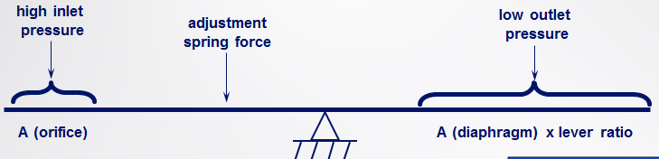

Q1 Q2 Flow Increases

L1 L2 Spring Length Increases

F1 F2 Spring Force Decreases - Outlet Pressure Decreases

The lightest spring that will produce the required outlet pressure will give the greatest capacity with a given pressure drop. The capacity tables in the literature are based on the lightest spring for the listed outlet pressure.

**Diaphragm Effect**

When the regulator is pressurized, a convolution is formed between the upper diaphragm plate and the inside wall of the diaphragm case. The effective diaphragm area is determined by measuring the diameter from the high point of the convolution on one side to the high point on the other side. As the valve opens and the diaphragm moves down with the lever, the diameter and the effective area are increased.

At the same time force is decreasing from the extension of the adjustment spring, the diaphragm is gaining effective area. The result is that an even greater loss of pressure under the diaphragm is required to balance the regulator. The boost mechanism helps offset the pressure loss related spring and diaphragm effect.

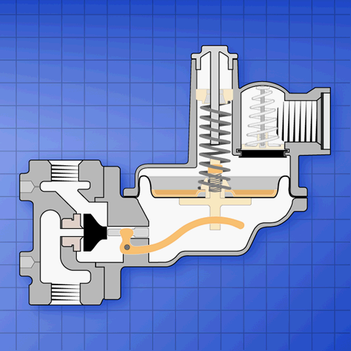

**Inlet Effect**

Inlet pressure times the area of the orifice opening is one of the opening forces on a regulator. As the inlet pressure increases, there will be a corresponding change in outlet pressure. If the inlet pressure drops, there will be a related drop in outlet pressure. The inlet pressure used to adjust the outlet pressure must be specified to ensure accurate outlet pressure. If the inlet pressure varies, the maximum and minimum the regulator will see must be known to allow safe and proper sizing of the regulator. The smaller the orifice the less effect a change in inlet pressure will have on the outlet pressure. This is one of the reasons for sizing a regulator with the smallest orifice that will meet the maximum flow requirements at the lowest inlet pressure the regulator will see.

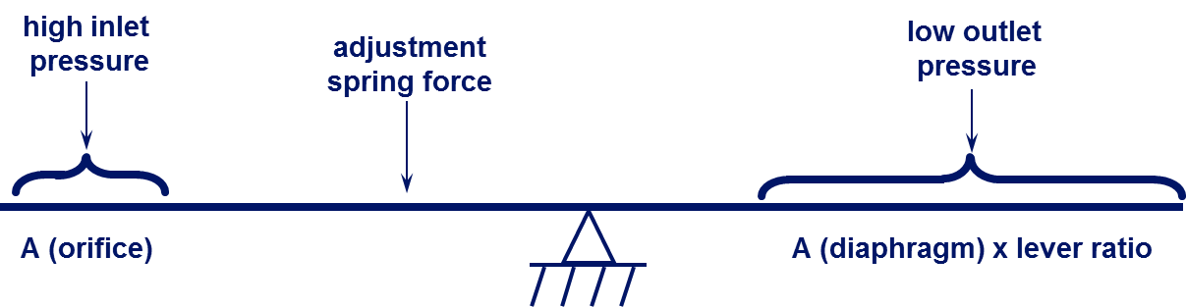

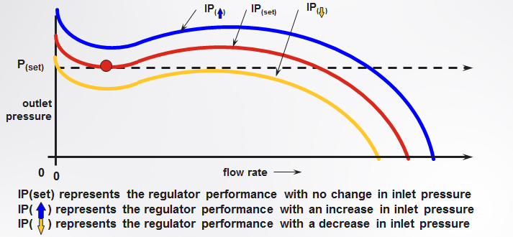

**Over Pressure Protection**

A device to prevent excess pressure being delivered to the customer in the event of regulator failure must be considered on any regulator installation. This protection may be in the form of internal relief, external relief, an internal monitor, and external monitor, or an over pressure cutoff.

**Internal Relief**

Protection against over pressurization is built into Itron spring loaded regulators with an “R” in the model designation. A relief valve is built into the diaphragm assembly. If foreign matter between the valve seat and orifice, a nick in the orifice, or a cut on the valve seat prevents complete lock up of the valve, pressure continues to build under the diaphragm. The lower diaphragm plate is connected to the valve lever. The lever has a stop point on it that will contact the lower diaphragm case casting as the diaphragm rises. The stop stem connected to the lower diaphragm plate also contacts the seal cap or seal cap extension rod as the diaphragm rises. Contact at either point will stop the lower diaphragm plate. Increasing pressure working against the relief spring and the adjustment spring will lift the diaphragm off the lower plate, opening the relief valve. There is a vent valve assembly in the upper diaphragm case with a light spring holding the valve closed. The gas flowing through the relief valve will force the vent valve open and gas will flow to atmosphere.

**Inlet Effect — Change in outlet pressure associated with a corresponding change in inlet pressure**

If “full capacity” relief is requested, it must be defined by providing a pressure build up maximum. There are relief curves in the literature that show the pressure build up downstream with the regulator failed wide open with various orifices at a range of inlet pressures. Additional curves are available from the factory. The smaller the orifice, the lower the pressure build up will be downstream in the event of regulator failure. This is another reason to choose the smallest orifice that will meet the flow requirements when sizing a regulator. A B38 with a 3/8 orifice, used for 7 inches outlet with 60 PSIG inlet, will have a pressure buildup of slightly over 1 PSIG when failed wide open. The same regulator, with a 1 inch orifice, will build up over 9 PSIG on the outlet side when failed wide open. If the regulator does not meet the required parameters for maximum build up, additional protection must be employed.

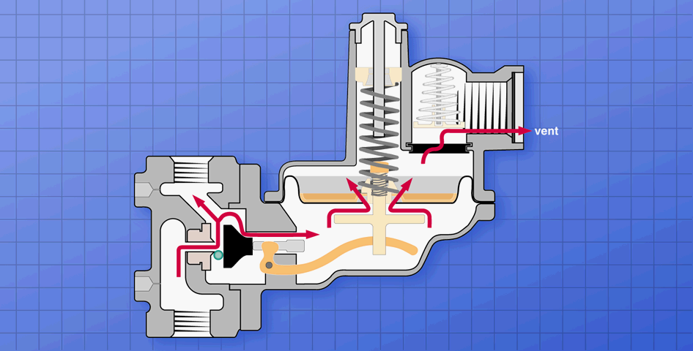

**Relief Vent Valve**

The vent valve assembly present in all Itron spring loaded regulators, with the exception of the farm tap B35, is an important control mechanism for the regulator. If the regulator could instantly respond to changes in downstream demand, there would be a surge in outlet pressure when the valve opened. In response to excess downstream pressure, the valve would slam shut. The cycle can be so rapid that it causes pulsation in the gas stream and vibration in the regulator and piping. The diaphragm must push air out through the vent when it rises. If it needs to rise rapidly to close the valve, the air will open the vent valve. When the diaphragm drops to open the valve, the only place air can enter to allow diaphragm movement is through a breather hole drilled through the casting toward the end of the vent threads or through the vent valve disc. If the vent disc sticks in the open position or does not seat fully on the vent valve seat, pulsation can result. When the seal cap is removed, it provides an additional path for the regulator to breathe. If pulsation occurs while adjusting the regulator, it can usually be stopped by placing a hand over the seal cap opening.

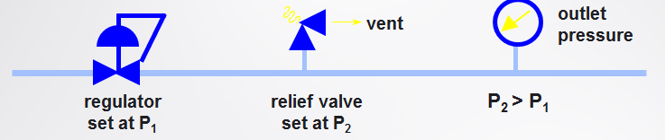

Pipe screwed in the vent will cause an increase in the pressure build up under failed conditions. Many of the product bulletins show pressure build up both with and without vent pipe. Vent pipe can also cause pulsation. Vent pipe should always be as large as the vent threads and should be stepped up in size for long runs. Pulsation related to vent pipe can often be stopped by reducing the breather hole size. Contact the factory if a problem occurs.

**External Relief**

Another method of over pressure protection is the installation of an external relief valve downstream of the regulator. Itron, USA does not manufacture external relief valves. The external relief valve is adjusted to open at a pressure higher than the operating pressure of the control regulator.

* **Regulator fails**
* **Outlet pressure builds to P2**
* **Relief valve begins venting excess gas to minimize downstream pressure build-up**

**Internal Monitor**

The Internal Monitor, designated by IM in the model name, was designed to comply with DOT OPS 192.197 Paragraph B which states, “or if the gas contains materials that seriously interfere with the operation of a service regulator, there must be suitable protective devices to prevent unsafe over pressuring of the customer’s appliance if the service regulator fails.” The code lists devices, one of which is regulator and monitor. The code further states these devices may be installed as an internal part of the service regulator or as a separate unit.

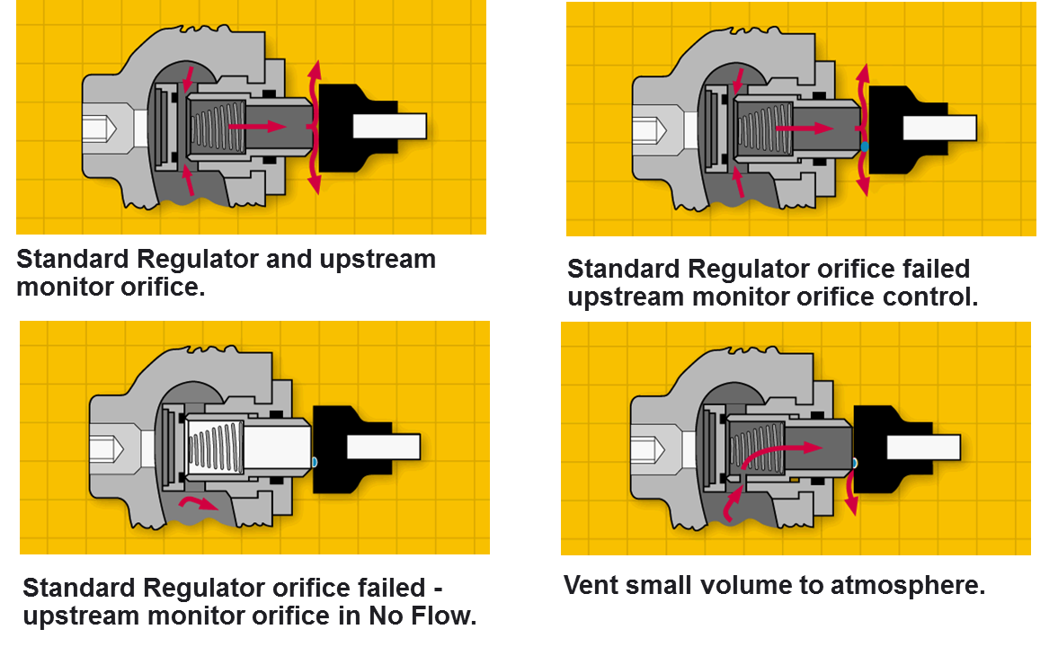

The IM orifice is available in both spring loaded and constant loaded regulators. The sliding orifice has a face machined on both ends. There is a second rubber seat at the back of the sliding orifice. An IM assembly with dual sliding orifices is available in the 531 and 838 models. One sliding orifice has a rubber seat at the monitor end, the other has a chisel point face. If the valve in an IM regulator adjusted to 7 IWC fails to lock up, outlet pressure continues to build under the diaphragm. And increase of about two inches will start to move the sliding IM orifice. An increase of four inches will move the sliding orifice back to a second seat where it can shut off bubble tight. No gas will be vented to atmosphere. Most failures are caused by foreign material in the gas stream. Gas will be regulated at the IM orifice until downstream demand again opens the main valve. The foreign material will pass through the valve and the regulator will return to normal operation. In the over pressure shut off regulators manufactured by the competition, foreign material in the valve will cause gas to be shut off to the customer, resulting in a service call and inconvenience to the customer. With the IM regulators there is no customer outage, the problem usually corrects itself and the regulator returns to normal operation. A vented version of the internal monitor orifice, designated IMV is available if the customer desires a failure signal. A small bypass hole is drilled in the sliding orifice, allowing pressure to build under the diaphragm when the main valve fails. The pressure will build to the relief point of the regulator and a small amount of gas determined by Inlet pressure, will vent to atmosphere. The vented model is available only on regulator models with a relief valve in the diaphragm assembly.

The B531 and B838 regulators are adjusted for simultaneous operation. Normal regulation occurs with gas flow controlled simultaneously on both sides between the orifices and valve seats. If foreign material becomes lodged between on orifice and valve seat, pressure builds beneath both diaphragms. An increase of 2 IWC will start both sliding orifices moving in a regulator adjusted for 7 IWC. With a pressure increase of 4 IWC, the sliding orifices will meet in the center of the inlet chamber of the valve body and shut off gas glow without venting gas to atmosphere. Gas will be regulated between the two sliding orifices until downstream demand opens the main valves. The contamination will pass through and the regulator will return to normal operation without interruption of service to the customer. If on side were to fail completely due to lever disconnect or foreign material lodged between the valve seat and stationary orifice, the sliding orifice on the other side will travel across to the non-moving orifice and provide total lock up. It will continue to regulate gas between normal set point and the monitor lock up point until the problem is corrected. The twin regulator IM orifice is also available in a vented version.

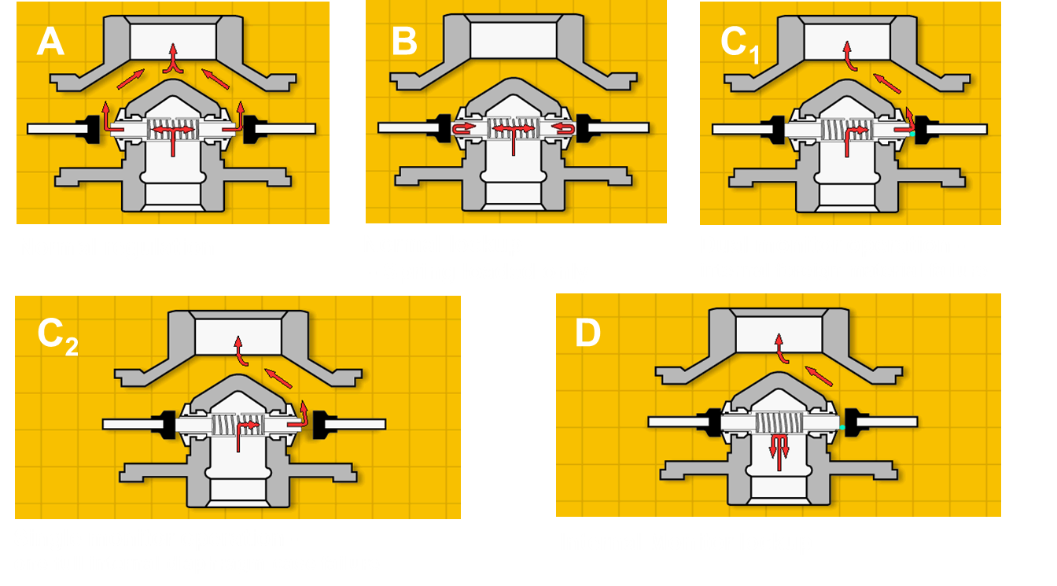

**External Monitor**

In a regulator set with an external monitor, two regulators are installed in line. The upstream regulator has a closed throat in the diaphragm case. The valve stem is sealed with an “O” ring. There is a tapped opening in the lower diaphragm case. A control line is connected between the lower case and a tap downstream of the second regulator. The monitor regulator with the closed throat senses only the pressure changes downstream of the second regulator. If the operating regulator downstream is adjusted for 7 IWC and the monitor is adjusted for 10 IWC, the monitor valve will remain wide open in normal operation. If the downstream regulator fails to control the pressure and it builds to 10 IWC, the monitor regulator will respond and will regulate pressure downstream of the second regulator in the range of its 10 IWC set point. The monitor regulator may be used as the operator by adjusting it to 7 IWC and adjusting the downstream regulator to 10 IWC. The downstream regulator becomes the monitor and stays in the open position until the monitor regulator, now used as an operator, fails.

**Advantages:**

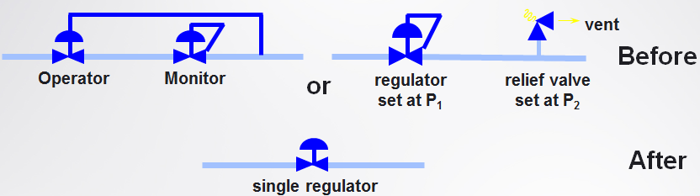

* **Single regulator cuts costs by almost half**
* **Reduced inventory costs**
* **Shorter meter set/better aesthetics**
* **No control line to tear out**

An over pressure shutoff, referred to as an OPSO, is a device usually located opposite the diaphragm case on the valve body. It can also be a separate unit installed in the piping downstream of the operating regulator. The OPSO senses the outlet pressure of the regulator. The OPSO device has a spring loaded valve seat that is tripped by pressure under its diaphragm. The trip point is spring adjustable and is set for a pressure value greater than the lock up pressure of the regulator. When the OPSO trips, gas is shut off to the customer until it is reinstated by a service man. Internal monitor regulators give the same protection against over pressurization of the customer without the need for an expensive service call and without causing a gas outage to the customer.

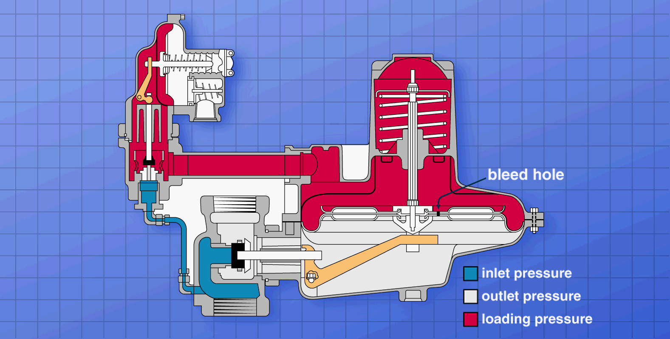

**Constant Loaded Regulators**

In a Constant Loaded regulator, a spring loaded pilot regulator is connected on its outlet side to the vent of the main regulator diaphragm case. A pressure tap on the inlet side of the main case valve body supplies pressure to the inlet of the pilot regulator. The spring used as an opening force in spring loaded regulators is installed to close the valve in the main regulator. When there is no demand downstream, a 5/32 communication hole through the main case diaphragm assembly allows pressure to equalize above and below the diaphragm of the main case. Pressure under the diaphragm of the pilot regulator, which is common with the pressure in the main case, will build until it is sufficient to overcome the opening forces in a spring loaded regulator (adjustment spring and inlet pressure) and achieve total lock up.

When there is a demand downstream, the pressure drops under the main case diaphragm. Differential initiates the flow of gas through the communication hole in the diaphragm, dropping the pressure in the upper case of the main regulator and under the diaphragm of the pilot regulator. If the flow rate is less than the capacity of the communication hole, 50 to 120 cubic feet per hour, depending on closing spring used and differential required to overcome it, the main valve remains closed and gas is supplied by the pilot regulator. When downstream demand exceeds the capacity of the communication hole, the differential above and below the diaphragm overcomes the closing spring and the main valve begins to open. Once the capacity of the communication hole is exceeded, the flow required from the pilot remains constant and there is no spring effect on the outlet pressure of the main valve. The diaphragm in the main case has an effective area of 78 square inches. Once the main valve has begun to open, the pressure decrease required under the diaphragm to reposition the valve to a wide open position has a negligible effect on the outlet pressure. When downstream demand decreases, the pressure under the diaphragm increases. Pressure will equalize above and below the diaphragm, allowing the closing spring to close the main valve. Pressure will build in the main case above and below the diaphragm and in the pilot under the pilot diaphragm until it is sufficient to fully close the pilot valve.

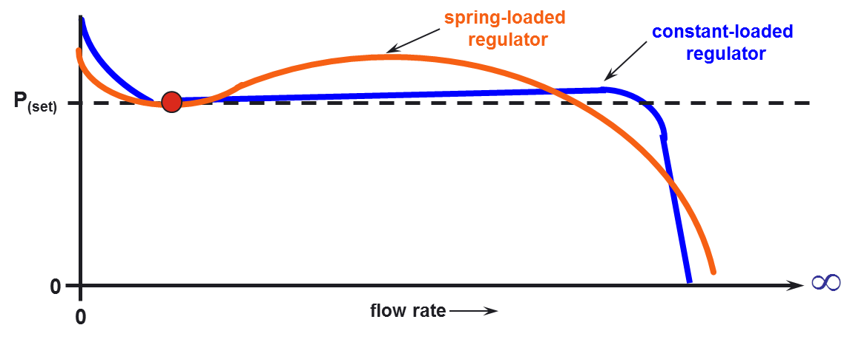

Constant Loaded regulators are used for high volume flow requirements when the required outlet pressure is in pounds rather than inches water column. The spring effect, which becomes greater with the stronger adjustment springs required for pounds outlet pressures in spring loaded regulators, is not a factor with CL’s. The result is more accurate control of downstream pressure with pounds outlet over a wider range of flows.

Most of the spring loaded regulators sold for use on meters sets are set at 7 inches outlet or about one quarter pound per square inch. 27.707 inches of water at one atmosphere and 60 degrees Fahrenheit equals one pound per square inch.

Constant Loaded regulators were designed primarily for use on meter sets with elevated pressure. Increasing the pressure through a meter allows the use of smaller meters and piping with the associated savings in installation cost. If the pressure through a meter can be controlled within 1 percent of absolute pressure (atmospheric plus gage), a pressure factor number can be used to multiply the reading on a standard index to determine the standard cubic feet of gas used. The capacity tables for CL regulators are all based on a 1 percent change in absolute pressure. Expensive electronic instruments or chart recorders are required when the pressure through the meter varies more than 1 percent of the absolute pressure.

There is seldom any reason to sue CL regulators when the outlet pressure is less than 1 PSIG. CL capacity tables give the capacity with a one percent droop. Spring loaded regulator capacity tables show capacity with a one inch droop for a 7 IWC set point. The CL capacity in the table for a 7 IWC set point is shown with a one percent absolute pressure droop, more than four inches. If the spring loaded regulator were allowed to droop four inches, the capacity would be equal to that shown for the CL.

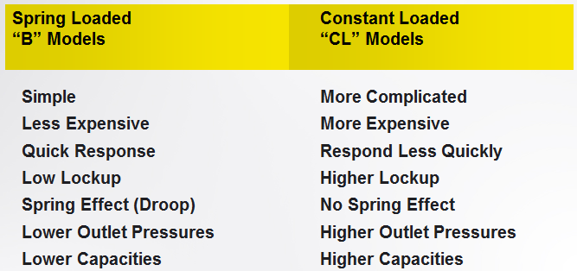

Spring loaded regulators are simpler to install and repair than CL’s. Two screws hold the diaphragm case and valve body together on both regulators. When removed from a spring loaded regulator, the diaphragm case can be removed allowing access to the valve seat, loading ring, and orifice for adjustment or replacement. CL regulators have a control line between the pilot valve body and main valve body that must also be removed before the diaphragm case can be removed. The closing spring force should be removed from a CL before reinstalling the diaphragm case to prevent damage to the valve seat.

Spring loaded regulators are less expensive. CL regulators have an additional regulator attached for pilot loading. All CL diaphragm cases are tank tested at 90 PSIG to insure integrity of the aluminum castings due to the high outlet pressure rating. This additional test is not required on spring loaded regulators as they are only rated to 5 PSIG outlet.

Spring loaded regulators respond quicker to snap acting or quick off loads. Pressure must equalize above and below the diaphragm in a CL through the 5/32 communication hole before the pilot achieves total lock up.

CL regulators have a higher lock up point. The set point is adjusted with the main valve open. It requires, depending on closing spring color, about a seven inch drop in outlet pressure to overcome the closing spring force and open the main valve. The same amount of pressure increase will occur as pressure equalizes above and below the main case diaphragm and the valve closes. There is an additional increase in outlet pressure required to lock up the spring loaded regulator used as a pilot.

The CL regulator has its greatest advantage in pounds to pounds regulation. Once the main valve starts to open, there is no spring effect on the outlet pressure. If outlet pressure droop were of no concern, a spring loaded B38 set for 5 PSIG would have the same capacity as a CL34 set for 5 PSI using the same size orifice. Using 15 PSIG inlet and 5 PSIG outlet with a one inch orifice, the capacity tables show the capacity of a CL38 at 16,900 cubic feet. A B38, given the same conditions, shows a capacity of 2,100 cubic feet. The difference in capacity is due to spring effect in the B38 model. The difference shown in the two curves below would increase as the adjusted outlet pressure increased.

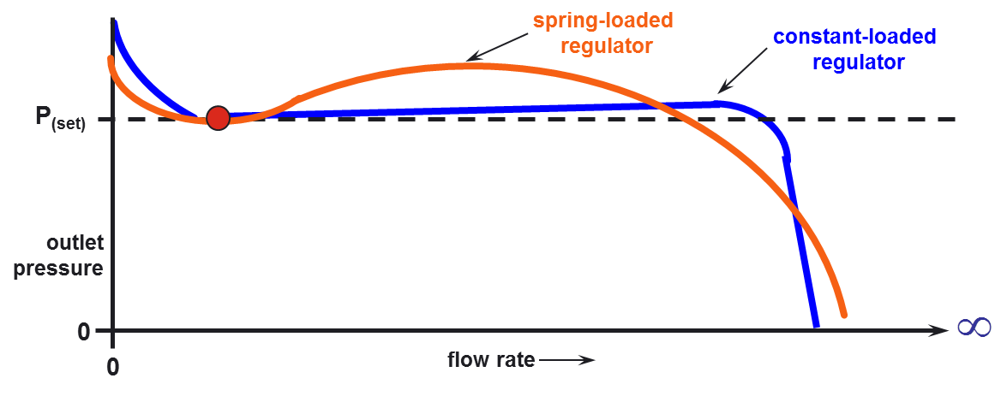

While there is a virtually no difference in capacity between “B” and “CL” model regulators when used for inches outlet, when used for pounds outlet pressures the capacity advantage for “CL” models increases as the adjusted outlet pressure increases. If the required outlet pressure is less than on pound, spring loaded regulators are generally used. Schlumberger spring loaded regulators designed for pressure control suitable for metering purposes have a maximum outlet pressure of 5 PSIG. CL34 regulators have a maximum outlet pressure of 60 PSIG. CL38 and CL838’s have a maximum outlet of 30 PSIG. For CL31 and 231 regulators, the maximum outlet is 20 PSIG.

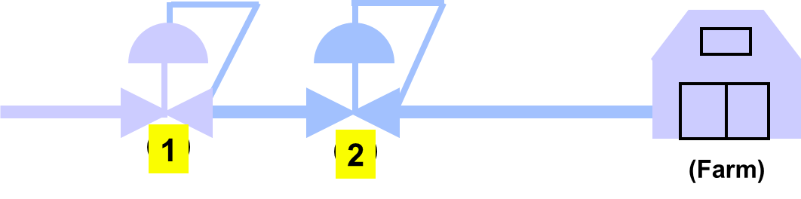

There is a relief valve in the pilot of the “CL” regulators with the exception of the CL31N and CL231N. These pilot relief valves will handle a failure of the pilot relief valve only. If the main valve fails, the only path for gas to the relief valve is through the 5/32 communication hole in the main case assembly. The pilot relief valve is not adequate for a failure of the main valve. An external relieve valve, monitor regulator, or internal monitor orifice should be used with a constant loaded regulator for over pressure protection. This is another factor in selecting a spring loaded regulator for outlet pressures under one pound. Spring loaded regulators can often be sized so that the internal relief valve is adequate for over pressure protection.

**Field Service Regulators**

Field service, also referred to as farm tap regulators, are pounds to pounds regulators used for first stage or first and second stage reduction on high pressure lines. The B35 has a malleable iron valve body and cast iron diaphragm case. It can be used for up to 1000 PSIG inlet pressure and 10 to 150 PSIG outlet. The B56 uses the same malleable iron valve body as the B35 with an aluminum diaphragm case. It can be used for up to 1000 PSIG inlet and 2 to 60 PSIG outlet. The B36 has a cast iron valve body and an aluminum diaphragm case with only a few parts different than the B56. It is used for up to 175 PSIG and 2 to 60 PSIG outlet.

**Inlet Pressure: 400 – 1000 PSI (30 – 68 bar)**

**Outlet Pressure : 5-150 PSI (0.3 – 10 bar)**

**1**

**Outlet Pressure : 7” W.C. – 2 PSI (14 – 140 mbar)**

**2**

**Flow: Up to 10,000 CFH (285 CMH)**

**1**

**Regulator : B36, B56, B35**

**2**

**Regulator : B42, B34**

These regulators are not suitable for pressure control for metering purposes. Their capacity tables show capacity with 20 percent or 10 percent droop from set point. They are designed to reduce high line pressures to a level that can be safely handled by other regulators.

The greater the pressure drop across a regulator, the greater the temperature drop. With a high volume flow and moisture present in the gas, this can cause ice to form in the orifice restricting and possibly halting gas flow. If dust particles are present in the gas, the high velocity generated in a one stage drop from high inlet pressure can cause erosion of the valve seat. If the inlet pressure is above 500 PSIG, it is often helpful to have a two stage reduction. A B35 can be used to reduce high inlet pressure to 150 PSIG and a second Field Service regulator can be used to reduce the 150 PSIG to a safe level for a CL or a low outlet pressure spring loaded regulator. Proper sizing of the regulators used in multiple stage pressure drops will result in safe pressure control under failed conditions as the Field Service Regulators are available with relief valves.

**Regulator Model Designation**

The oldest of the current Schlumberger USA Gas regulators is the B31. It was designed to comply with and old ANSI code for relief regulators, B31.8. All subsequent designs used the “B” designation for Spring Loaded regulators. The numerical designation for Spring Loaded regulators was assigned chronologically and has no other significance. Exceptions are the B56, a combination of the B35 and the B36 designs, and the B531 and B838. The BB531 and B838 each have two diaphragm cases and are based on the B31 and B38 designs. The missing numbers in the sequence such as B37, B40, and B41, existed in the design stage but never went into production. CL regulators were designed using castings, orifices springs and many other parts common with “B” model regulators. The numerical designation in the model name for a CL reflects the Spring loaded model with which it shares parts.

Suffix

The letters and numbers following the numerical designation have the following meanings:

R With internal relieve valve

N Without internal relieve valve

D Downstream control

M Monitor

IMR Internal Monitor with internal relief

IMN Internal Monitor without internal relief

IMRV Internal Monitor with relieve valve and vent signal for failure

SO Safety orifice (replace with IMRV if possible)

SR Small diaphragm case (8”) B34 with relieve valve (standard B34 is 12”)

SN Small Diaphragm case (8”) B34 with relieve valve

HP High Pressure-used only for B31, B42, B34SR, and B34SN which use   
 special parts for pounds outlet

RAS Automatic shutoff in response to low outlet pressure

RH Internal relief valve with high pressure shut-off (must be manually reset)

RHL Internal relief valve, high pressure shut-off (must be manually reset), and low pressure shut-off

CR Compact regulator (special 90 degree valve body)

-1 CL pilot for up to 5 PSIG outlet pressure

-2 CL pilot for 2 to 30 PSIG (2 to 60 for CL34 only) outlet pressure

**Regulator Sizing**

The accuracy and safety of downstream pressure control depends on proper regulator sizing. Obtain as much of the following information as possible:

1. Inlet and outlet connection size
2. Adjusted outlet pressure required
3. Normal operating inlet pressure
4. Maximum inlet pressure the system may supply
5. Minimum inlet pressure the system may supply
6. Maximum downstream pressure limitations
7. Maximum flow required or maximum BTU requirements
8. Type of gas if other than .6 specific gravity natural gas
9. In addition to the obvious need to match the regulator to the pipe size, pipe can limit capacity. If the outlet pressure is less than 1 PSIG the following limits based on pipe size should be considered:

¾” 600 cfh

1” 1200 cfh

1-1/4” 2500 cfh

1-1/2” 7500 cfh

2” 10000 cfh

Exceeding these limitations will result in the pipe rather than the regulator causing excessive downstream pressure droop. The B838 and CL838 catalog literature have separate tables for 2”, 3”, and 4” outlet that show at a glance the impact that outlet piping can have on capacity.

1. Always choose the lightest spring that will provide the required outlet pressure. The capacity tables are based on use of the lightest spring for a given outlet pressure. If a heavier spring will give the same outlet pressure, (i.e. both a green and a black spring will give 7 IWC in a B34), the droop will be greater than 1 IWC when the listed capacity is reached with the heavier spring.
2. It is necessary to use the inlet pressure the regulator will see in operation for accurate adjustment of the outlet pressure at the factory.
3. The maximum inlet pressure the regulator may be subjected to is used to determine downstream pressure build up in the event of catastrophic failure. It also determines if the application is within the capability of the regulator with a given orifice size. It is used to determine the correct closing spring for CL regulators.
4. Minimum inlet pressure is used to determine the orifice size. The orifice must supply the maximum flow required with the minimum inlet pressure the regulator will need to operate on.
5. Maximum downstream pressure build up that can occur with catastrophic failure can be determined using the relief curves in the catalog information. Always use the maximum inlet pressure for analysis. If the relief valve does not meet requirements, suggest an IM version. To size an external relief valve for the customer, refer to bulletin JOT-10 “Schlumberger Regulator “K” values and their Application”.
6. Maximum flow required with the minimum inlet pressure the system will see is used to size the orifice. If given in BTU, 1 CFH of .6 specific gravity natural gas is equal to 1000 BTU.
7. If other than natural gas, the B42 catalog shows the conversion factors to apply to the capacity tables for various specific gravity gasses. The BTU value for a cubic foot of other than natural gas will also be different.

**Conclusion**

This paper has given the reader the fundamentals of the different types of gas regulators. Only authorized and trained personnel should attempt to size, install, or service any type of gas regulating equipment.