FUNDAMENTALS OF FLOW COMPUTERS

JOHN SWARTZ
APPLICATION ENGINEER
EAGLE RESEARCH CORPORATION
TUSHAR SHAH, M.S.E.E., M.B.A.
SR. DIRECTOR OF BUSINESS DEVELOPMENT
EAGLE RESEARCH CORPORATION

Introduction
The intention for this paper is to provide an overview of flow computers and how they integrate into the world of electronic gas measurement while utilizing the American Petroleum Institute (API) 21.1 standard. This overview is for those who are new to the industry or for those who are looking for a refresher on the basic application of flow computers.

As natural gas moves from the well head to the burner tip, there are several electronic devices in the field used for measurement and control. The electronic flow computer is referred to in API 21.1 as a tertiary device in the electronic gas measurement system (EGM). In the natural gas industry a flow computer is used for differential meter measurement or used for linear meter measurement. Many contracts between companies for custody transfer of natural gas often stipulate that measurement falls into compliance of API 21.1.

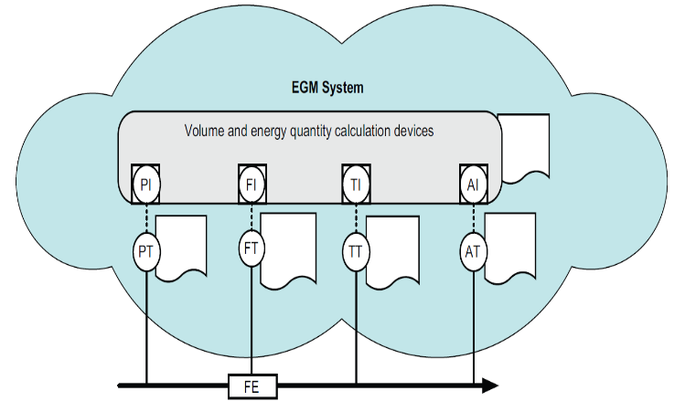
Fig. 1. Electronic gas measurement (EGM) as defined in API 21.1.

API 21.1 Overview

API 21.1 is a standard written by the American Petroleum Institute which describes the minimum specifications for electronic gas measurement (EGM) and the reporting of that measurement, see Fig. 1. The EGM includes primary, secondary, and tertiary devices. Orifice and turbine meters are primary devices while pressure and temperature transmitters are secondary devices. The flow computer would be defined as the tertiary device as it takes the received inputs and performs the flow calculations.

To have auditable measurement these specifications also include: EGM System Algorithms, Audit and Record Requirements, Data Availability, Commissioning, Equipment Verification and Calibration, and Security and Data Integrity.

Electronic Flow Computer Basics

The overall basic function of an electronic flow computer is to calculate and record flow rate and its volume using industry standard algorithms as natural gas passes through a meter. These meters could be, but are not limited to, orifice, turbine, rotary, v-cone, ultrasonic, and coriolis meters.

For a typical orifice measurement application, a differential pressure, static pressure, and flow temperature are required. These inputs could be individual remote transmitters, individual local transducers/RTDs, or they can even be outputs from a single transmitter that has all three variables which is known as a Multi-Variable transmitter.

For typical turbine meter, rotary meter or diaphragm meter applications, static pressure, temperature, and a pulse generating device, e.g. mechanical index are required. A flow computer on this type of meter would usually have a local pressure transducer paired with a resistive temperature detector (RTD) and the enclosure would be mounted directly to a meter drive output.

For typical Ultrasonic Meter (UM) applications static pressure, temperature, and a pulse output from UM are required. A flow computer on this type of meter would usually have a local pressure transducer paired with a resistive temperature detector (RTD) and receive pulses from the UM. In some cases, the flow computer may interface serially with the UM and receive all the information via MODBUS protocol.

Basic Components

An electronic flow computer typically consists of the following main components:
- Enclosure
- Processor Board (motherboard)
- Display
- Keypad
- Pressure Transducer
- Temperature Probe (RTD)
- Multi-Variable Transmitter (For differential meters only)
- Pulse Generating Device
  - Mechanical Index (For turbine, rotary or diaphragm meters only)
  - Electronic pulse output (For Ultrasonic or Coriolis meters)
- Local Communication Port
- Remote Communications Options
- Operating Software/Firmware
- Power Supply

While the above are typical components, each application requires its own combination of basic components and could include more or less of the items listed.
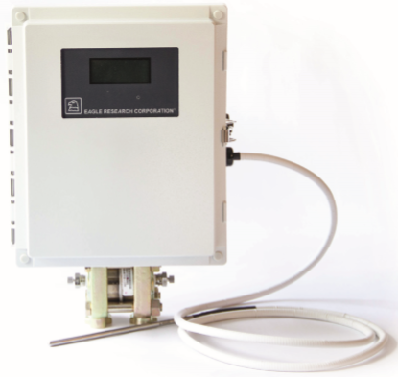
Fig. 2. Example of an electronic flow computer with multi-variable transmitter for orifice meter.

Enclosure is weather proof and suitable for outdoor use. Most enclosures also allow for a security seal, door lock and entry/exit connections.

Processor Board (motherboard) is the “brains” of an electronic flow computer, see Fig. 3. The processor board is a printed circuit board assembly (PCBA) with all the electronic parts necessary for the flow computer. The PCBA has the appropriate connectors and terminals for interfacing to accessories, such as pressure transducers, temperature probes, index wiring, display, etc.

The processor board also has power supply circuitry, at least one microprocessor, multiple memory types, analog/digital converters, analog inputs/outputs, digital inputs/outputs, counter inputs, signal conditioning, as well as several other supporting circuitries.

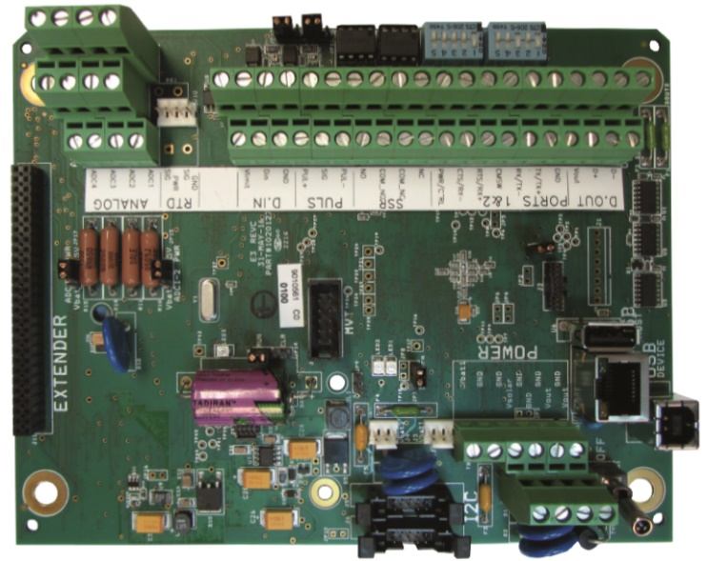
Fig. 3. Example of a microprocessor based processor board (PCBA).
The processer board internal circuits are usually powered by 5 VDC or 3.3 VDC depending on the technology used on the board and who the manufacturer is. The on-board power supply regulator allows the flow computer to be powered externally by 12VDC or 24VDC. External power requirements vary by manufacturer and could require for example an exact 7.2VDC or have a range of 7-30VDC.

Display provides a way to view designated parameters locally at the flow computer. The most common display type is a Liquid Crystal Display (LCD). The LCD may be a part of the processor board or a separate PCBA connected to the processor board.

Most single line LCD’s are designed to display a limited number of characters; however some will show full naming conventions. In this case, the parameter value is preceded by a letter designator, e.g., CV for corrected volume. Multi-line displays can display the value along with descriptive labels.

Manufacturers allow for different parameters to be scrolled through by pressing a button or waving a magnet on a designated area.

If a magnet is used to control scrolling, a magnetically activated reed switch is used on the display PCBA.

Keypad is used for local data entry. A Keypad allows for configuration or quick access to flow computer parameters. Not all flow computers may be equipped with a keypad as they are not a requirement.

Pressure transducer is a sensor used in measuring flowing gas pressure, see Fig 4. The pressure transducer generates proportional electrical signals as a function of the pressure imposed on its pressure sensor element. The electrical side of 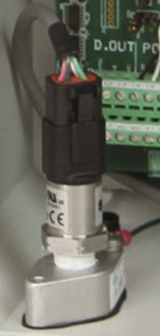 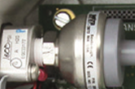
the pressure transducer is connected to the analog inputs signal, power, and ground connections on the processor board. The other side of the pressure transducer is threaded to accept tubing from a pressure tap.
Fig. 4. Example of a pressure transducer inside the enclosure.

Proper valves and tubing are installed to allow maintenance and calibration of the transducer. A quick connect for a mechanical gauge should be considered for quick verification of the electronic readings.

Temperature probe is a Resistive Temperature Detector (RTD) sensor used to measure flowing temperature, see Fig 5. The temperature probe has a metal jacket called a sheath which houses an element in the tip usually made of platinum with a resistance of 100 Ohms at 0 degrees C (32 Degrees F). As the temperature of the metal changes the resistance changes and can be correlated to a temperature. The wires from the probe are connected to the processors RTD input.

The probe is inserted into the thermowell that is installed in a gas pipeline. In some instances the temperature probe is inserted into the meter temperature port.

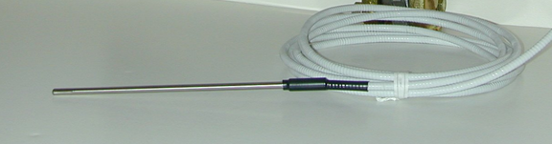

Fig. 5. Example of a temperature probe.

Thermowell is a tubular fitting that is used to allow the temp probe to be directly in the flow of gas for a more accurate readings and is also to protect the temperature sensors, see Fig 6. A thermowell consists of a tube closed at one end and mounted in the process stream.

The thermowell facilitates inserting and removing a temperature probe to measure a gas flow temperature without the need to shut off gas the gas flow. The adaptor is used with the temperature probe to thread and secure the probe into the thermowell. The thermowell is selected based on the gas pipe size.

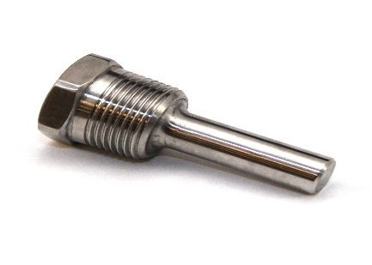
Fig. 6. . Example of a thermowell.
Multi-variable transmitter measures differential pressure (DP) as well as static pressure. This avoids having to install two transmitters to measure differential pressure and static pressure when doing orifice flow measurement. See Fig 7. For an example of differential pressure meter run with multivariable transmitter attached to electronic flow computer.
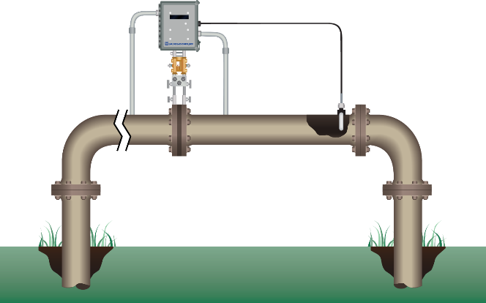
Fig. 7. Example of differential pressure meter run with multi-variable transmitter attached to electronic flow computer.
Pulse Generating Device provides a pulse signal proportional to the gas volume flowing through a gas meter. The pulse generating device may be part of the gas meter and provide its own wiring for connection to the flow computer. Typically meters with an instrument drive can use a mechanical index as a pulse generating device for the electronic flow computer. In the case of some Rotary, Ultrasonic, and Coriolis meters, the pulse is generated electronically for the flow computers.

Mechanical index is a dual use component that generates pulses and also provides a mechanical counter readout for uncorrected gas volume, see Fig 8. The mechanical index has a pulse generating board which generates pulses representative of the meter drive rate. Typically, signals are generated in a pulse generating board by activating reed switches as a magnet moves past the switches. Pulse generating boards commonly use one or two reed switches to accomplish this.

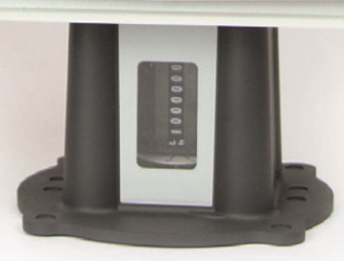

Fig. 8. Example of mechanical index
The index is mounted on the meter’s instrument drive which couples with the index’s counter shaft mechanism. The instrument drive rotates as gas flows and in turn the mechanical counter increments forward and is representative of the uncorrected volume that has passed through the meter.

When installing the electronic flow computer, the index must be configured to reflect if a meter has a clockwise rotation or counter-clockwise rotation. A masking kit is used to mask (cover up) digits of the mechanical readout so that the accumulation multiplier and meter drive rate is reflected properly. Masking allows the mechanical uncorrected volume to match the electronic uncorrected volume. The index may come with vertical or horizontal counter readouts.

Local communication port is typically a serial port with a mechanical or InfraRed (IR) connector on the side of the flow computer enclosure. This allows for direct communication to the user’s laptop or tablet. A unique data cable may be required between the flow computer and the user’s computer. The local communication port is used for initial setup, calibration, maintenance, and data collection.

Remote communication options allow users to interrogate the flow computer without being physically present. Remote communications are often achieved by, but not limited to, the use of cellular modems, satellite transceivers, or radio transceivers. This allows the user to communicate with the unit in the field from another location, such as a field office. Often times, a Supervisory Control and Data Acquisition (SCADA) software or a measurement collection software is used to remotely collect data on a scheduled basis.

Operating software is software that is loaded onto the user’s laptop or tablet to use for communication with the electronic flow computer. This software, provided by the manufacturer, allows for system setup, configuration, data collection, maintenance, and troubleshooting of the electronic flow computer.

Power supply is the main source of DC voltage for the flow computer and is available in many options, such as uninterruptable power supplies (UPS), solar power supplies (SPS), multi cell battery packs, thermo-electric generators, etc. The type of power supply is based on the power available at the site and/or the hardware requirements.

Battery pack is a widely used power source for electronic flow computers in the field, see Fig 9. The battery packs are often installed directly inside the flow computer enclosure. The most popular types of battery packs include alkaline and lithium thionyl chloride (Li-SOCI2).

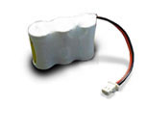
Fig. 9. . Example of battery pack
Alkaline and Li-SOCI2 battery cells are not rechargeable. The battery must be replaced before it reaches the low voltage limit required to operate the flow computer to avoid loss of measurement. A low voltage alarm can be configured in the flow computer to alert a user when a battery pack is near its end of life.

The battery pack should be sized to handle both operation of the flow computer and the communication requirements. To preserve battery life, many electronic flow computers can be setup to wake up at periodic intervals to perform calculations and communications tasks.

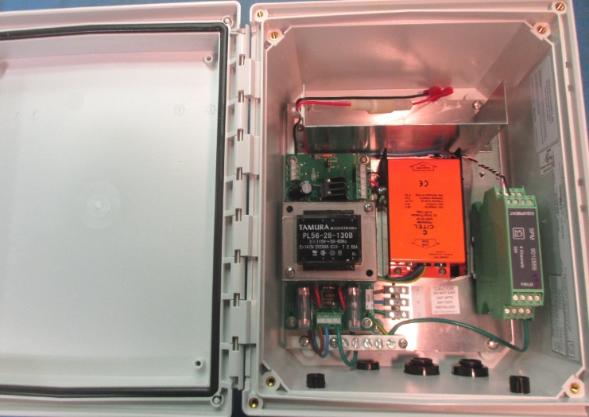

Fig. 10. . Example of an Uninterruptible Power Supply (UPS)
Uninterruptible Power Supply (UPS) consists of a rechargeable battery and AC to DC converter, see Fig 10. The UPS is powered by AC voltage, 110VAC or 240VAC. Upon AC power failure, the flow computer can continue to run on a rechargeable backup battery until AC power is restored. Backup battery sizing is determined by how long the electronic flow computer is required to run in case of AC power loss.

Solar Power Supply consists of a solar panel, mounting bracket, solar charger and a rechargeable battery. The solar panel is typically mounted onto a pole with the mounting bracket and adjusted to face South to get the most sunlight exposure possible.

The size of the solar panel depends on how much average sunlight is available per day and how much charging current is required. The size of the rechargeable battery is determined by how long the flow computer should continue to operate and how many amp hours (Ah) the system draws while in operation.

Solar panels can be as small as 1 watt and directly mounted to the enclosure of the electronic flow computer. They can also be as large as 130 watts or more and require a large supporting structure/mounting bracket.

Remote Communications

There are many options available for remote communications

These may include:
- Analog Phone Line
- Wireless Licensed Radio
- Wireless Unlicensed Radio
- Cellular Modem
- Ethernet Drop
- LEO Satellite

For each of the above options, the appropriate hardware needs to be connected to the processor. Additionally, for each communication type, the proper baud rate (setting for the speed of communication) when appropriate and any related communication parameters need to be setup in the flow computer.

The electronic flow computer is identified in the field by its unique Site Identification (ID), or identification address. This is important for the remote measurement system or SCADA system to identify the flow computer while communicating. This unique ID could be manufacturer specific or simply a modbus address.

Dial-Up Phone Line uses a traditional analog telephone line to communicate with the flow computer. The flow computer requires being equipped with a dial-up modem. At present, in many areas analog dial-up lines are going away. The users are commonly switching to cellular technology for remote communication with the flow computer.

Wireless Radio communications require a radio transceiver, coax cable, and antenna. The radio network could communicate to individual flow computers or many on a broadcast network.

There are two types of radios: licensed and unlicensed. Licensed radios require a dedicated frequency license from the Federal Communications Commission (FCC). The most popular unlicensed radios are frequency hopping spread spectrum (FHSS) type radios.

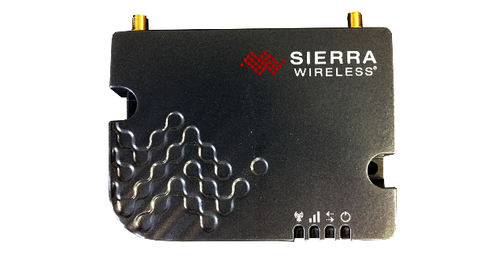
Cellular has become one of the most popular methods for communicating with electronic flow computers in the field. The flow computer requires being equipped with cellular modem, coax and antenna. Cellular modems use internet protocol (IP) technology, see Fig 11. Instead of having a phone number like an analog line, the cellular modem has an IP address (e.g. 166.56.73.128). This allows for the remote computer connected to the internet to connect to the device in the field via cellular towers. The use of cellular modem requires signing up with a cellular service provider. IP addresses can be dynamic or static, dynamic IP addresses can change when the devices power is cycled as where a static IP will always stay the same. Users can latch to the carriers generic access point name (APN) for standard static IP addresses or can get custom APN’s from the carrier to have a private network for their cellular devices which provides enhanced security.
Fig. 11. Example of Cellular Modem
Fig. 12. Example of Iridium Satellite Modem installed on a circuit board.

Satellite communication technology uses a satellite modem installed in an electronic flow computer with an antenna that provides communication with a satellite in the sky, typically a low earth orbit (LEO) satellite though other technologies are used as well, see Fig 12
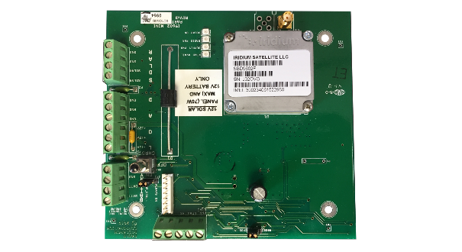
Satellite communication supports two-way data communication. The data service is provided by a satellite service provider.

Maintenance

The electronic flow computer has minimal moving parts, therefore it requires minimal maintenance. Following certain maintenance guidelines will minimize failure and increase the effective life.

Enclosure maintenance is a program of routine inspections to ensure the integrity of the door seal and other sealing gaskets. Excess moisture can cause problems with electronics if allowed to accumulate within the enclosure, even though most circuit boards are coated to protect against humidity usually up to 95% RH. The wiring connections and various exposed metal surfaces are susceptible to corrosion in extreme cases of interior humidity.

Ensure that the mounting arrangement for the unit is secure, level, and provides a stable platform for termination of the pressure tubing, conduits, etc. Check the lid gasket for deterioration, chemical damage, tears, or compression. Check for damaged or not fully tightened cord grips.

Battery Packs will need to be replaced or new cells installed at regular intervals. Any non-rechargeable battery pack, under normal operating conditions, will eventually drop below the voltage level needed to maintain power for the flow computer. Its lifespan is determined by multiple variables specific to each flow computer and type of battery construction, and therefore difficult to generically predict a replacement interval.

The rechargeable battery pack, under normal operating conditions, should provide many years of productive service before needing to be replaced. When it becomes apparent that the rechargeable pack cannot maintain its charge or its voltage has dropped below 10.8VDC, the battery should be changed.

Calibration is a crucial element of any scheduled maintenance program. Today, most of the electronic flow computers use software calibration. The software calibration does away with the need for laborious adjustments, thereby simplifying field calibration. Calibrations can be a simple two point Zero and Span or an elaborate 11 point calibration.

Other Electronic Flow Computer Features and Options

The electronic flow computer does more than just calculate gas and liquid flow.

Historical data can be stored in the flow computer’s memory on a secondly, minutely, hourly, or daily basis. Typical historical data can be uncorrected volume reading, corrected volume reading, average flowing pressure, flow time, average flowing temperature, supply voltage, ambient temperature, etc.

Alarms limits can be set with parameters to alert on a local display and store a local history record if parameters fall outside the alarm limits. It can also be set up to report to the remote computer system via a communication link.

Audit Trail is an important feature to record any changes made to the corrector. Typical audit trail records include the date and time the change was made along with the old value, and new value of a parameter.

Power Management features allow the flow computer to minimize power usage, thus extending the battery life. Today, flow computers can be configured to power up periodically to perform detailed calculations or power the communication devices only at predetermined times. Most of the communication devices consume large amounts of power when compared to the power required to operate the flow computer. For example, a flow computer could use 100 micro amps as it calculates flow averages and samples while a cellular modem can easily use 100 milli amps while connected to a network and not communicating.

External Pulser can be used when the flow computer is required to be installed away from the meter or in some cases when more pulses per revolution may be required to keep a smoother more accurate instantaneous flow rate. This may require additional signal conditioning.

High Frequency Pulse Input may be handled by some flow computers. This may require additional frequency conditioning circuits on board or on a separate board.

External Transmitters for pressure or temperature may be used with some flow computers. The external transmitter may output a signal of 4-20 mA or output a voltage from 1-5VDC. These transmitters generally require a 24 VDC supply.

Bidirectional Index or Bidirectional Multi-Variable Transmitter is available for some flow computers in the market to measure gas flow in both directions. Usually forward, reverse, and net totals would be recorded.

Chromatograph Interface can be available for some flow computers using an additional serial communication link. This allows AGA8 Detail Calculations to use updated values from the chromatograph as they are sampled instead of staying static over time, increasing accuracy.

Odorizer Interface can be available for some flow computers using additional pulse output, analog output or serial communication link.

API 21.1 Compliance

Calculations

The electronic gas measurement (EGM) system algorithms define sampling and calculation methodologies and averaging techniques.

Differential pressure measurement, which is used most commonly in orifice measurement applications, the appropriate flow equations can be found in the latest revision of API MPMS Ch. 14.3 (AGA Report No. 3) or other approved differential pressure metering standards.

For linear meters, such as rotary, diaphragm or turbine meters, the appropriate flow equations are found in the latest revision of AGA Report No. 7. or other approved linear metering standards.

Flow variables must be sampled at least once per second and input into a flow time linear average for any meter type. There is an exception to this if it can be demonstrated that less frequent sampling produces less than a +/-0.05% difference in the quantity.

Equations of state for compressibility, are calculated using the AGA Report No. 8.

Audit Trail and Records

An EGM shall be capable of creating an audit trail by compiling and retaining satisfactory data for verification of hourly and daily quantities. The audit trail shall include proper units of measure for all reported values.

The main reason for retaining historical data is to provide support for the current and prior quantities reported on the measurement and quantity statements, such as a Gas Volume Statement.

The audit trail should include, but not limited to unedited historical data, event logs, field test reports, edit reasons, configuration logs and supported information for the accounted for mass, volume or energy. API 21.1 refers to this as the Quantity Transaction Record (QTR). The QTR shall be collected and stored with enough resolution to allow for recalculation within 50 ppm per API MPMS Ch. 14.3, Part 4.

Below is a sample of records (not all) that makeup a QTR:

- Date and time
- Quantity (volume, mass, and/or energy)
- Flow time
- Integral Value
- Meter output
- Static pressure average
- Temperature average
- Differential pressure average

The Configuration Log shall contain and identify all flow parameters, calculation methods, as well as general information used in the generation of a QTR.

The Event Log must also be a part of the audit trail for each accounting period. The Event Log is used to note and record any exceptions and changes to the flow parameters contained in the Configuration Log that occur and have an impact on the QTR. Each time a constant flow parameter is changed in the system, the old and new value, along with the date and time of the change, shall be logged, this is commonly known as a split history.
The Test Record shall be part of the audit trail and consists of any documentation (electronic or hard copy) generated in the testing of metering and analyzer equipment that would affect the calculation of measured quantities.

Common elements in a Test Record are:

- Calibration reports
- Primary device inspection reports
- Equipment change tickets
- Equipment maintenance and inspection reports

Data Availability

Data availability requirements are intended to ensure that the minimum necessary data is collected and retained in order to allow proper determination of the quantities measured by the EGM.

Remote collection of this data, such as through a SCADA system or polling engine, is acceptable unless prohibited by statute, regulation, tariff, or contract.

Onsite data is typically store in the flow computer of the EGM. Local storage could be in months or years for total records however the minimum requirement for total records is defined below. Onsite data requirements for API 21.1 are summarized below:

- Minimum of seven days of hourly QTRs
- Minimum of seven days of daily operational data
- Constant flow parameters and manually entered input variables that affect quantity calculations
- Current values for live input variables or calculated variables
- Current value of gas analysis data
- Equipment information

The data retention period for the EGM audit trail is defined by regulation, statute, tariff, or contract.

Commissioning

Commissioning is the process of the initial verification and documentation that the EGM system is installed and functioning according to its specifications, design, and regulatory/contractual requirements.

For secondary devices, such as electronic flow computers, the manufacturer should provide documentation for field commissioning and calibration/verification procedures.

In addition, the range, operating, and environmental limits for all transducers/transmitters in the flow computer.

Factory calibrated devices from the manufacturer should include documentation of the testing and accuracy verifications, including equipment specification and performance documentation.

For final integrated EGM site commissioning, the flow computer (secondary device), the following must be completed. Verification of configuration, process input verified to tertiary device inputs, review, and acceptance of diagnostic data. Additionally, at a minimum, verifications must be performed on differential pressure, static pressure, temperature, as well as any other points recommended by the manufacturer.

Equipment Verification and Calibration

The following EGM components require verification/calibration:
- Static pressure transmitters
- Differential pressure transmitters
- Temperature transmitters
- On-line analyzers
- Other EGM devices

Verification is the process on confirming accuracy of an EGM device, such as an electronic flow computer using measurement or reference standards. The frequency of these verifications is based on contractual or mutual agreements between customers.

Calibration is the adjustment of an EGM device to conform to certified reference standards to provide accurate values over the user’s defined operating range. The frequency of needed calibrations is based on contractual or mutual agreements between customers.

Security and Data Integrity

Security is required to prevent unauthorized alterations of configurations and data which affect measurement integrity.

The electronic flow computer in the EGM system shall be configured to deny unauthorized access to configuration profiles and measurement data via unique access codes and/or username and password. A hardware lockout jumper can also be used.

All data records as required in API 21.1, shall be stored in such a way they cannot be altered. There must not be any changes to the original data. Both original and edited data must be retained.

Software containing measurement algorithms for the electronic flow computer must contain the software version number loaded on the device. The software version number must be a unique identifier.

The electronic flow computer shall provide a battery backup capable of storing all data in the unit’s memory for no less than 35 days. If there is a primary power failure, the date and time of the failure must be logged in the audit trail, as well as date and time when unit returns to normal power status.

Summary

An electronic flow computer is one piece of an electronic gas measurement (EGM) system. The electronic flow computer collects live uncorrected gas volume or liquid volume through any type of meter and calculates corrected volume and energy. This is achieved by measuring live differential pressure, live flowing pressure, live flowing temperature, and/or by counting pulses from the meter. Additionally, other devices can feed the flow computer, such as an online chromatograph to provide additional data which provides a more granular look at how volume and energy are affected by gas quality.

Many calculations are performed inside the flow computer to obtain a corrected volume and energy.

With flexibility in communication and power technology, coupled with measurement standards such as API 21.1, reliable and accurate data can be obtained from most any measurement point.

References

- Measurement of Petroleum Measurement Standards Chapter 21.1 (ANSI/API MPMS CHAPTER 21.1, SECOND EDITION, FEB. 2013)
- Basics of Electronic Volume Corrector, Tushar Shah, WGMSC 2011
- Basics of Electronic Volume Corrector, Jereme Stewart, Tushar Shah, WGMSC 2016
- www.eagleresearchcorp.com
- www.wikipedia.com

