REGULATOR FREEZE PROCTECTION

AUSTIN SORENSEN, P.E.
Sr. ENGINEER
Williams

Introduction

Freezing can be a problem in both transmission and distribution systems in the natural gas industry. This problem can affect a Company’s ability to deliver gas on demand. Damaging its reputation and its license to operate in the public’s eye. It typically occurs when there is a reduction of pressure at natural gas regulating stations. The problem can be complex so there are multiple solutions to address the problem.

The four primary contributors to the problem are pressure drop, presence of water, hydrocarbon liquids, and ambient temperature. Hydrocarbon dew points also need to be considered when dealing with hydrate issues. The Joule-Thompson (JT) effect is what causes the hydrate to form with pressure drop. As the pressure of a gas drops, so does the temperature. For every 100 psi of pressure drop, the temperature of natural gas will drop approximately 7 degrees F as a good rule of thumb.

Why Does Freezing Occur?

There are typically two types of freezing that can occur on natural gas systems. Internal freezing within the pipeline and external freezing. Internal freezing is caused by liquids within the pipeline. Transmission pipelines receive processed gas where hydrocarbon liquids and water have been removed.

Transmission lines have gas quality standards called tariffs for gas that is shipped within their pipeline system. A typical water limit is 7 lbs per million standard cubic feet of gas. This is considered dry gas. Local Distribution Company (LDC) lines should have minimal problems with water when lines are properly maintained.

Hydrocarbon dew point shifts can also cause the formation of hydrocarbon liquids within the pipeline. The hydrocarbon liquids in gas pipelines can cause several operational issues with regulators, control valves, and compressors. In order to avoid hydrocarbon liquid dropout hydrocarbon dew point (HDP) and/or the cricondentherm hydrocarbon dew point (CHDP) are monitored at receipt points on the pipeline.

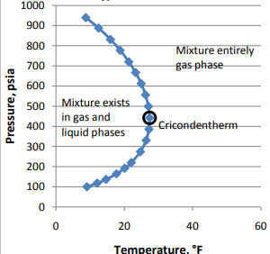
Figure 1- HDP Curve for Typical Nature Gas Mixture
Both temperature shifts and pressure shifts have effects the HDP as shown in Figure 1 above. Higher BTU gas generally is more likely to have liquid drop. Figure 2 below shows a hydrate formation found within a pipeline system.

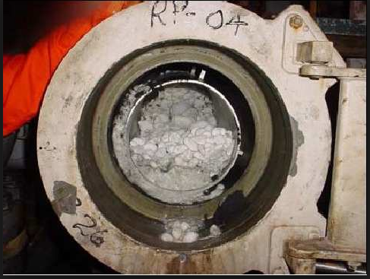
Figure 2-Natural Gas Hydrate
External freezing is mainly caused by the JT effect downstream of regulators. This can be observed at city gate stations where the transmission line feeds into the LDC. It is not uncommon for the regulator station to make 300-600 lbs pressure drops. These types of pressure drops decrease the gas temperature by 21-42 degrees F.

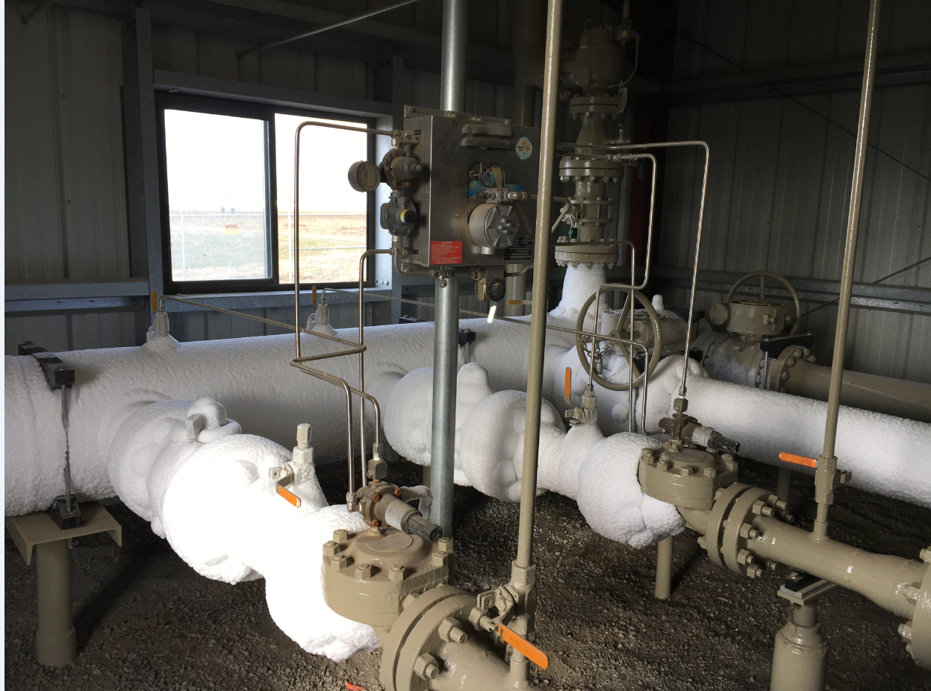
Figure 3-Example of Pipeline Freeze
Problems Caused by Freezing

Both internal and external freezing can lead to service disruptions. The internal freezing as shown in Figure 2 can directly impact the amount of gas that can flow to end customers. The formation of hydrates within the pipeline can create a physically barrier blocking the flow of gas. The external freezing of regulators is problematic on both pilot and directing acting regulators when the atmospheric vent port freezes over. The regulator is not able to function properly leading to service interruptions or safety issues. Figure 4 below, shows a regulator that has its vent frozen over. This regulator could potentially be sending high pressure gas downstream causing a safety issue.

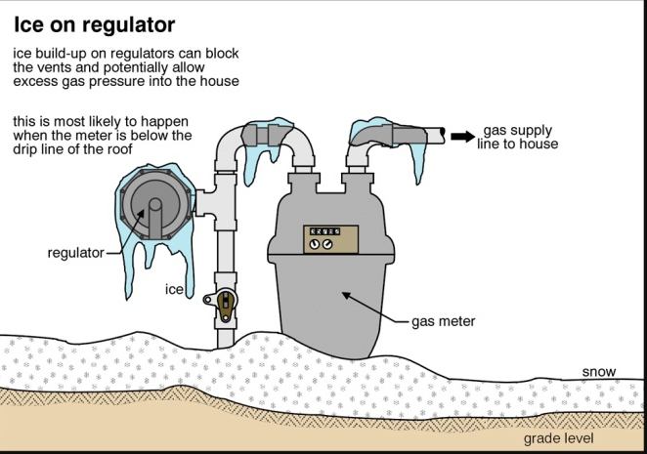
Figure 4-Frozen House Regulator
It can also create issues with equipment working properly. Regulators and control valves may not be able to control pressures and volume correctly due to ice buildup on the internal sealing surfaces. Icing can also exceed the temperature ratings of internal components leading to failure. Flexible element regulators can receive damage by internal icing cutting or impairing its functionality. Hydrate formations can damage positive displacement type meters and turbine meters causing physical damage to the internal parts. Orifice meters can have ice buildup on the plates causing inaccuracies within measurement.

Sulfur fallout is another problem that can occur with gas temperature changes. Sulfur vapor is present within the gas stream in the parts per million levels. The sulfur vapor becomes supersaturated due to the JT effect caused at regulating station. The supersaturated sulfur vapor forms drop out in small particles that cling to surfaces and continue to collect. The picture below shows the sulfur dropout on the downstream side of Mooney trim plate. The high pressure side is free of sulfur but the downstream low pressure side sulfur has built up reducing performance and capacity of the regulator.

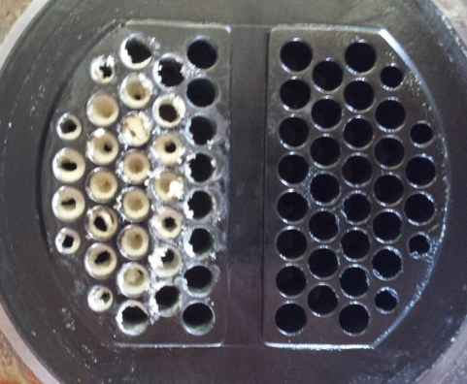
Figure 5- Sulfur Buildup Mooney Trim Plate

How to Prevent Freezing

There are several options available to prevent freezing. The following options will be discussed dehydration, heating, and methanol injection. The best way to prevent a problem is by removing the problem completely. Dehydration when functioning properly will do this. It works because the glycol bonds with the water in the gas stream. Glycol dehydration units removes the water by having the gas stream pass through the glycol. As gas passes through the glycol the water and the glycol will combine. The gas continues through the process making dry gas on the outlet side. The glycol is then treated to remove the water from the glycol and separated out. The water is byproduct and the glycol is used again within the process. The Figure 6 shows a schematic of the dehydration process.

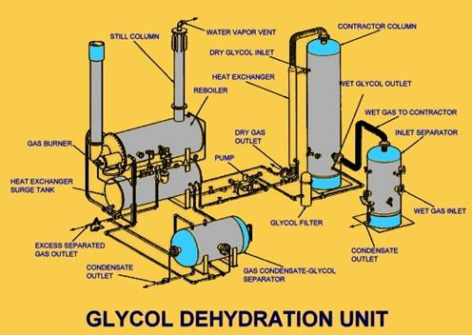
Figure 6-Glycol Dehydration Unit
Heating the gas above the freezing point of water is also an effective method. This is a simple math problem of temperature of gas coming into the gate station, minus the JT effect for temperature loss and making sure that number is about 32 degrees. There are several heating options commercial available to Operators. The heater options existing for both pilot and instrument gas heaters and station heaters.

Catalytic heaters are options for both pilot gas heating and station heating. The Figure 7 below shows a typical pilot gas heater. The heater uses a catalytic element once lit to heat the enclosures. It uses pipeline gas as the fuel to burn. The pilot loading line is routed through the heater to prevent freezing within the pilot.

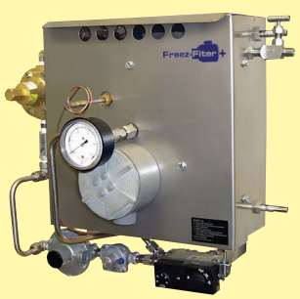
Figure 7- Pilot Gas Heater
Another option for pilot line or instrument line heating is vortex heaters. Vortex heaters use the kinetic energy of one gas stream to heat another gas stream. The high pressure gas passes through special designed inlet nozzle that cuts the pressure and increase the velocity of the gas. This creates a high and low temperature vortex currents. The high temperature current goes to the outer wall of the heater canister and the cooler gas is routed up the center of the canister. These gas streams are both returned to the downstream system. The pilot gas is routed between the outer wall and the hotter gas caused by the vortex. The heat exchange happens between the pilot gas and the heated gas within the vortex canister. Figure 8 shows the heat cycle within the vortex system. This system has some benefits when unitized correctly, there is no gas loss within the system, no maintenance to the heater, and zero emissions.

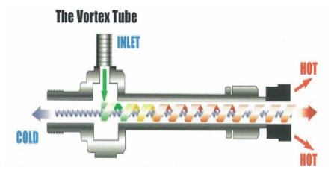
Figure 8-Vortex Heater
For heating the station flow the same principle is followed but on a large scale with catalytic heaters. The gas generally flows through a large volume bottle where the piping is heated by catalytic heaters around the bottle as shown in Figure 9. The heat transfer occurs between the pipe and the gas stream. Some of the system benefits are no tube bundle maintenance, no burner maintenance, no moving parts, and no boil-off concerns. Some system draw backs are: catalytic elements do degrade, upfront capital cost, control setup can be more complex.

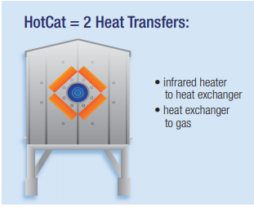
Figure 9-Catalytic Heater
Indirect fired water bath heaters are also common used to heat the main stream of gas. The indirect water bath heater works similar to the water heaters found within homes. An indirect water bath heater heats the gas through heating the bath media. The heat transfers take place between the water bath and the process coil and between the bath and the process coil. The water bath helps with uniform heating and reduces the chance of hotspots. The heater consists of five main parts: burner, fire tube, process coil, shell, and fluid. The burner box is where the pilot flame and burner is contained. The fuel for the process is typically natural gas. The flame is directed into the fire tube. The exhaust gases also travel out the fire tube to the flue gas stack. The fire tube heats the fluid contained in the shell. The heated fluid then heats the process coil. The process coil is transporting the gas through the heater. The process coil size is determined by the gas flowrate, gas pressure, and desired temperature. Pressure drop through the heater is also considered when designing the heater. The indirect heater typically achieves 50-55% heating efficiency. Indirect heaters are considered a reliable way to provide heating for the main gas stream at gate station. When installing indirect heaters consideration needs to be taken in the downstream piping configurations. There can be significate loss in gas temperature between the heater outlet flanges and inlet of the regulators. Try to keep the heater as close to the regulators as reasonably possible.

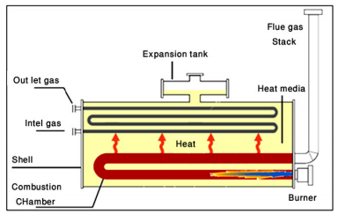
Figure 10-Indirect Fired Water Bath Heater
Another type of heater is heat driven loop system as shown in Figure 11. It is also an indirect method of heating the gas. These systems use steam energy to heat the process coil that contains the main gas stream. There are two heat transfers that occur. The first is between the steam and the process coil and the second is between the process coil and the gas stream. The process begins with a flame heating a water-/glycol mix to the point of boiling in a vacuum. Steam rises and interacts with the lower temperature coil carrying natural gas. The steam changes phase to water while heat is exchanged to the coil flowing gas. The water condensate is then returned to the water/glycol mixture to repeat the process.

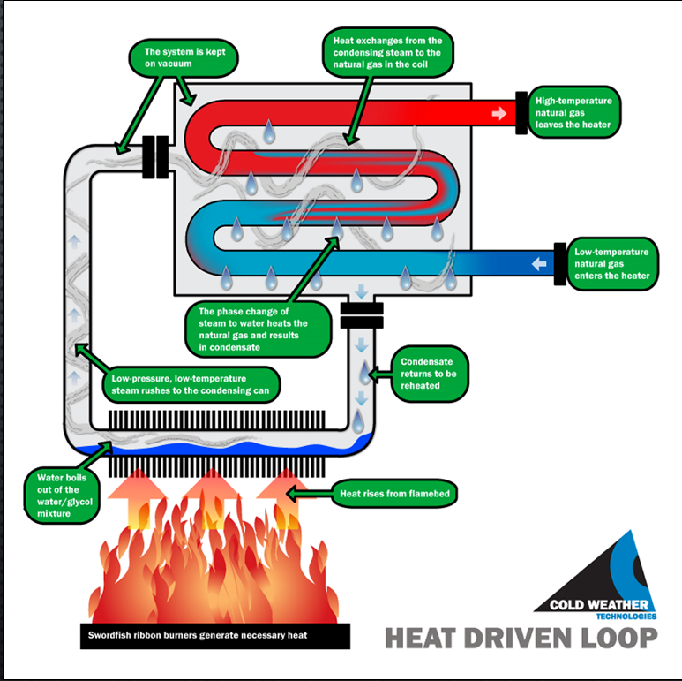
Figure 11-Heat Driven Loop by Cold Weather Technologies
Chemical methods may also be used to prevent freezing within the pipeline system. A system drawing is shown in Figure 12. This system works by adding chemicals to work as an anti-freeze. A couple commonly used chemicals are alcohol and methanol. These can be added to the gas stream to mix with the water and lower the freezing point of the mixture. This type of system normally requires a metering pump and methanol storage tank.
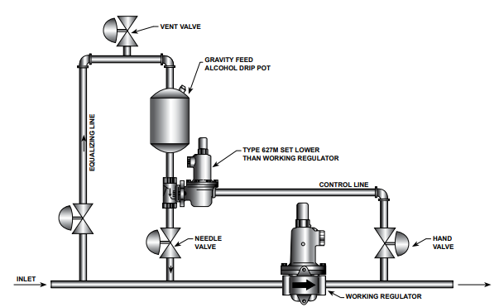
Figure 12-Chemical De-Icing System
Conclusion

In a regulator station temperature drop will exist and freezing is always a possibility. But with implementing a few strategies regulator freezing can be prevented. First ensuring you have pipeline quality gas entering the system. Second add heat when it’s needed in form of instrument heaters or station heaters. Heater technologies are evolving and becoming more efficient and are automated with burner management systems. Also remember that heating the gas has been found to be a beneficial solution with sulfur drop. Keeping up with emerging technology and issues can help you stay ahead of the game and not frozen.

References

The author used the following resources while compiling information for this paper.

Pipeline Rules of Thumb Handbook, 2nd Edition, Gulf Publishing Company, Houston, TX, 1989.

“Freeze Protection for Natural Gas Pipeline Systems and Measurement Instrumentation,” David J. Fish, Presented at American School of Gas Measurement Technology, Houston, Texas, 2007.

“Regulator Freeze Protection,” Erik Anderson, Presented at Western Gas Measurement Short Course 2011

Regulator Freeze Protection,” John Tomich, Presented at Western Gas Measurement Short Course 2015

“Cold Temperature Considerations”, Emerson Technical Bulletin

“Test Show How Drips Lips Can Prevent Regulator Freeze-Ups”, Emerson Technical Bulletin LP-18

“The Vortex Pilot Gas Heater,” Universal Vortex, Inc.

